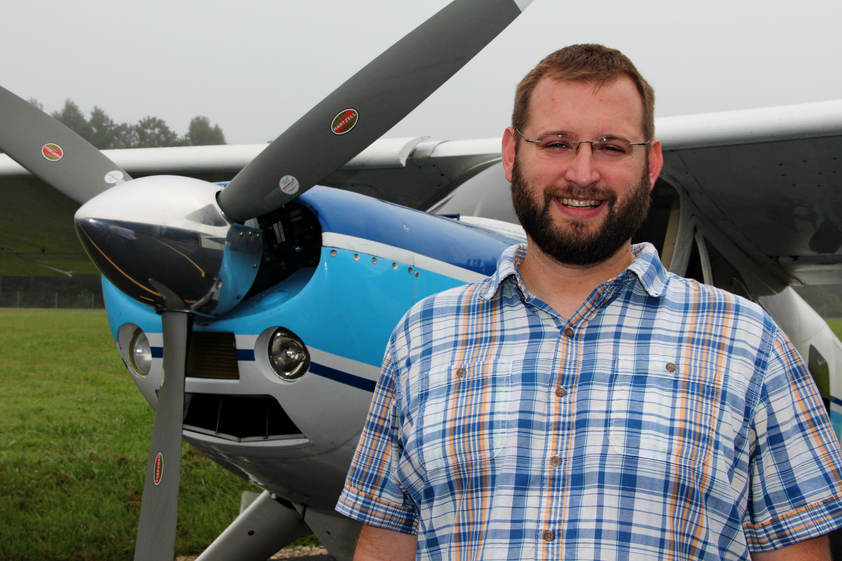
Jonathan Faught
JAARS
Jonathan grew up as an Army brat all over the world. His passion for flight began at an early age, by the time he was 3, aviation was his love. He came to faith in Christ at the age of five while living in Jerusalem, Israel. In high school he started flight training at the same time as his parents. He completed his undergraduate degree in Aerospace Studies from Embry-Riddle Aeronautical University in Daytona Beach, Florida with concentrations in Logistics, Aviation Maintenance, and Business Administration.
Upon completing his flight training after college, Jonathan, worked as an aircraft mechanic, director of maintenance, aircraft appraiser, as well as a licensed insurance adjuster on large loss aviation claims and commercial properties. Jonathan has also worked as an aerial survey pilot as well as pilot and system operator trainer with airborne visual spectrum, IR, and LiDAR sensors and systems.
Mission aviation had been a part of Jonathan’s life since a young child as his parents have supported the work of a number of organizations. In 2010 Jonathan felt called to prepare to go into mission aviation himself. After leaving his position as a senior pilot and maintenance trainer he begin preparing full time. During the fall of 2013 he started the process of technical evaluation with JAARS and application to Wycliffe Bible Translators to serve as a fixed wing pilot and aircraft mechanic.
Jonathan will serve as a pilot and mechanic in South East Asia/Oceana supporting the work of national organizations partnered with Wycliffe Bible Translators and JAARS. There he will be helping support the work of Bible translation while also helping meet the physical needs of the remote and isolated communities through aviation. He will be working with the very capable Pilatus PC-6 Porter and PC-12 aircraft there.

