Garth Pederson
MAF
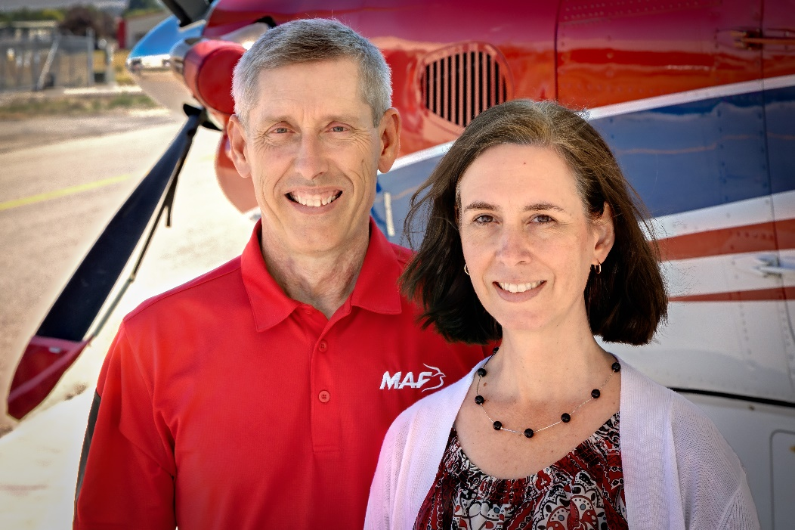
Garth and his wife Jody have been serving as missionaries with Mission Aviation Fellowship since 1995. They worked in the Democratic Republic of Congo for 21 years where Garth served as a Pilot/Mechanic, also taking leadership roles as Program Manager, Aviation Accountable Manager, and Instructor Pilot. Garth’s current position as North Central Mobilizer puts him in touch with many who are in the process of responding to God’s call on their lives to become mission aviators, teachers, computer specialists, or fulfill other needs within MAF. He also continues on call to respond as a pilot/mechanic for disaster relief around the world.
For Garth, Micah 6:8 “He has told you, O man, what is good; and what does the LORD require of you but to do justice, and to love kindness, and to walk humbly with your God?” is a favorite verse. He shares, “This verse is so appropriate to what we do around the world – demonstrating mercy to many suffering people in remote locations. We enable missionaries and national pastors to bring the Gospel message to isolated people.” Garth says, “In my new role as Mobilizer, it is a joy to talk with those God is speaking to about joining MAF and encourage them along that path.”
Garth grew up in a Christian home in Rochester, Minnesota. His mother had the joy of leading him to the Lord at age five, after a Sunday evening service. After high school, Garth earned a B.A. degree in Business from Bethel University, St. Paul, Minnesota and an M.B.A from Liberty University. He holds an A&P mechanic’s license, commercial pilot’s license with instrument rating, certified flight instructor license, and over 8,000 hours of field flight time.

