**Geoff Russell**

**Recurrent Training Coordinator**

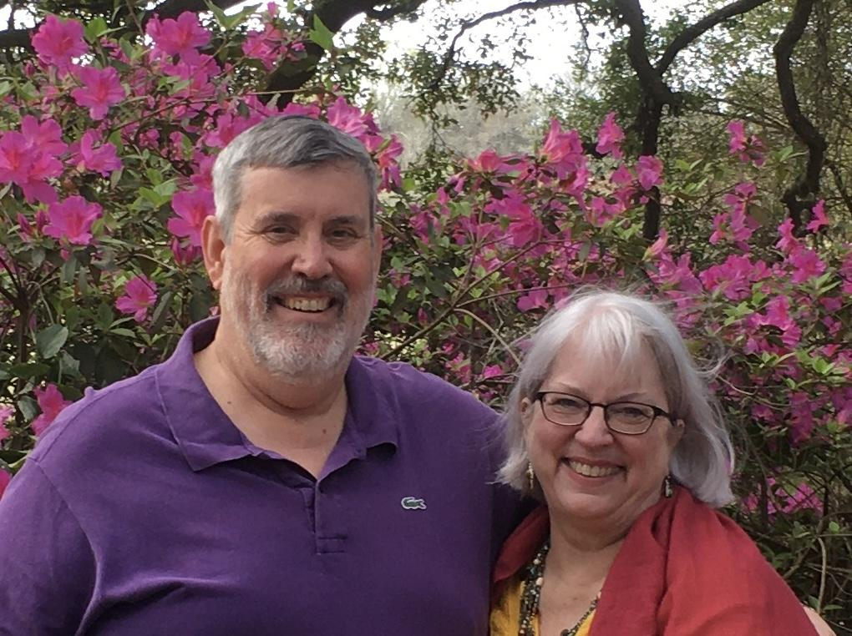

My wife Sue and I went to Papua New Guinea in Dec. 1999 to be Children's Home Parents and spent the best 8 years of our lives doing that. Following that I spent two years in our Aviation department as the Helicopter Flight Coordinator. Then we returned to our roots managing the Children's Home Department.   
In April 2013 we returned to the US for a study furlough, and in May 2016 Sue completed a 3 year course of study at Talbot School of Theology's Institute of Spiritual Formation on the Biola University campus and graduated with High Honors receiving her Master of Arts Degree in Spiritual Formation and Soul Care.  
Following that we re-located to take up ministry at the JAARS Center near Waxhaw N.C. Sue is using her training to work in Wycliffe's Spiritual Development Department helping to craft new programs that will enhance the abilities of our fellow missionaries to maintain their spiritual health, both on and off the field. My assignment is in the Aviation Training Department coordinating the recurrent training of pilots and mechanics for JAARS and from other missions around the world as they come to JAARS for recurrency training.