**Jeff Johnson**

**Helicopter Operations Supervisor**

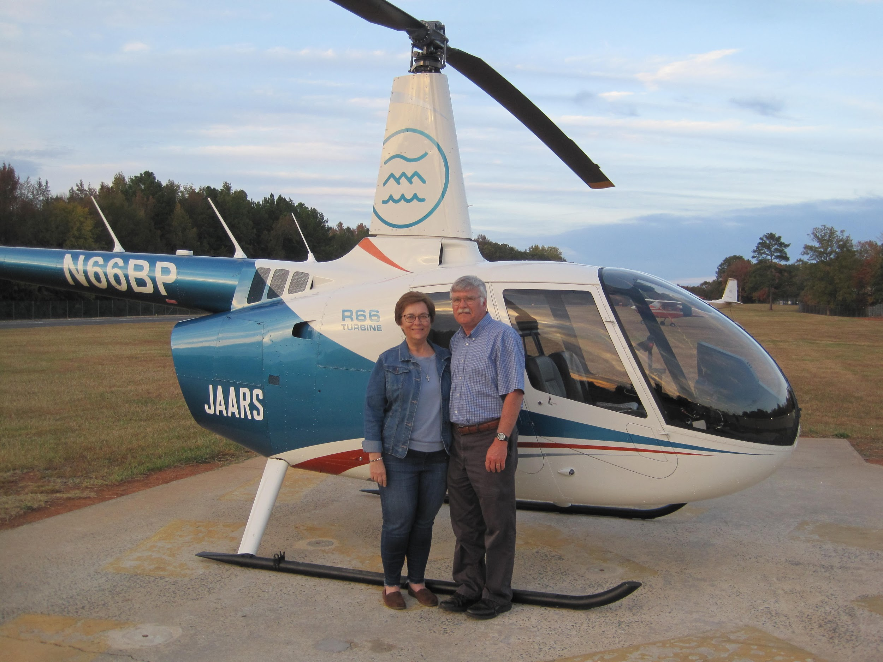

Jeff attended LeTourneau University after moving toward missionary aviation at age 17. He and his first wife Deb joined Wycliffe/JAARS in 1986, and initially served in Liberia. The ongoing civil war redirected them to the Philippines, where Jeff again flew the Helio Courier airplane.   
In 1996, the Philippine aviation program manager asked Jeff to learn to fly a helicopter before returning to the Philippines. At the end of his training in 1998, Deb’s breast cancer returned, which precluded their return overseas, and she died in 2001.   
In 2003 Jeff married Mary Beth Freitag, whose husband and son were killed in a small airplane crash in 1999. Jeff and Mary Beth have served together at the JAARS base, as well as in Cameroon. Jeff is the Helicopter Operations Supervisor, and Mary Beth is a writer and the social media manager in the Communications Department. He enjoys bicycling, reading, and (generally :-) working around the house.