**Jeremiah & Julie Diedrich**

**Instructor Pilot / Aviation Liaison**

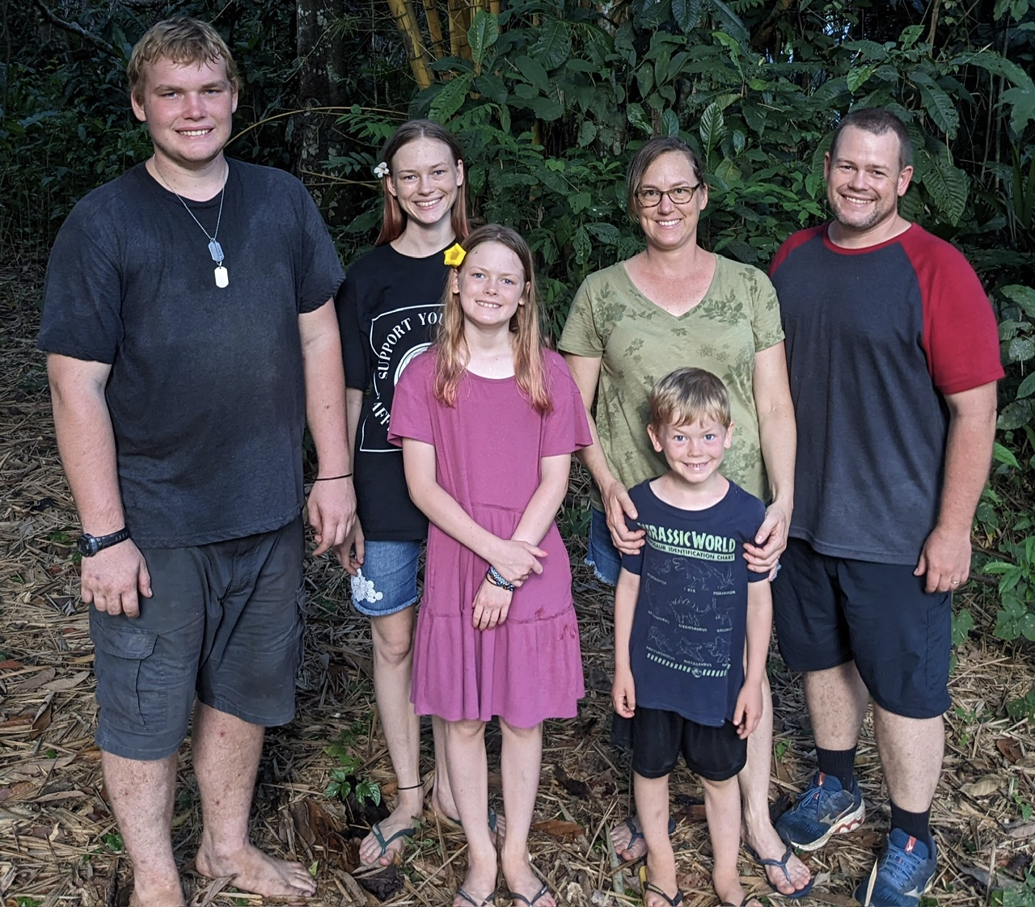

Jeremiah & Julie met at Moody Aviation in Elizabethton TN, where Jeremiah was training to be a missionary pilot and Julie was training as an aviation maintenance specialist. After graduation they joined Wycliffe Bible Translators and in 2006 were assigned to serve with JAARS in Brazil. After Serving 16 years in Brazil they returned with their four kids, Miriam, Nehemiah, Hadassa, and Simeon to the United States, and are currently assigned to the JAARS training department where Jeremiah serves as an instructor pilot, and Julie serves as aviation liaison.  
.