**Jim Elder**

**Director of Partnership Ministries**

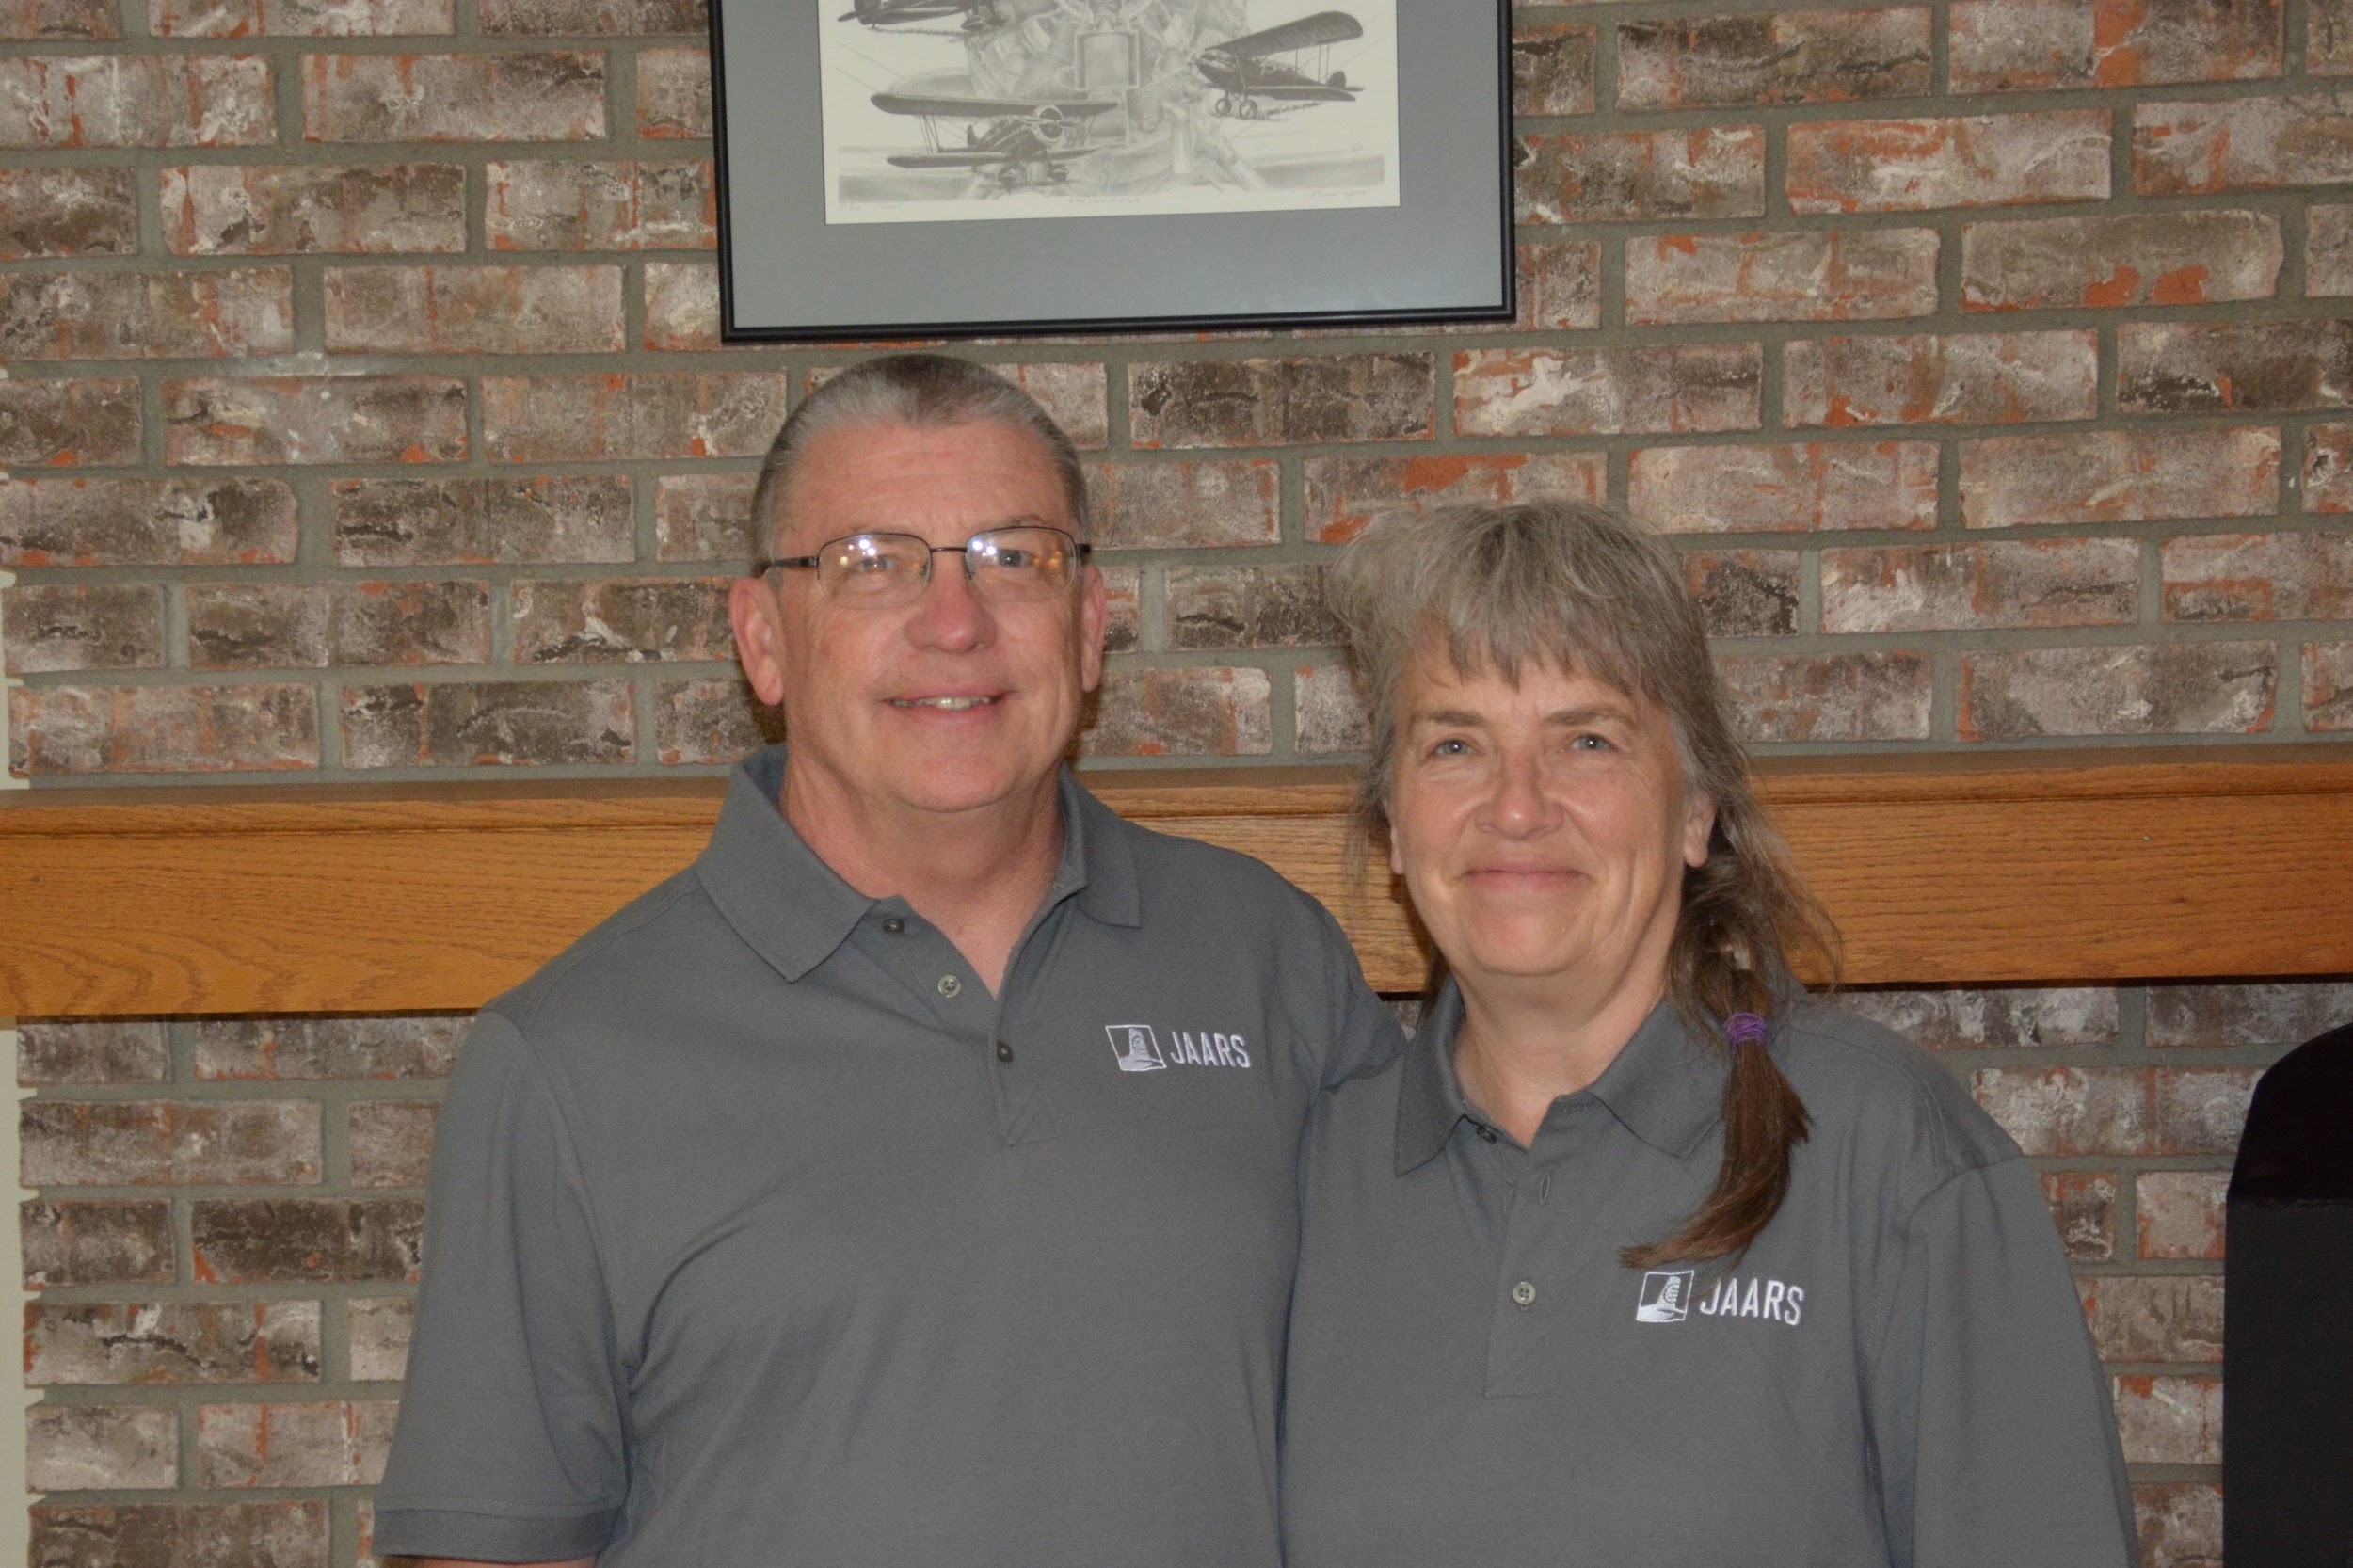

Jim was born and raised in rural Ohio. He accepted Christ and was baptized at the age of 13. After high school graduation in 1980, Jim attended the University of Akron and received a Bachelors degree in Accounting. He entered lay ministry in 1993 at the Wooster Grace Brethren Church where he served on the Board as Assistant Treasurer and adult Sunday School teacher. In May of 2002, Jim married his wife Stella whom he met at church. In April of 2002 Jim and Stella relocated to Homerville Ohio. Jim served as Elder of Missions for a term, and currently is an adult Sunday School teacher at the Homerville Grace Brethren Church.  
  
In 2014 Jim and Stella were called to full time mission service and joined Wycliffe Bible Translators. After completing 2 years of support raising and missions training, they were seconded to JAARS where Jim currently serves as Director of Partnership Ministries with Stella by his side.  
  
Jim and Stella enjoy working on the family farm, gardening, and most outdoor activities.