**Jonathan Federwitz**

**Flight Instructor**

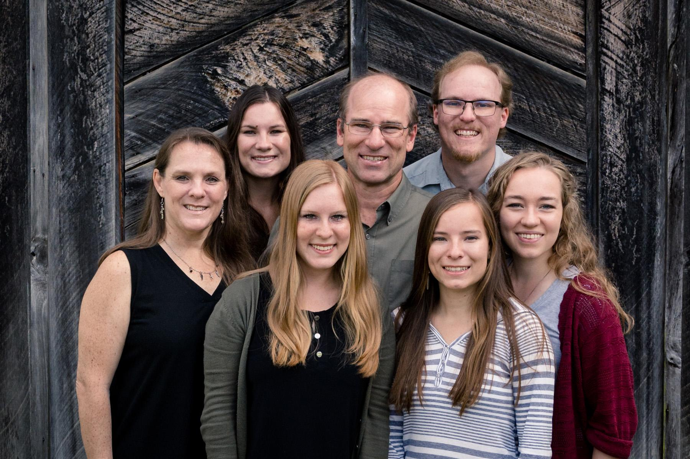

Jonathan (and his wife Carrie) served as missionaries in Papua New Guinea for 23 years where Jonathan was a JAARS pilot. Using his experience from Papua New Guinea, Jonathan now trains and prepares new pilots for mission field service. Jonathan & Carrie are graduates of Concordia University in St Paul, MN and Jonathan is also a graduate of Moody Aviation in Elizabethton, TN.   
While in Papua New Guinea, Jonathan flew Bible translators, their families, and others to and from remote areas within the country. Due to rugged mountainous terrain and lack of roads, aviation saves hours or even days of travel by land. Missionaries depend upon airplanes for their basic travel needs and also for receiving mail and supplies.  
The Federwitzes are now based at the JAARS center in Waxhaw, NC where Jonathan is preparing new pilots for mission field service. JAARS provides practical, day-to-day support to make Bible translation possible. The JAARS aviation headquarters provides training for missionary pilots serving around the world.   
Jonathan and Carrie have four adult children and one daughter-in-law: Nathan (& Sarah), Julia, Leah & Rachel.