Kerrick & Connie Tweedy
Service Oriented Aviation Readiness (SOAR)

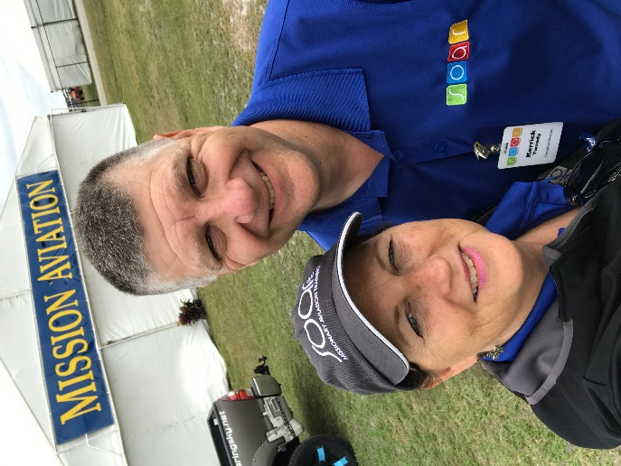
In April 2011, Kerrick Tweedy, Founder and Executive Director of SOAR, felt a very specific calling to begin a ministry to address the shortage of mission pilot/mechanics. Six months after this calling, he and his wife, Connie, began a training center at their home airport in Bolivar, MO. In May, 2014, Kerrick was added to the IAMA board of directors where he currently serves as secretary of the board.

Kerrick and Connie both hold a bachelor’s degree in Computer Science from Southwest Baptist University in Bolivar, MO, where they met, and they both had careers in insurance software development before the call to missions in 2011.

Kerrick and Connie have 3 grown children and 3 young grandsons.

About Service Oriented Aviation Readiness (SOAR)

SOAR is located in Bolivar, MO at the Bolivar Municipal Airport (M17). The primary purpose of SOAR is for the training and education of mechanics and pilots for mission aviation that is provided at an affordable rate. SOAR’s financial model helps mission candidates continue their debt-free mindset and take time out of the cycle from training to the field. Through its curriculum, programs, and supervised-experience training, students are prepared and qualified for the progression of testing and certifications.

Offering low-cost training to mission candidates is partially possible since SOAR serves as the airport manager for the city and operates as the only Fixed Base Operator (FBO) at M17. The FBO provides a public model for light flight instruction and aircraft rental. This public model allows SOAR to supplement its revenue and provides aircraft for maintenance in its shop as well as opportunities for training and serving customers.

SOAR currently has four mission candidates. Three of the candidates are well on their way in their A&P/Pilot training. The other one received his A&P in January, 2019 and has been accepted to Ethnos 360 Aviation as a maintenance specialist where he will transition to their training at MTC in Roach, MO, in August 2019. We are currently in the process of bringing in a new mission candidate to begin training at SOAR later this summer.

SOAR has enjoyed plugging in and being part of the IAMA family with involvement in the annual conference, EAA AirVenture, Sun ‘n Fun, etc…and looks for future opportunities to work with other IAMA family members.

SOAR has been attending EAA AirVenture since 2012 where we have been recipients of the wonderful support of the MASA team and volunteers and enjoyed the company of our gracious hosts. We are extremely grateful for the ministry of MASA.

The best way to keep up with the happenings of SOAR is by following us on our website at http://www.soarm17.org, Facebook at https://www.facebook.com/SOAR.M17 or Instagram at soar_missionary_aviation.

