Dan and Rachael Stoner
Pilot/Mechanics with JAARS Aviation
Waxhaw, North Carolina

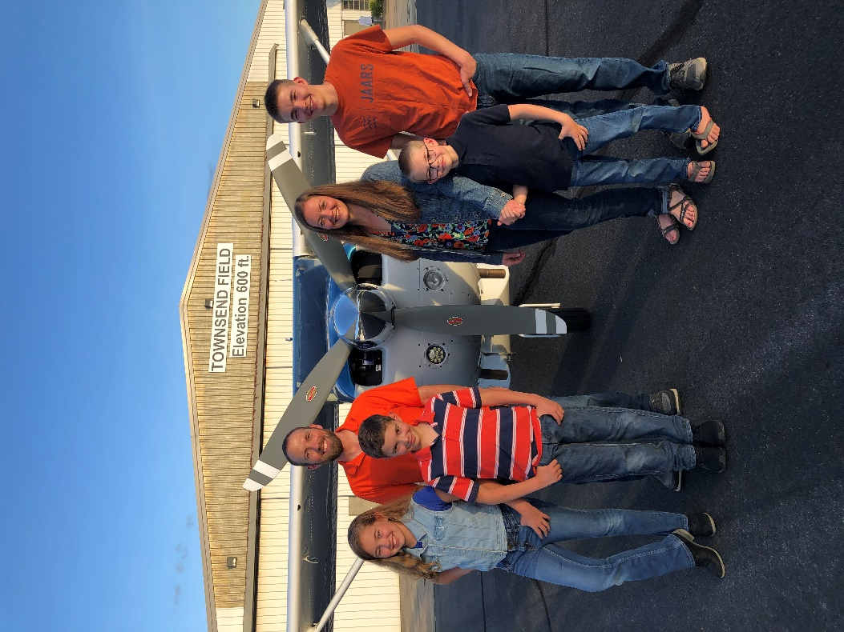
Dan and Rachael Stoner form a unique team as they both serve as Pilot/Mechanics with JAARS. Propelling the gospel faster and farther through aviation, maintenance and hospitality ministry is their mission.
At the age of 12 years old Dan committed his life to serve the Lord through missionary aviation when he was on a mission trip to Mexico. Rachael was 17 years old and at a summer church camp when she did the same. They met while attending Moody Bible Institute’s aviation program. After completing their training in 2007, Dan and Rachael moved to Ohio where Dan gained experience working as an aircraft inspector for five years. They have 4 children, Isaac (17), Lydia (13), Josiah (11), and Ethan (9).
The Stoners studied French for their service in Africa; Dan battled and defeated cancer; they rebuilt a Cessna 206 at JAARS for ABWE’s use in Togo; and then they served in Cameroon, supporting Bible Translation efforts through aviation. Dan served as a line pilot and mechanic, Rachael served as the Safety Manager, and she implemented a new computerized inventory and work order management system while working through her flight check out.
Dan and Rachael are presently assigned to the Aviation Department at the JAARS Center in Waxhaw, NC. Dan enjoys applying his maintenance skills to manage aircraft inspections and he currently is involved in a maintenance software transition for the JAARS Repair Station. Rachael works to engage the next generation in missionary aviation through coordinating Vision Flights and Brigade Air Camps.
In their free time, the Stoners enjoy camping trips, gardening, and working with the Wings Over Waxhaw Flying Club.

