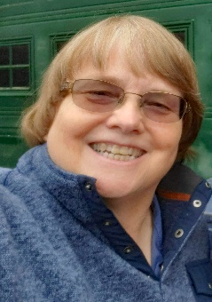****

**Caryl Mallory**

**JAARS Outreach Coordinator**

When Caryl became a Christian in her junior year of college, she was introduced to having a daily time with the Lord. That ignited her passion for God’s Word and ended up reading the entire Bible in two months in an easy to understand translation. Through InterVarsity she was also introduced to missions.

After graduation, she continued to serve as a State Park Ranger/Peace Officer. But her heart was for missions.

Caryl served one summer in Alaska with Solid Rock Ministries, and was accepted on staff. After raising some support, she attended Urbana 81 where she heard Marilyn Lazlo shared how many people didn’t have God’s Word in their heart language. She found that unacceptable and even though she had just a little financial support, she started supporting Bible translators.

Today, four languages have God’s Word (Two complete Bibles and Two New Testaments) that she has had a part in. Caryl even attended a Bible dedication in Ghana and helped in Australia at an Aboriginal conference.

While serving in Alaska as a missionary with Solid Rock Ministries, Caryl oversaw the Bible Correspondence Course for children as well as directed Wagon Train Camp and promotional events.

Due to various circumstances, she ended up working for the Girl Scouts, Kenai Borough School System, Probation Guard, and finally with the US Forest Service as a Roving Interpreter.

Upon moving to “outside” (the lower 48), she continued to gain a wide variety of administrative experience in marketing, public relations, publishing, training, career consulting, and management of volunteers. God was preparing Caryl for His service at JAARS through these various work experiences and degrees including from Moody Bible Institute and a master’s in public administration.

Altogether Caryl has been involved in Bible translation for over 33 years by volunteering while working, and then becoming a missionary serving at JAARS for the past 16 years.

At first, Caryl served in International IT Mobilization with the placement of staff worldwide. She also administered the Check-IT-Out conferences that challenge those serving in technology areas to become involved. With great joy, over 85 people have become members and over 200 people have volunteered since then. Quite a few serve on the JAARS campus.

Caryl now serves as the Outreach Coordinator, as she coordinates and participates in events outside of JAARS to encourage people to become involved in Bible translation. This involves festivals, homeschool conferences, church speaking opportunities, and some aviation related events for example.

She also researches and coordinates the purchase and distribution of giveaways for these events as well as orders products for the Gift Shop.

***Her greatest joy will be when EVERYONE has access to God’s Word in the language they understand best!***