**Michael Bunn**

**Missionary Pilot, Instructor at JAARS**

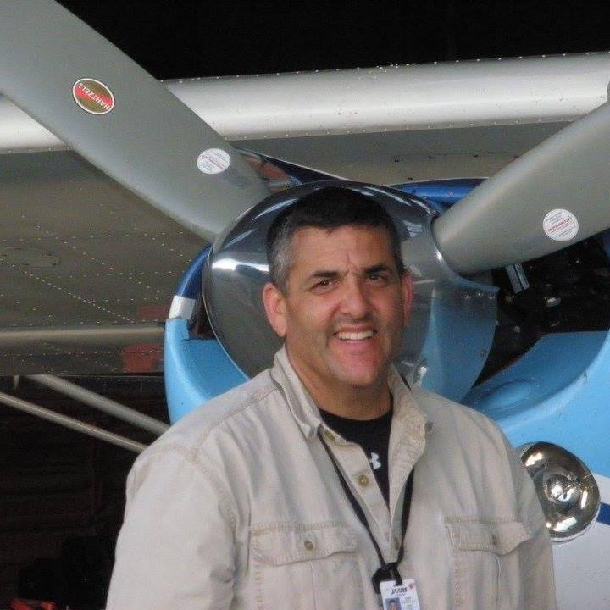

My wife and I served 3 years in Mozambique and 17 years in the Brazilian Amazon as missionary pilots, flying floatplanes and land planes to Indian villages. Now my wife and I train new mission pilots in airplanes and helicopters, to serve in the most remote locations of the world to be able to serve missionaries and unreached communities. We both graduated from Letourneau University with mission aviation degrees. We’ve now served at JAARs for 12 years, training over 60 new missionaries every year. We both have the privilege to travel overseas to check on our pilots and other missionaries, to do check flights and to encourage those now on the front lines. We have five children, three are married and three are serving in full time missions also. I, Mike, love wood working, rebuilding old machinery and of course flying.