Mike Mower

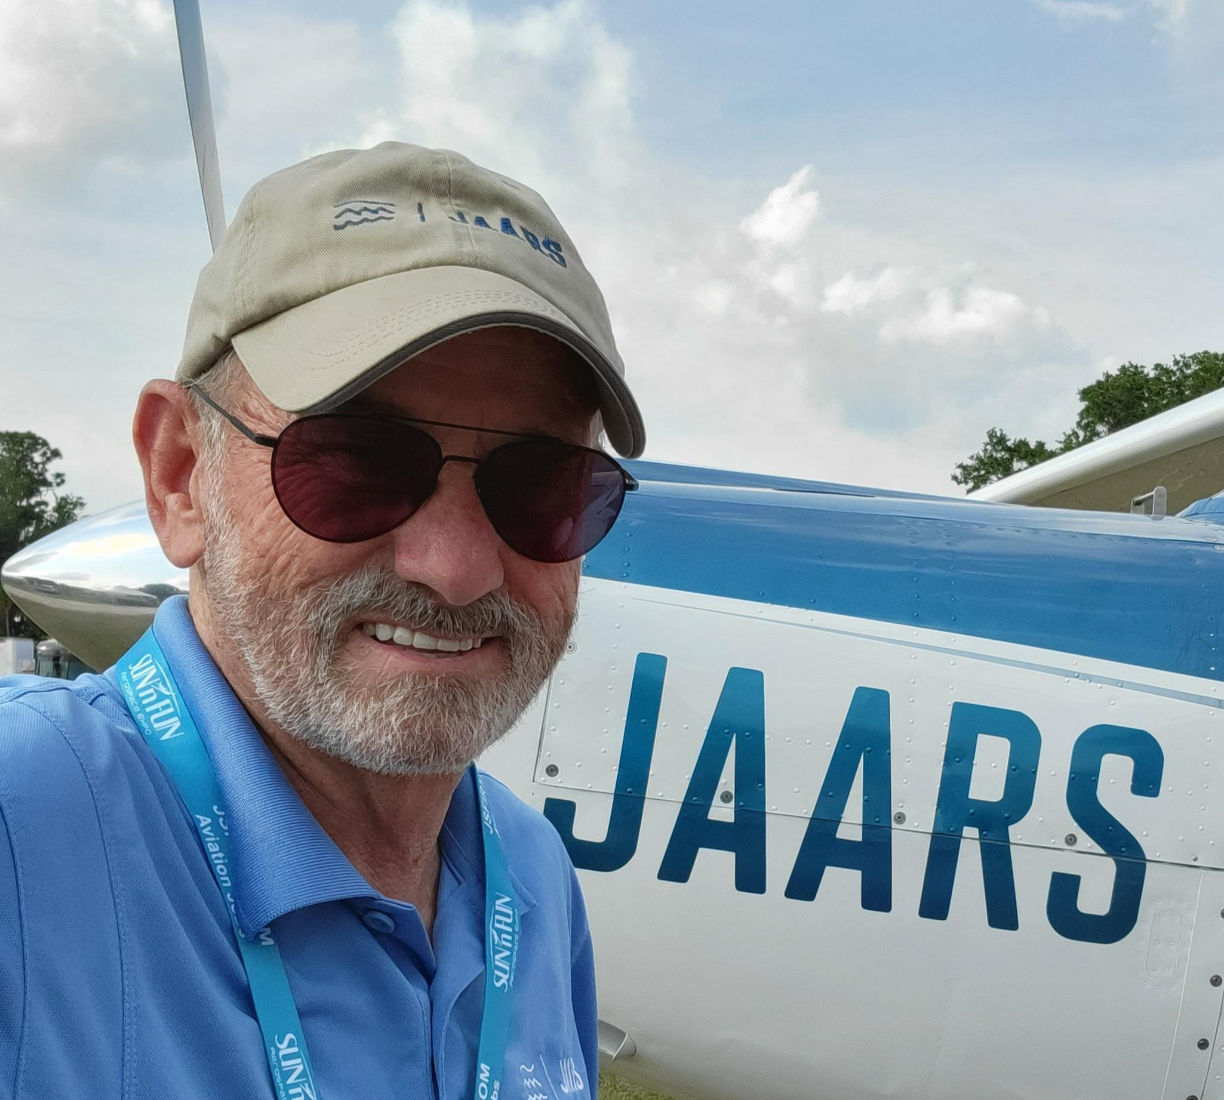
A burden for Bible translation, coupled with a desire to use Mike’s aviation training in service for the Lord, led him and wife Pat to Wycliffe and JAARS in 1981. Assigned to the Philippines in 1984, the Mowers were a vital part of the ministry of providing God’s Word in the heart languages of the Filipino people.
As an airplane pilot and mechanic, Mike provided for the transportation needs of those working in remote areas of the Philippines. Over twenty years, he logged nearly 5,000 routine flight hours, as well as flights for medical emergencies, evacuations, and disaster relief. On furlough in 1999 Mike ferried a Helio Courier across the Atlantic to Cameroon where it was used in support of translation efforts in west Africa.
After returning to the U.S. for home assignment in 2002 the Mowers were assigned to serve in the Missions at the Airport program, an outreach of JAARS to engage the Christian community and challenge others to greater involvement with JAARS. Mike led the program from 2010 until his retirement from JAARS.
Mike and Pat retired from Wycliffe Bible Translators and JAARS in March 2022 after nearly 41 years of service. In retirement Mike continues to work part time in the JAARS Missions at the Airport program as a Retired Volunteer.

