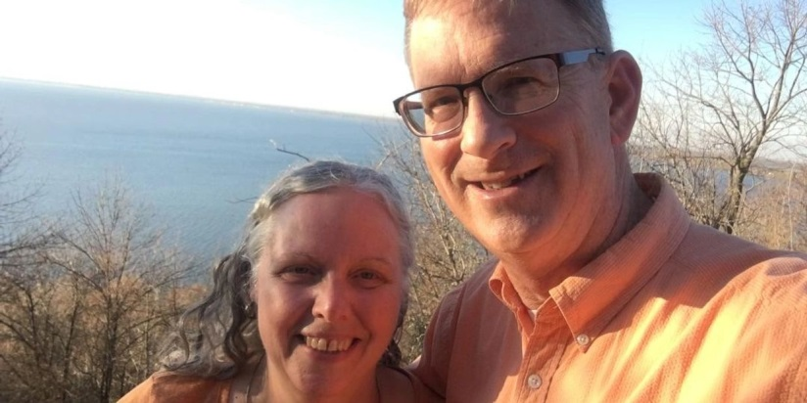

Executive Director

Nevin and Elissa Webster
We were both blessed with a godly heritage and came to know Jesus as our Savior and Lord in our youth. Elissa spent her early years living in eastern Nebraska, where her parents served as missionaries, and later in western Michigan. Nevin grew up in upstate New York, New Jersey, and Denver, where his father served as pastor.
We were brought together while at Hope College during a spring choir tour. We have enjoyed being married 40+ years, and have been blessed with four sons and four daughters. We are so grateful for them, the spouses of the four that are married and the children with which the Lord has blessed them.
We came to Wisconsin 40 years ago with Elissa’s youth and education work at First Reformed Church in Waupun. Shortly thereafter, Nevin began work as librarian at Waupun Correctional Institution where he continues to serve. Elissa was promoted to full time motherhood in 1985. Since 2012 we have been a part of Grace and Truth Christian Fellowship (GTCF), which meets in Fond du Lac, where Nevin serves as a preaching elder.
Our first contact with MASA came with a phone call Nevin received in the early 2000’s asking if our Waupun church would be interested in having an aviation missionary speak, to which the church agreed. Thus began our annual Sunday morning MASA speaking visits during AirVenture.
Over the next few years, we attended a MASA AirVenture follow up meeting, a planning meeting, a Sunday evening missionary potluck, hosted a MASA midweek speaker session in our home, enjoyed attending midweek speaker potlucks at our friends’ home, and contributed food for a meal at the MASA tent.
In 2009 we got to see the tent in action when we helped GTCF serve a meal during mission aviation’s Fly4Life feature year at AirVenture. Since then, we have enjoyed serving at the tent each year, with some of our sons and daughters helping throughout the entire week.
It has been our joy to work with and get to know many of the devoted MASA volunteer servants. In March 2020, it was Nevin’s privilege to begin serving on the MASA board. We look forward to continuing to serve the Lord Jesus Christ alongside His faithful team known as MASA as together we support His mission aviation community!

