**Peter and Linda Stuart**

**Pilot mechanic**

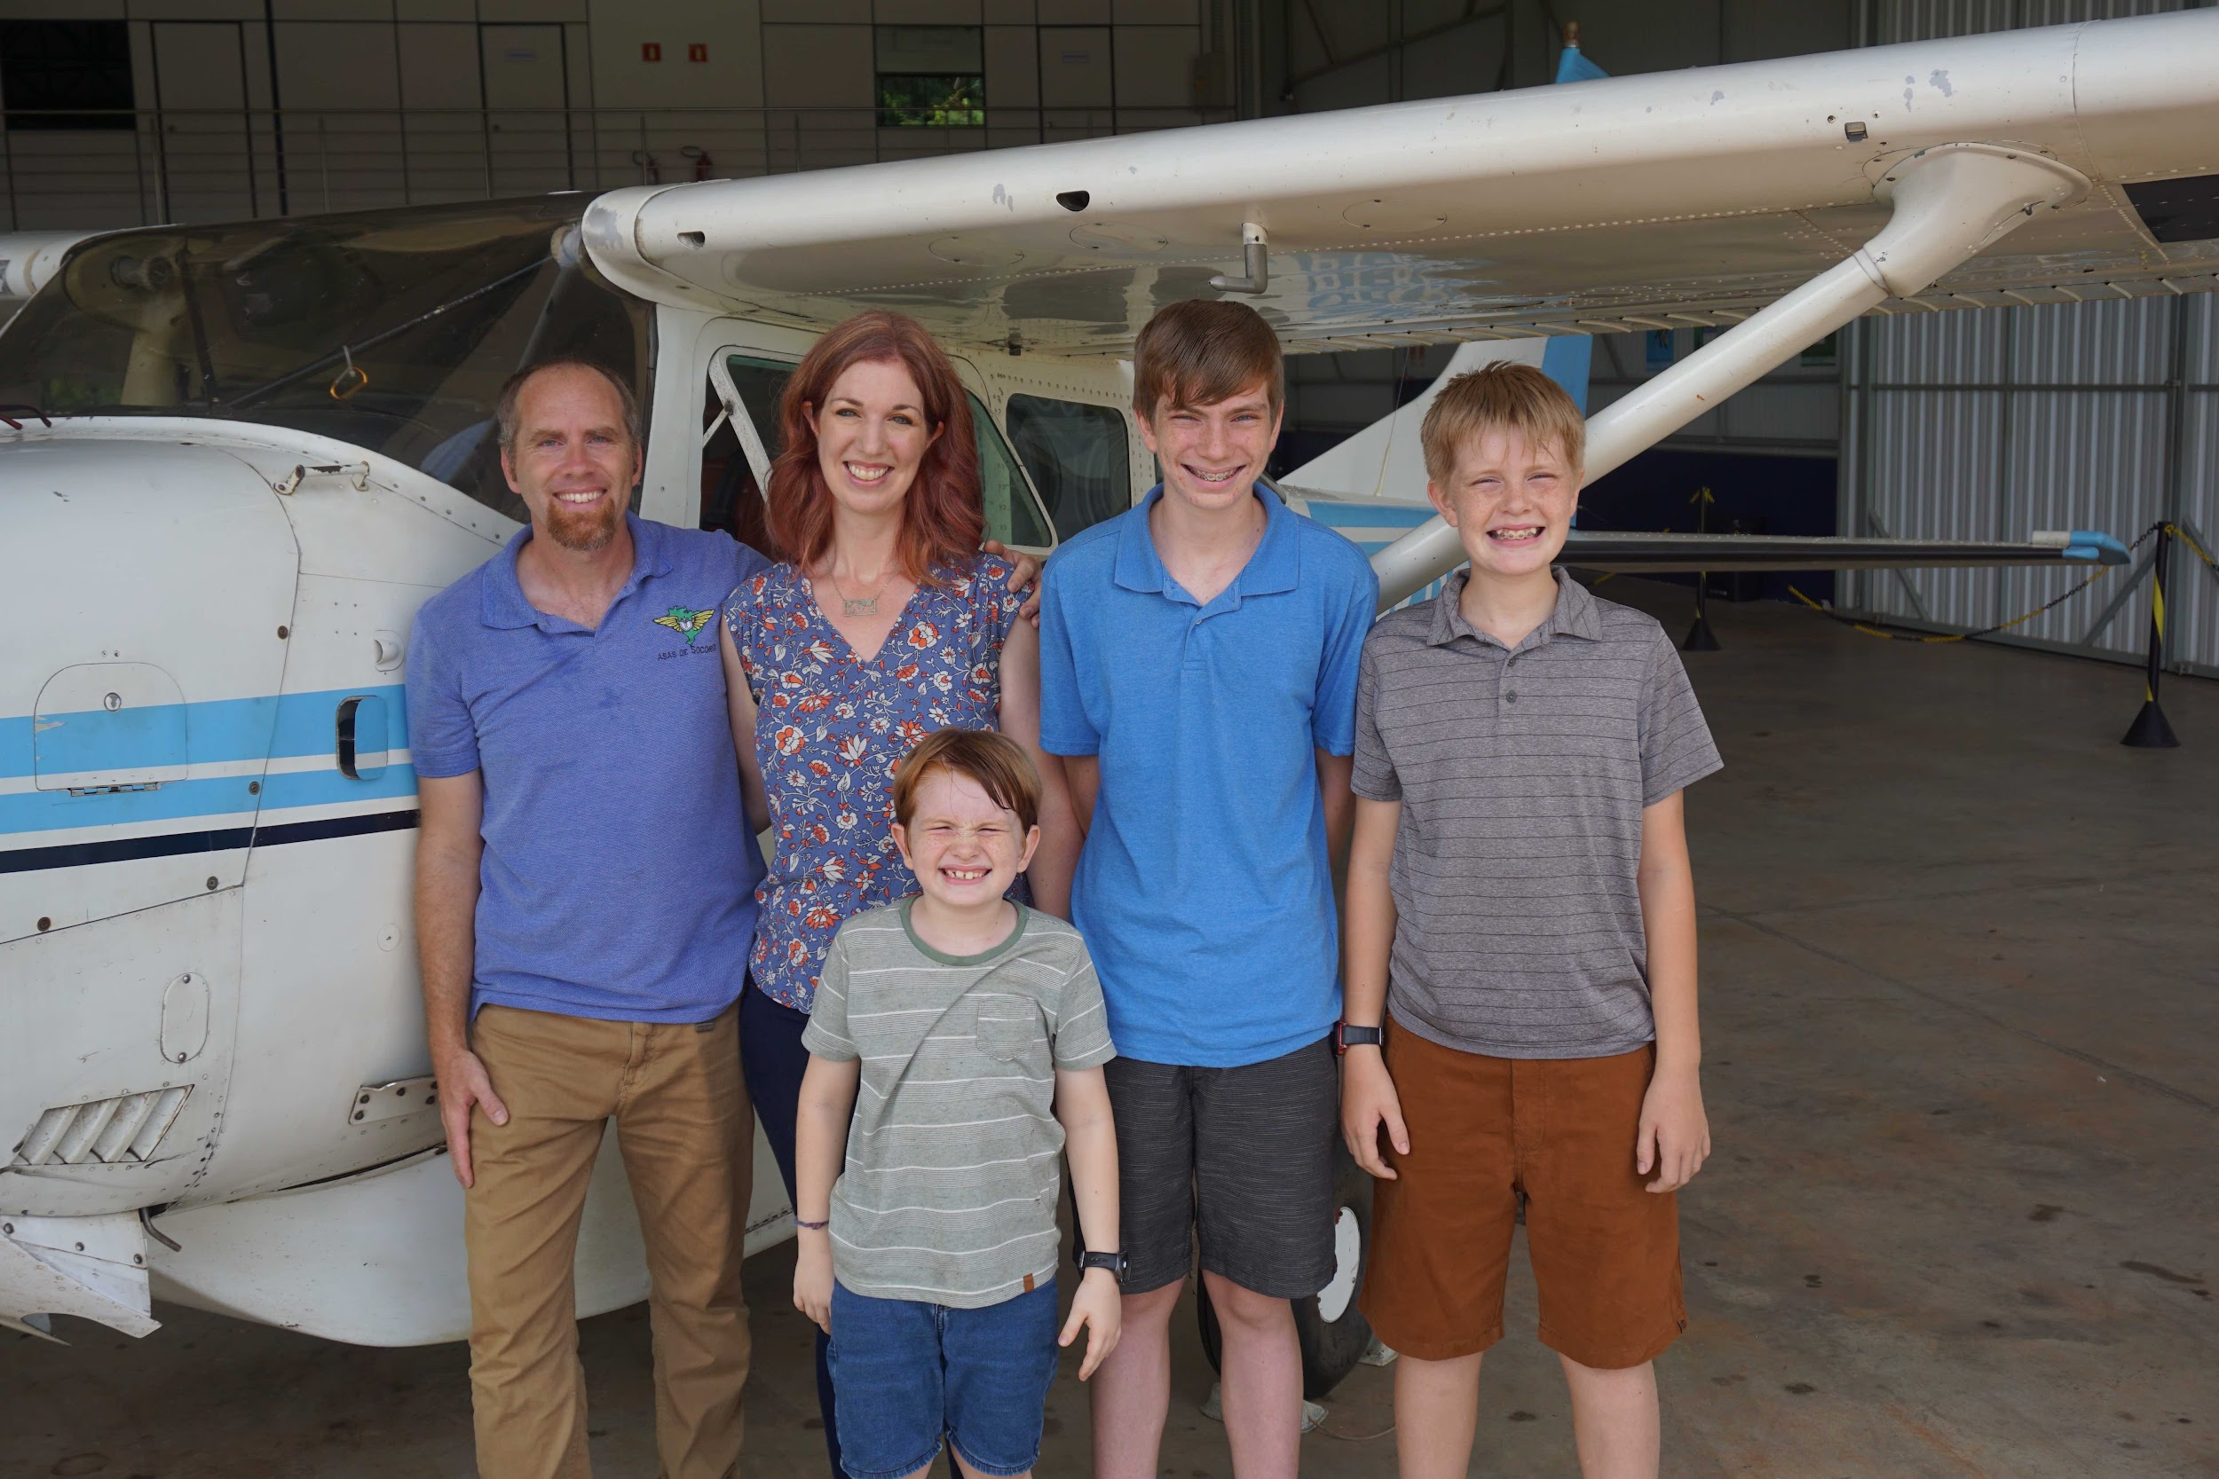

Peter Stuart is a pilot mechanic currently serving with JAARS in Porto Velho, Brazil. He and his wife, Linda, met at Moody Bible Institute and have three sons: Isaac (14), Joel (12) and Kean (8). Peter grew up in Nova Scotia and Linda grew up in Appleton, WI. They have been in Brazil for 8 years.