

ROB AND BINTOU PETERSON

Biographical Sketch
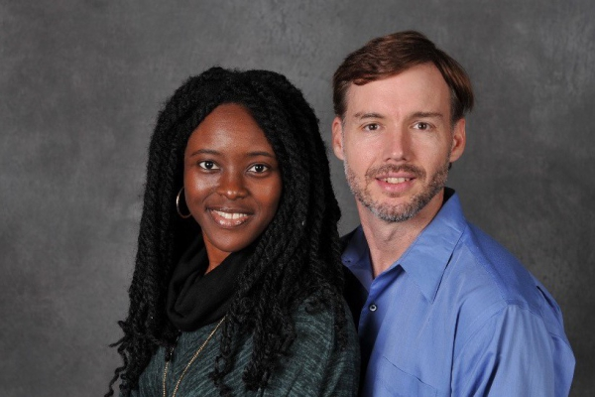
Rob’s introduction to missions and aviation was when he was three days old. His dad flew him in a JAARS airplane from the clinic in Malaybalay to his new home in Nasuli, Philippines.

The burden for all people groups to have God’s Word in their own language was birthed during his years surrounded by Bible translation in the Philippines. God confirmed his call to missions in 1994 at Bryan College. After completing his aviation training, he joined JAARS in 2004 and started flying in support of Bible translation and other ministries in Cameroon in 2007.

Bintou was born and grew up in Cameroon. Her dad was a lay pastor, church planter and evangelist. She graduated from medical school as a doctor in Yaoundé. Rob and Bintou met on a flight while she was traveling to serve at a mission hospital in Cameroon and got married in 2012.

In 2013, Rob and Bintou moved to Bongolo hospital, a mission hospital in the forests of southern Gabon. Rob ran the aviation program and Bintou worked as a doctor. Together they partnered with the local church to encourage Bible translations among the roughly 50 people groups in Gabon. Currently only a few of languages have a portion of Scripture in their own language.

Rob and Bintou have been in the US for the last 5 years due to the premature birth of their son. During this time of serving at JAARS, Rob was able to add his helicopter pilot license and flight instuctor rating.

Rob and Bintou are preparing to return to Gabon. They are excited to again be able to serve at the hospital and alongside the local Bible translation teams.

http://www.thebalafoncall.org

