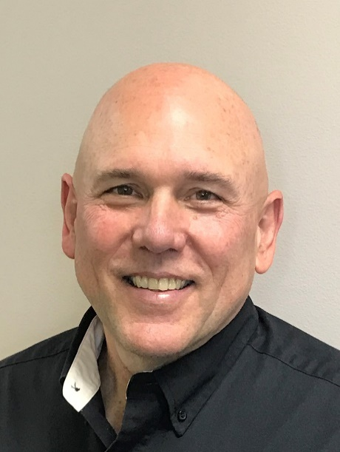

Lyle Reffley
Mission Safety International

Lyle accepted Christ as his Savior when he was a child. When Lyle was a freshman in college, he read the BEYOND magazine from JAARS during Christmas break. The magazine told of missionary pilots serving in South America. That night God spoke to Lyle and called him to be a missionary pilot.

Lyle trained at Moody Aviation in Elizabethton, TN to become a pilot and mechanic. After Moody, God confirmed to both Lyle and his wife, Becky, that they should serve with JAARS, supporting the work of Bible translation. First, God took them to Liberia, Africa. Due to a civil war they were evacuated back to the USA twice. Both times they lost everything, except what could be stuffed into four suitcases. Next God led them to Papua New Guinea. They served there for 20 years.

After their youngest graduated from high school, God brought them back to JAARS in Waxhaw, NC where they help prepare missionary pilots and mechanics to serve overseas. Four years ago God led Lyle to join the Mission Safety International team that works with mission aviation organizations to make safety a way of life.

Lyle and Becky have been married for 39 years, and have three grown children, Michael, Daniel and Laura.

