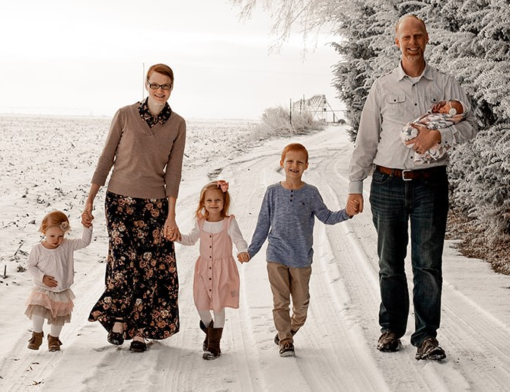

Elijah Renicker
MAF

Elijah and Melanie Renicker have been serving with Mission Aviation Fellowship since 2017 when they moved to Southeast Asia. Prior to serving in the creative context country where they are currently stationed, Elijah and Melanie served in both China and Haiti.

Elijah grew up in Alaska where aviation became a passion. Growing up in a missions-oriented family, Elijah has known, all his life, that God was directing him to serve overseas. Finding a way to combine aviation and missions is certainly a dream come true.

Melanie grew up in the heart of Washington State’s farm country. At 9 years old, Melanie clearly remembers the first time she read an article in the National Geographic about starving orphans in Africa, and immediately knew that God was calling her to be a missionary.

Elijah and Melanie met while serving in Haiti. They were married nearly two years later after Melanie returned to the States upon completing a term as a mission school teacher. Together they taught in a private Christian school in Washington state for a while after being married and then moved to China.

Now 10 years later, they have served in three countries, and most recently based back in the United States, and have 4 children Samuel (6), Mercy (4), Selah (2) and Adaiah (6mo).

