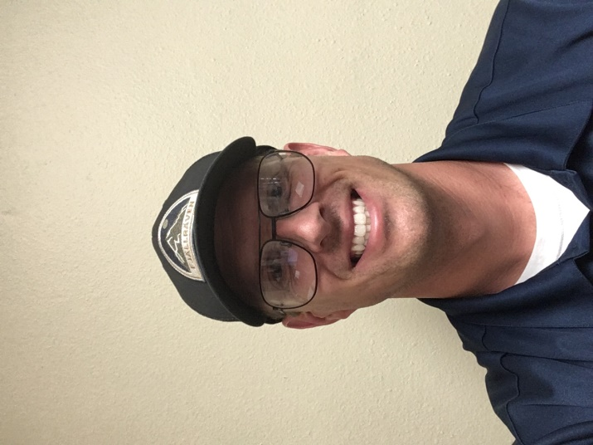
Sean Royer
California Baptist University
Sean grew up in Riverside, CA and has loved flying from a young age. He received his first flight while volunteering for the Young Eagles program at the local airport and decided from then on that aviation was going to be his career.
He spent the last 12 years flying for the U.S. Air Force is now serving at California Baptist University on an internship where he is able to not only instruct students but share his aviation experiences with the next generation of pilots.
Sean has been married to his beautiful wife Kristen for 9 years and they have 4 wonderful children: Irelynn (6), Lenynn (4), Stone (2), and Silas (1).

