**Steve Bevelhymer**

**Chief Pilot, Technical Evaluation Coordinator**

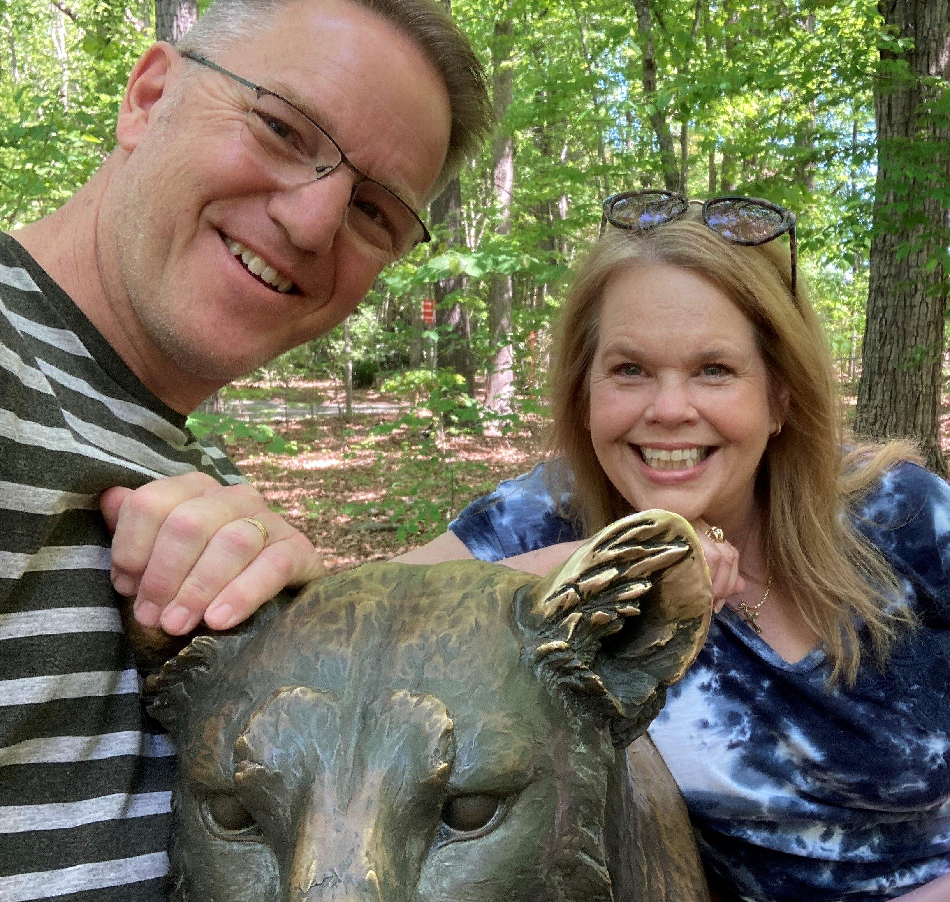

Steve has always felt a calling to missions and an interest in aviation. A contact with a friend of his dad who flew airplanes in Central America showed him that aviation and missions can go hand in hand. While attending San Jose State University, he developed his flight experience as well as earning his mechanic's licenses and experience.   
Steve and Kelli met during his senior year in college and it was their mutual desire to serve the Lord in overseas missions that drew them together. They were married in 1990 and recognizing the impact of the Bible and the truth of God's word in their lives, joined JAARS as a pilot/mechanic in 1991.  
As a family, the Bevelhymers have served in Southeast Asia, Kenya, Cameroon and the Philippines. Steve has flown throughout Central Africa as well as the Philippines. In both those programs he also served as the Chief of Maintenance.  
Steve and Kelli have two boys (Eric - 24 and Zachary - 20). Both boys were adopted in North Carolina while Steve and Kelli were on home assignments.  
Since returning from the Philippines, Steve has been an Instructor Pilot at JAARS in addition to coordinating the screening of new pilots and mechanics. Last year he took on the additional role of Chief Pilot.  
In their free time, Steve and Kelli enjoy discovering new hiking trails and spending time at the ocean.