**Sydney Johnsen**

**FlightSpan Subscriber Support Specialist**

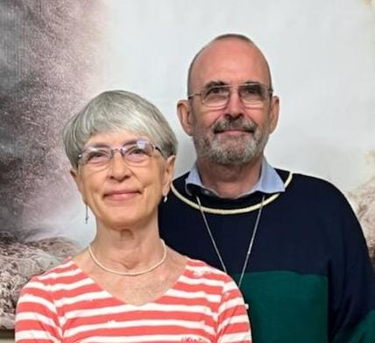

At the age of 16, while attending my church’s missions conference in Atlanta Georgia I committed my life to full time Christian work. I attended Moody Bible Institute in Chicago in Fall 1974 and graduated from Moody Aviation in 1979. Nola in junior high committed her life to Christ at a Church camp in Nebraska, we met at Moody and were married in 1977. We joined Wycliffe in 1980 and we went to Sudan in 1982 as a mechanic and pilot, until the civil war forced us to leave in 1988. In 1990 we went to Indonesia and served in Indonesia until 2021 serving in many roles from bookkeeping, hospitality, pilot and part time administrator. We have 2 children living in Durham,,NC and 10 grandchildren ages 5 to 14. We are retired but continue to volunteer at JAARS with the Flight Span team. We enjoy working behind the scenes, gardening, hospitality and serving others.