**Tim Ruth**

**Initial Training Coordinator**

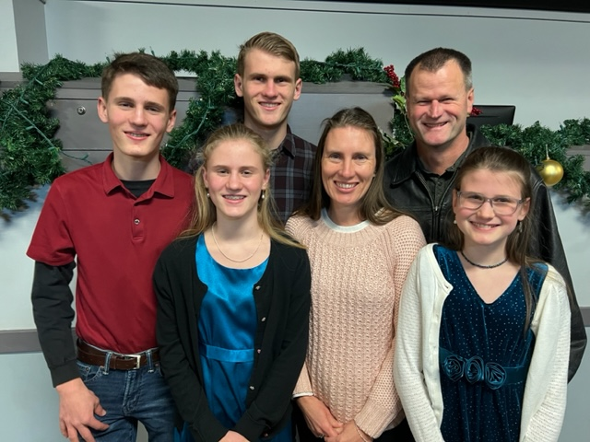

Tim grew up as a Wycliffe MK in Papua New Guinea, and is married to Lori who grew up as a CAM, Intl. MK in Honduras. They have four children, two boys and two girls.  
  
Tim completed his aviation degree at LeTourneau University and joined the Air Force. Tim and Lori met while Tim was serving in the Air Force as a C-130 Instructor Navigator in San Antonio TX.   
  
God brought them back into missions in 2005 and they served in Indonesia at YAJASI with their 4 children until 2020 when God brought them back to serve at JAARS.  
  
Tim is an Instructor Pilot and the Initial Training Coordinator at JAARS, working to prepare new personnel for aviation service overseas. Lori works with wives and families to prepare them for the transition to cross cultural service so they can be ready for some of the challenges they will face.