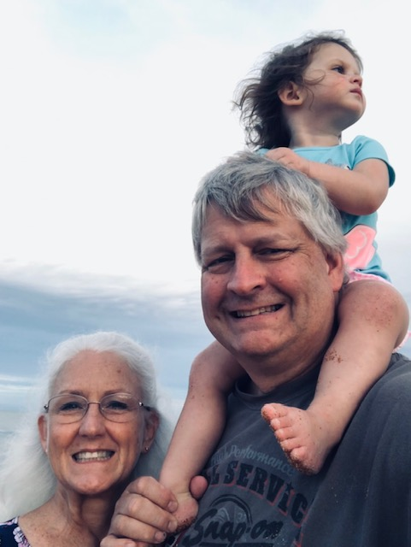

Tim & Carol Files
Fellowship of Christian Airline Personnel (FCAP)

Tim is an Air Force veteran and 31-year employee at Delta TechOps in Atlanta where he works as an Aircraft Systems Analyst. He is the current President of FCAP Ministries at Delta, and serves on the FCAP International Board of Directors.

Their mission is to share the gospel of Jesus and teach others about God’s divine call to the workplace, and the necessity of living as a Christian while there.

The Files have three grown children and 4 grandchildren. They have fostered nearly 40 kids and have recently adopted Meredith. They make their home in Bremen, Georgia where they attend First Baptist Church.

