Ron and Roz Wismer
Mission Aviation Fellowship

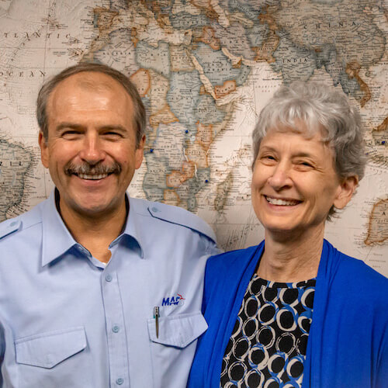

Proverbs 16:3, “Commit to the Lord…” is a life verse for Ron and Roz Wismer, currently serving in eastern Congo. Ron is the Program Manager for the team in EDRC.
While living in Africa (Zaire/DRC, Central African Republic, Mali), Ron served as a pilot/mechanic and program manager, and Roz had the responsibilities of wife and mother. Whether the task was to inspect and fuel the airplane, instruct a first-time passenger on seatbelt usage, load and unload medicines, care for a child, feed unexpected visitors, shop for co-workers, give a shot or clean a wound, or teach Sunday school, both Ron and Roz are motivated to follow and honor God so that all people might have access to the gospel and resources that advance God’s Kingdom.
Ron was raised in a Christian home in Michigan, accepting the Lord at age 10. After two years at Wheaton College, he went on to Moody Aviation and graduated with a BS in Mission Aviation Technology. Ron is a commercial pilot with instrument and multi-engine ratings, plus an aircraft mechanics license (A&P). Ron also received his airplane transport pilot’s (ATP) license. Though he does not fly regularly, he has been known to fill in as a substitute pilot as needs arise.
Roz grew up in Chesterfield, Indiana, and accepted Jesus Christ as her Savior as a child. She attended Taylor University for two years and graduated from Ball State University with a BS in Nursing. She also completed a Master’s Degree from the Alliance Theological Seminary. She and Ron were married in 1984. Verses from the New Testament writings of Paul (Colossians 1:10 & 3:17; Philippians 4:8) and Peter (I Peter 3:15) are challenges as well as guidelines for Roz for everyday living, whether in Africa or America.
Their three sons, Daniel, James, and Mark are following the Lord’s direction in their lives.
God calls the men and women of MAF to serve Him in unique ways. He may also be calling you to a special role in the Wismers’ ministry. Please prayerfully consider becoming a ministry partner with them through prayer and/or financial support.

