**Raegan Madoerin**

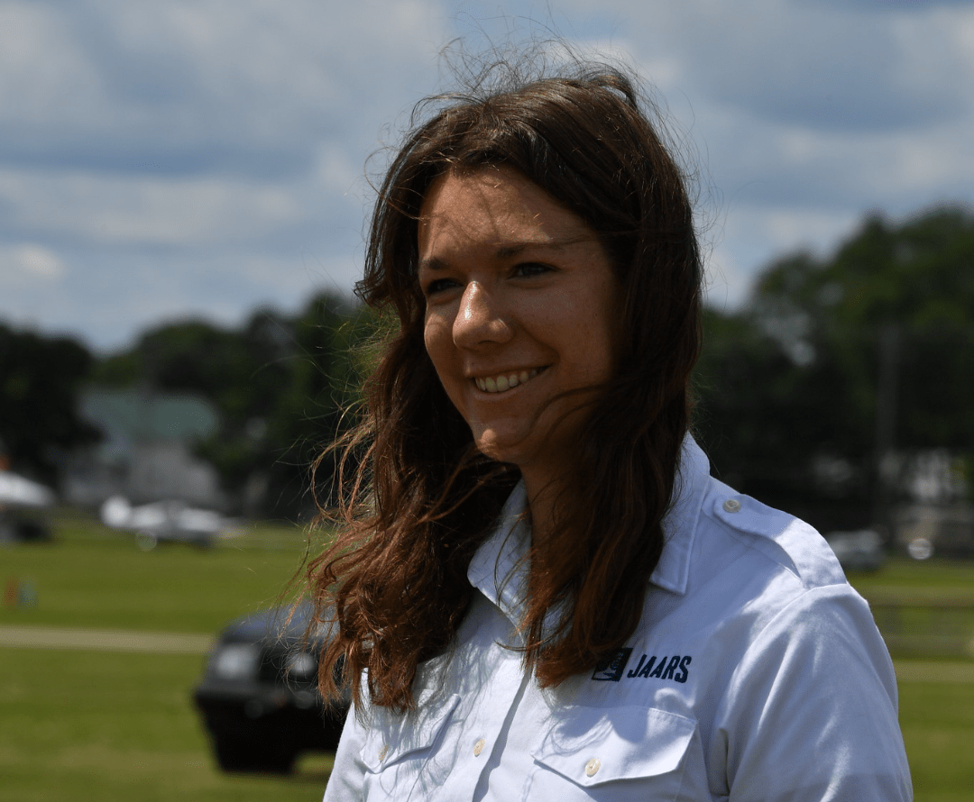

Raegan is currently training with JAARS (Jungle Aviation and Relay Service) at their base in Waxhaw, North Carolina, as a Pilot Apprentice. She fell in love with missions and aviation separately at a young age, and God nudged her to combine the two so that she could glorify Him while flying. In high school, she attended a summer camp at JAARS where she met and flew with missionary pilots. The missionaries spoke about the importance of providing transportation to remote people groups so that those people can learn about God’s love. God’s call on her life became clear: serving in mission aviation. She graduated from Louisiana Tech and worked as a flight instructor there for a year. She felt God pulling her back to JAARS, so she got a job working in the aviation training department, helping with the development of their online learning program. God provided a way for her to get more experience training for remote missionary flying in the Apprenticeship program. She is currently a year into her training and is looking forward to deploying overseas in 2026. In her spare time, Raegan enjoys mountain biking, reading, and watching movies with friends.