**Andrew and Elizabeth Roberts**

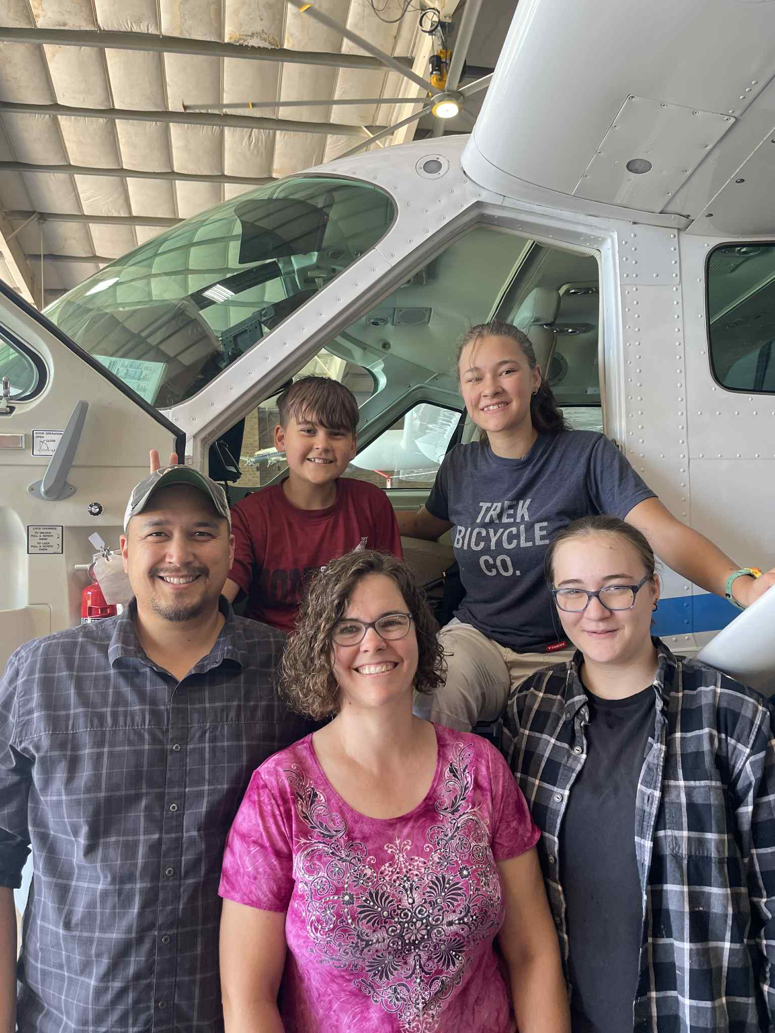

We served in Papua New Guinea and now at Jaars as the doam, we both attended moody Bible and my bike for fun