**Julia Cagasan**

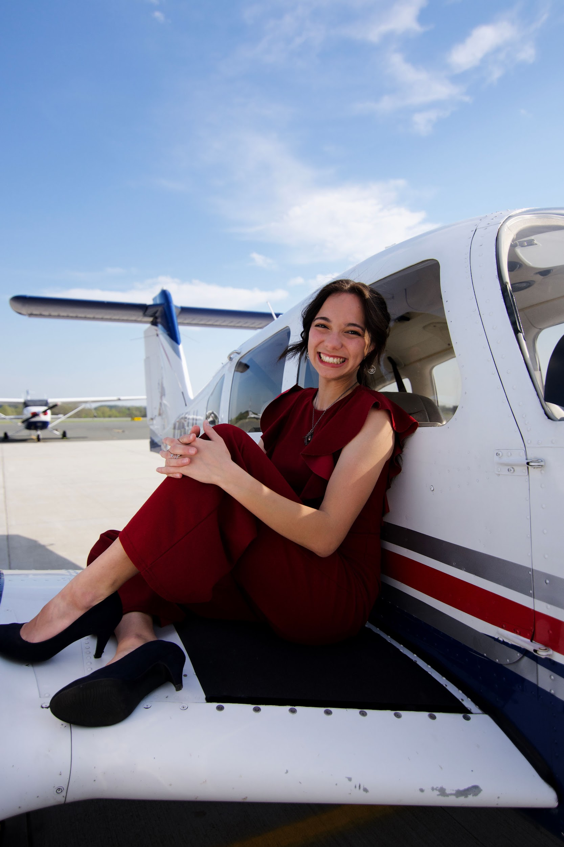

At the age of 5, Julia felt the Lord’s calling on her life to serve in missions but didn’t realize she could combine her heart for Bible translation and aviation until she discovered JAARS in 2019.   
  
Since 2020, she has volunteered or interned with JAARS in the Communications, Experience, and Aviation departments. A recent graduate of Liberty University, Julia is continuing to pursue training and experience with the goal of being a JAARS pilot mechanic. She has a heart for the people of Brazil and was deeply blessed by her vision trip there.  
  
In addition to her new role as aviation safety manager at Letourneau University, she is working with the International Association of Mission Aviation on the Next Generation of Mission Aviation Initiative. She is passionate about equipping others to fulfill their God-given purpose and potential, especially with planes and helicopters.  
  
When she’s not traveling around the country, Julia enjoys creative pursuits and outdoor adventures. She loves reading and writing true stories that tell of God’s faithfulness, playing a variety of musical instruments with her four siblings, and drawing and painting. Paddleboarding and waterfall hikes are her favorite ways to appreciate God’s creation!