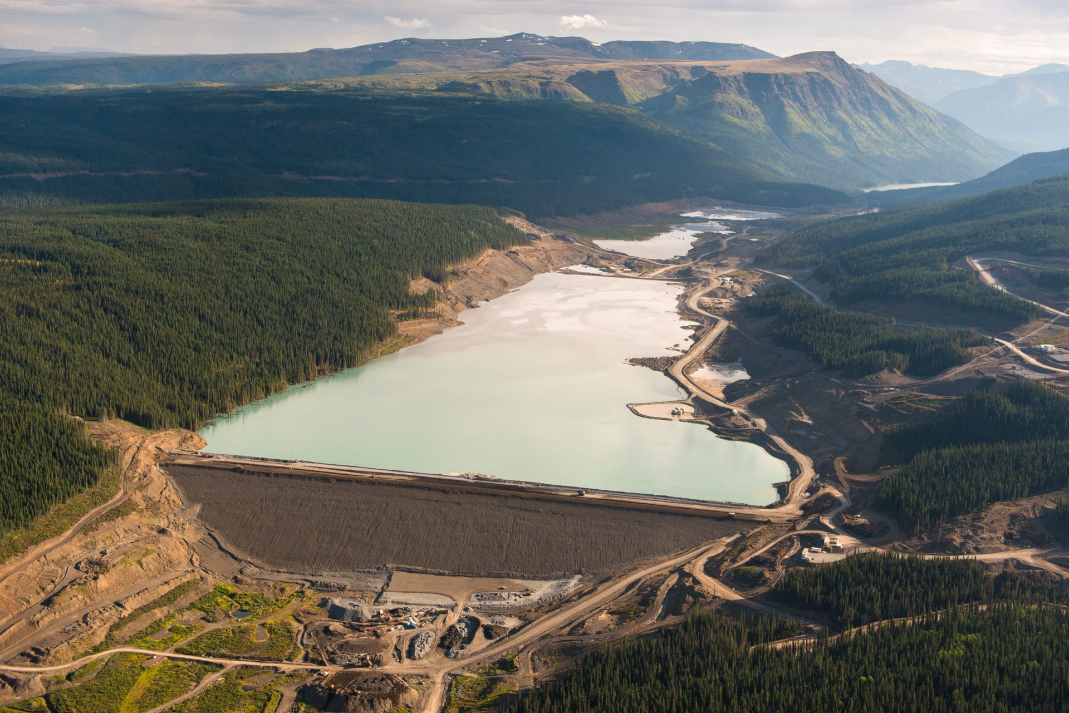 Earth Dams build up with sediment, pollutants from air and up-stream, and mining operations like this one. ROC is uniquely able to mitigate this type of dam.