Money Strong Net Paycheck Calculator Worksheet
Objective: Gain a better understanding of your net monthly income after factoring taxes and health insurance.
The numbers don’t have to be perfect, but this exercise is important in knowing your actual income…This will be the main amount that you will build your budget upon in the next step of the Money Strong Program.
Let’s Get Started: Go to the following page to start the Take-Home-Pay Calculator:
https://www.calculator.net/take-home-pay-calculator.html
Step 1: Determine your Estimated (Or Known) Income (Per Year)
If you are paid by the hour, please use this calculator to determine your annual salary (Please use the “Holidays and Vacation Days Adjusted” Amount):
https://www.calculator.net/salary-calculator.html
Step 2: Change the Pay Frequency to Monthly
Step 3: Your filing status will remain single unless you are recently married. I still recommend keeping filing status as single when you get married, as more taxes will be withheld and you will owe less/receive a higher refund during tax time.
Steps 4 & 5: Enter the number of children you have and if you have any other dependents. For most students, these will both be 0.
Step 6: If you have any other income from other investments or jobs, please enter the net amount(s) here. Otherwise, leave this at “0”.
Step 7: Add your annual 401k deduction and your health insurance here.
For students with loans, we suggest making deductions up to the employer match (anywhere from 0-6%).
For students without loans, we suggest making deductions between 10-15 % of your salary.
Plus, you will want to add your yearly medical (and dental) insurances here.
See the Butler Benefits Guide for an example of the various options:
Individual Medical Insurance ranges from $600-$2000 year
Individual Dental Insurance is approximately $100 per year.
https://www.butler.edu/wp-content/uploads/2023/10/2024-Butler-Benefit-Guide_OpenEnrollment-Final.pdf
Step 8: Deductions not Withheld and Other Itemized Deductions can be added.
Step 9: Find your state tax rate for where you plan to work. For Indiana and Illinois, there is a flat tax rate on all income, 3.05% and 4.95% respectively. Other States, including Tennessee and Florida, do not have State taxes.
Step 10: (Optional): Add the city income tax (if there is one). For example, Marion County (Indianapolis) has a 2.02% income tax, but the surrounding counties do not.
Click Calculate for your final net paycheck amount!
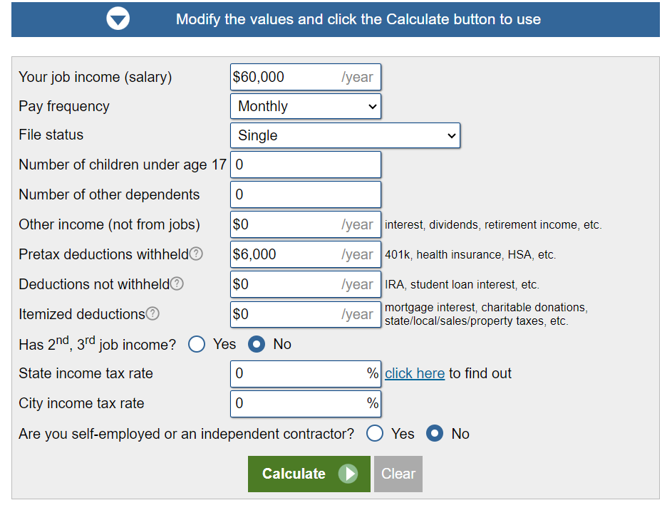
Final Step: How much do you take home per hour of work?
It’s easy: Take your net monthly paycheck amount and divide it by the estimated number of hours you will work per month (let’s say 40 hours * 4 weeks of work = 160 hours). If your net paycheck is $3600 per month, you take $3600/160 = $22.50 per hour net!

Your Deliverables:
Estimated Annual Income: ___________________________________
Your 401(k) Contribution: ___________________________________
Your Net Monthly Income: ___________________________________
Your Net Hourly Income: ____________________________________

