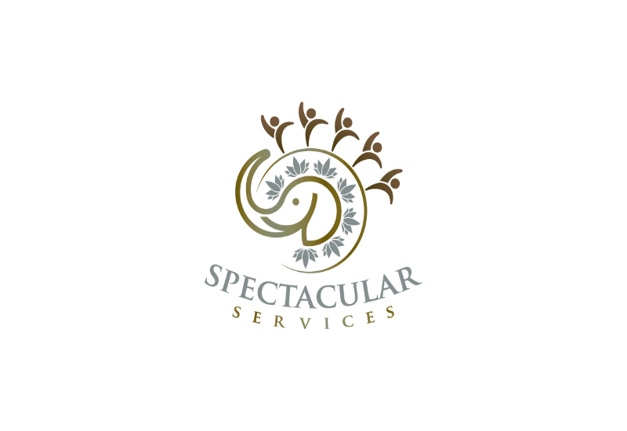 Website and Social Media Consent Form

Participants

I, _____________________________, am the parent/guardian of _____________________________, who participates in programs, and/ or activities with Spectacular Services.

I hereby give Spectacular Services, and their employees, representatives, and authorized media organizations permission to take and use photos, videos, audio, and other visual documents of the minor listed above for the purpose of posting on their website, documentation, social media, such publications may include but not limited to, newsletters, brochures, flyers, and other marketing materials. I further agree that the minors’ name and identity may be revealed. I give this authorization without expectations of monetary compensation for the usage of the photos, videos, or audio.

Throughout the program participants may be highlighted in efforts to promote Spectacular Services activities, and achievements. Participants will also have photos of themselves taken while on field trips and participating in the community.

Please indicate below whether you consent for these media images to be gathered and published, and your permission will remain in effect while the minor is enrolled in our program. If you wish to change or revoke your consent for the release of the minors’ photos, videos, and audio, while they remain in the program, you will be required to complete and submit an updated website, and social media consent.

*I acknowledge that I have legal authority to sign this form on behalf of the minor named above.*

I do ***not*** give my consent to include the minor in an photo, videos and audio

My consent is freely given to include the minor in photos, videos, and audio

* What is your preference regarding the use of your name?

I consent that you may identify the child by his/her first name only.

I consent that you may identify the child by initials only.

 Please do not identify this child by name or initials.

I consent to the use of my photographs anonymously.

* Please check the boxes regarding your preference.

I authorize Spectacular Services to take photographs of the minor child listed above.

I authorize Spectacular Services to use the minor listed above photos on Facebook, Twitter, Instagram, and other social media platforms.

I authorize Spectacular Services to edit, alter, copy, or distribute the photos for social media advertising and marketing.

I agree that the photos taken belong to Spectacular Services.

I agree that I will not receive any monetary compensation for usage of the photos for the minor listed above in photographs in social media platforms.

Name ____________________ Date ________________

Relationship to Minor_________ Signature _____________

*******************************************************************************************Spectacular Services Staff

Reviewed By___________________________

Date_______________________________­­­­­­­­___

Created on 1/1/2023