Keep your computer clean.
The listed procedure is simple, reliable and effective. It is not a panacea for all the problems that may hit your computer. It is also not the only approach, but these steps have worked many, many times in the past for myself as well as for other less experienced users who have managed to successfully perform them. The programs downloaded from the safe links here by the writer have been tested, used and found reliable by experienced members of the club. For those who are leery of downloading anything, the programs are available on a CD upon request of the member at a nominal cost of production. The links will take you to free versions of all the selected programs. You will be offered paid versions but you need not buy them, as the free versions will work just fine for your needs. The steps are outlined below with a link to AdwCleaner. That link will provide an up to date file on your computer and enable cleaning of most adware/redirect programs that may have been inadvertently gotten on your computer. Most links can be run with a CONTROL>LEFT-MOUSE-CLICK. If not, copy the link and paste it into your browser address box and run it:
These outlined steps will make your computer run lean, fast and free of most major junk programs.
- Remove any unwanted programs that start up when you boot up or stop them from automatically starting or at least stop them from startup in MSCONFIG menu.
- Remove all unused or rarely used programs with free “RevoUninstaller” at:
http://www.revouninstaller.com/revo_uninstaller_free_download.html
- Check and remove any malware using one or all of the following suggested links;
Free latest Foistware remover “AdwCleaner” from:
http://general-changelog-team.fr/fr/downloads/finish/20-outils-de-xplode/2-adwcleaner
Be sure when using AdwCleaner to press scan and following the scan, press clean. Should you see a large number of items found by the scan it might be a good idea to also consider running Microsoft program, Microsoft free Safety Scanner at safe link: this may have to be copied to your browser address box to reach the site.

http://www.microsoft.com/security/scanner/en-us/default.aspx

Here the program MSERT.EXE can be downloaded and run. Note that within ten days of the download, this program expires and to run it again it must be downloaded again.
- Install an Anti-Virus, like free “Avast” at:
http://www.avast.com/index .
There will be regular mini pop-up windows, most letting you know it has self-updated, occasionally suggesting a paid upgrade, but it is a small price to pay for an excellent service.
- Install the free “Malware Bytes” at:
https://www.malwarebytes.org/lp/lp4/02_r/?gclid=CJTx_tu53r8CFRGAaQodqhkAHA
- Clean up your browser of any remaining links to unwanted sites by going to ADVANCED<RESET as in Google
- Install and run a mild registry cleanup from the Free Auslogics Registry Cleaner at: http://www.auslogics.com/en/software/registry-cleaner/
- Do a hard drive defragmentation with Free Auslogics Defrag, unless you have a solid state drive. This program does it quickly an can be downloaded free at:
http://www.auslogics.com/en/software/disk-defrag/download/
Windows does an automatic defragmentation if your computer is idle. If your computer has a solid state hard drive it has been recommended to turn this option off. Defragging a solid state drive will somewhat shorten its life, as there are just so many writes in its life before it starts to lose storage capacity. That may be done in Windows 8.1 from
Control Panel | Administrative Tools | Defragment and Optimize Drives
There may be some remnants left of the garbage that has been removed but for most people that task is too complicated to perform, and these remnants have been made harmless by the above procedure. Do not be concerned about them. They occupy very little space in your system.
Due to the ease of being caught up in internet scams during attempts at downloading software, the following suggestions are to be considered. With the exception of AdwCleaner, download and install the above programs before any cleanup attempts are planned per this demo and install the programs before you need them. You will want to update each program to the latest configuration after installing it and there will undoubtedly be prompts to do so. It is usually safe to do so, and this definitely should be done to maximize usefulness. The above programs can also be made available as installable executable files on a club CD for a nominal fee to recover costs. An advance sign up basis is required. Sign up at any meeting and have it in your hands the following Saturday.
Note that there are more powerful registry cleaners and defragmenter programs available but the covered ones of this program have been tested for efficacy and for safety. These subject executables will not get you into trouble.

Why you need to do this. How you got this Junk. Here is a typical case reported on the net. Check it if you wish.
http://www.pcrisk.com/removal-guides/7146-remove-portaldosites-homepage-redirect-virus

Can you get undesired programs from reliable sources like Adobe? Yes if you don’t uncheck the boxes as at top center, see below.
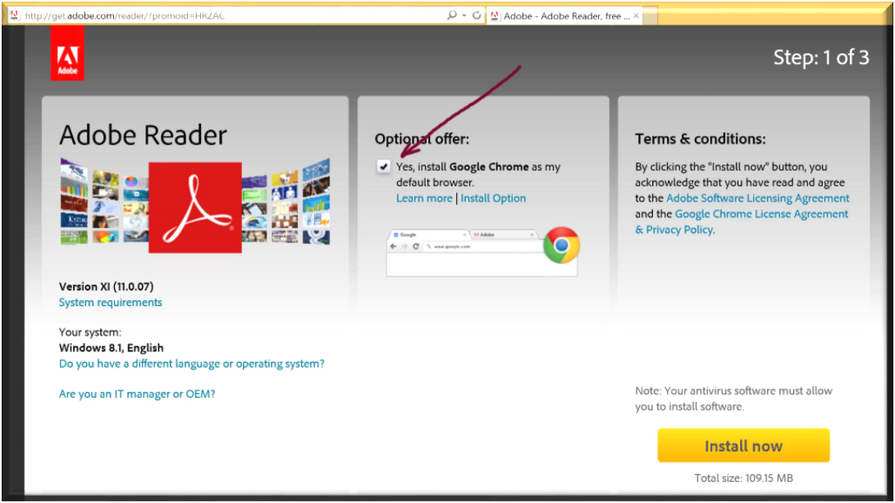
Google Chrome is not harmful, but do you want it on your machine?
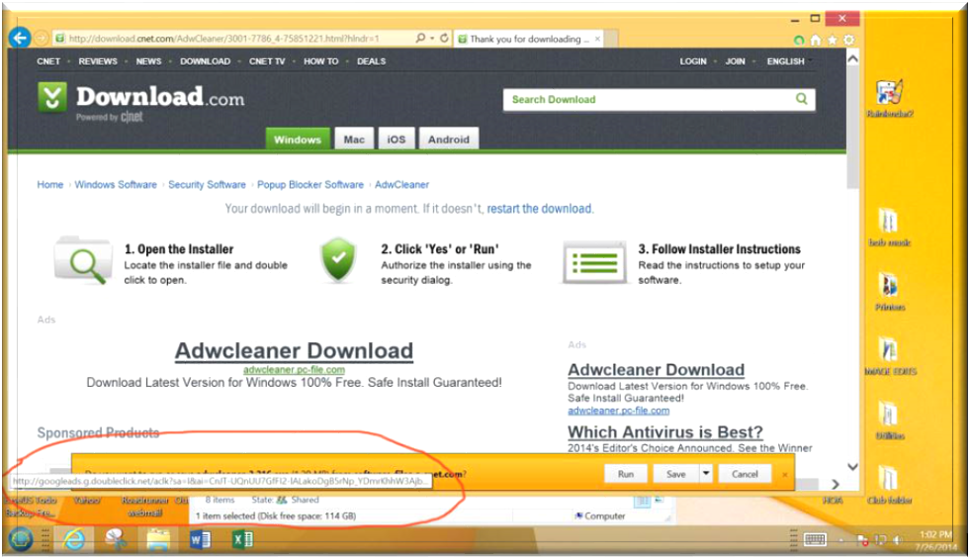
Even a supposedly reliable site could direct you to someplace else. Look at the bottom left address where Download.com takes you to DoubleClick, a media advertising service. Not dangerous but just another place to target you to ads.
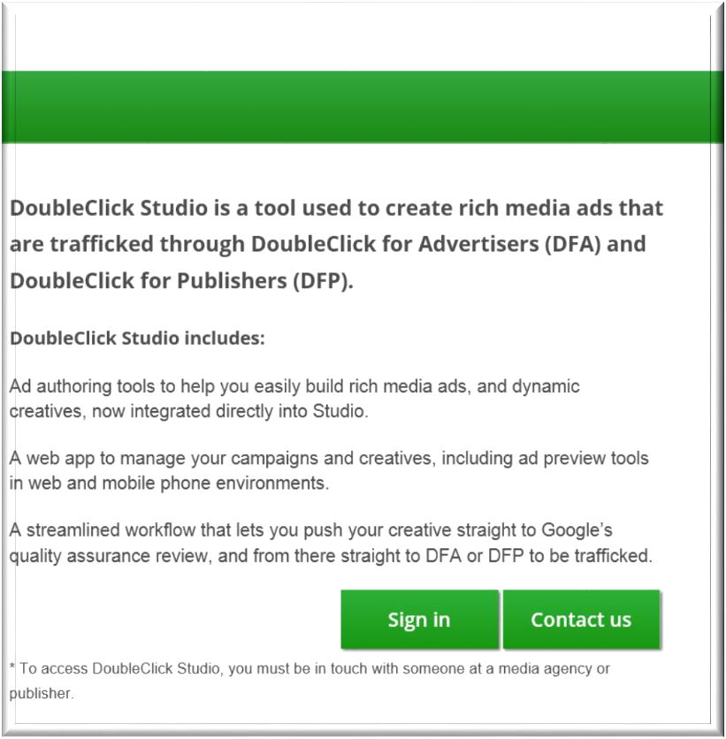

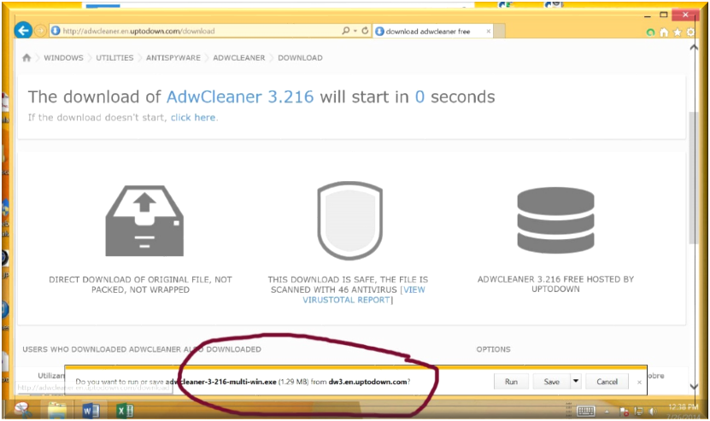
This clip on the left explains DoubleClick, which has been around since the internet used search engines. DoubleClick will take data from your search/download events and target you for related advertisements that you may not want. It will put bits of information on your computer to direct you to products you may or may not want. Otherwise harmless, it does direct commercial traffic to your browser. Your search travels will have been trafficked to advertisers. Harmful? No, but a pain to some!
So, who do you trust?
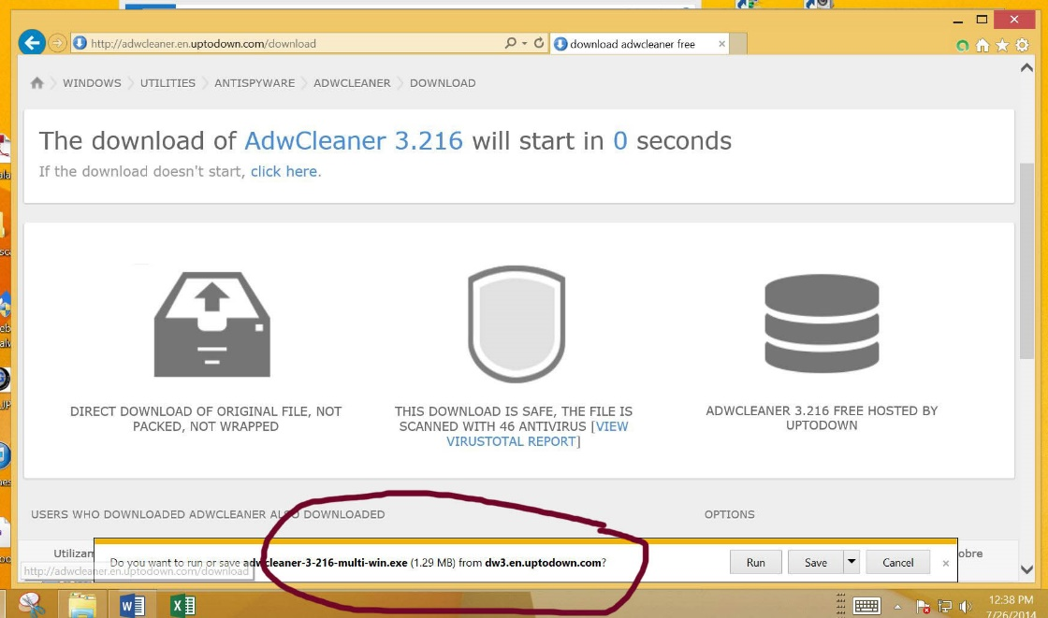
Maybe not this site on the left that has an unrecognized address for the download.
This may be a safe site but it is not the address of the AdwCleaner creator. Downloading from non genuine sites may get you more adware than adware cleaning. Download only from the creating website if at all possible. If not, at least exercise great care.
For the trouble free use of AdwCleaner, the following link is the real link for the latest version of the up to date application:
http://general-changelog-team.fr/en/tools/15-adwcleaner . There may be several web sites that are legitimate providers of it, however I recommend getting the latest version safely at your club website, sdgsd.org through this Program Notes document link. Your membership has resulted in the club website creation and we do our best to keep it up to date.
by Fred Wassermann, SCGSD

