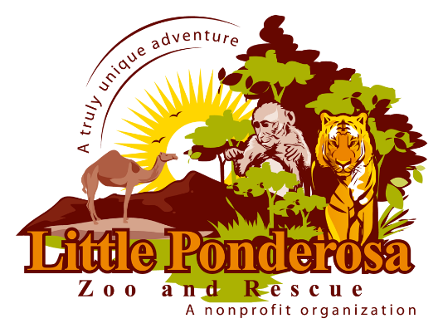
WHATS FOR LUNCH? SCAVENGER HUNT
Sharp beaks, teeth, and long tongues are tools to smell, bite, slurp, and munch. Search the zoo near and far to see what our animals love to eat. These clues will help you find each animal that you seek. Read the animals’ ID signs and write what they like to eat!

In the Southeast region of Who am I? _____
Russia and Northeast China
is where I am from. I live alone. What do I eat? _____________
Eating with my sharp teeth. I have _______________________
black stripes.

I am from Sub-Saharan Africa Who am I? _________
but can also be found in Italy.
I am the largest of my species and What do I eat? _______
protect myself with my sharp quills, _______________________
and like to live alone.

I am from Madagascar. I am most Who am I? _____
recognized by my black and white
ringed tail. I love my large family and What do I eat? ______________
sunbathing. _________________________

I live in a lot of different places Who am I? ___
United States, Canada, Europe
and Asia. There are several species
of me, and I come in a variety of What do I eat? __________
colors. I like to live with someone, ____________________
and I leap high to pounce on
my prey.

I come from Africa; I can run 40 Who am I? _____
mile per hour. I have distinct strips
which makes it harder for a predator What do I eat? ________
to pick me out when I am with my ___________________
large family.

My kind can be traced back to Who am I? _____ _____
biblical times. I come from
the Middle East. I have something
most sheep don’t have; What do I eat? ___________
I have 4 horns. _____________________

I come from Asia, and love Who am I? _____ _______
swamp areas. I have a big body,
and a short stocky muzzle. My
horns are curved; and I like to lay What do I eat? _________
in a mud hole. ____________________

I like to live in a pack. I live in Who am I? ____
North America and Western
Europe. I communicate with
scents, facial expressions, and What do I eat? _______
vocalizations. ___________________

