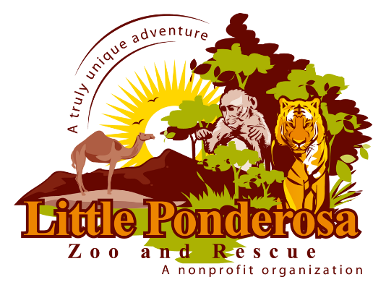
Sharp beaks, teeth, and long tongues are tools to smell, bite, slurp, and munch. Search the zoo near and far to see what our animals love to eat. These clues will help you find each animal that you seek. Read the animals’ ID signs and write what they like to eat!

In the Southeast region of Who am I? Tiger
Russia and Northeast China
is where I am from. I live alone. What do I eat? Elk, boar, bear, deer, rabbit, pika
Eating with my sharp teeth. I have fish
black stripes.

I am from Sub-Saharan Africa Who am I? Porcupine
but can also be found in Italy.
I am the largest of my species and What do I eat? Roots, bulbs, tubers, bark
protect myself with my sharp quills,
and like to live alone.

I am from Madagascar. I am most Who am I? Lemur
recognized by my black and white
ringed tail. I love my large family and What do I eat? Fruit, leaves, insects,
sunbathing. small vertebrates

I live in a lot of different places Who am I? Fox
United States, Canada, Europe
and Asia. There are several species What do I eat? Small rodents, rabbits,
of me, and I come in a variety of game birds, and reptiles
colors. I like to live with someone,
and I leap high to pounce on my prey.

I come from Africa; I can run 40 Who am I? Zebra
mile per hour. I have distinct strips
which makes it harder for a predator
to pick me out when I am with my What do I eat? Grass, shrubs, herbs,
large family. Twigs, leaves and bark

My kind can be traced back to Who am I? Jacobs Sheep
biblical times. I come from
the Middle East. I have something
most sheep don’t have; What do I eat? Grass, grains, plants
I have 4 horns.

I come from Asia, and love Who am I? Water Buffalo
swamp areas. I have a big body,
and a short stocky muzzle. My
horns are curved; and I like to lay What do I eat? Aquatic plants, grass, grains
in a mud hole.

I like to live in a pack. I live in Who am I? Wolf
North America and Western
Europe. I communicate with
scents, facial expressions, and What do I eat? Bison, moose, elk, caribou, deer
vocalizations. Rabbit, hare, beaver, mice, rodents, fish and
other animals

