Providence Preschool
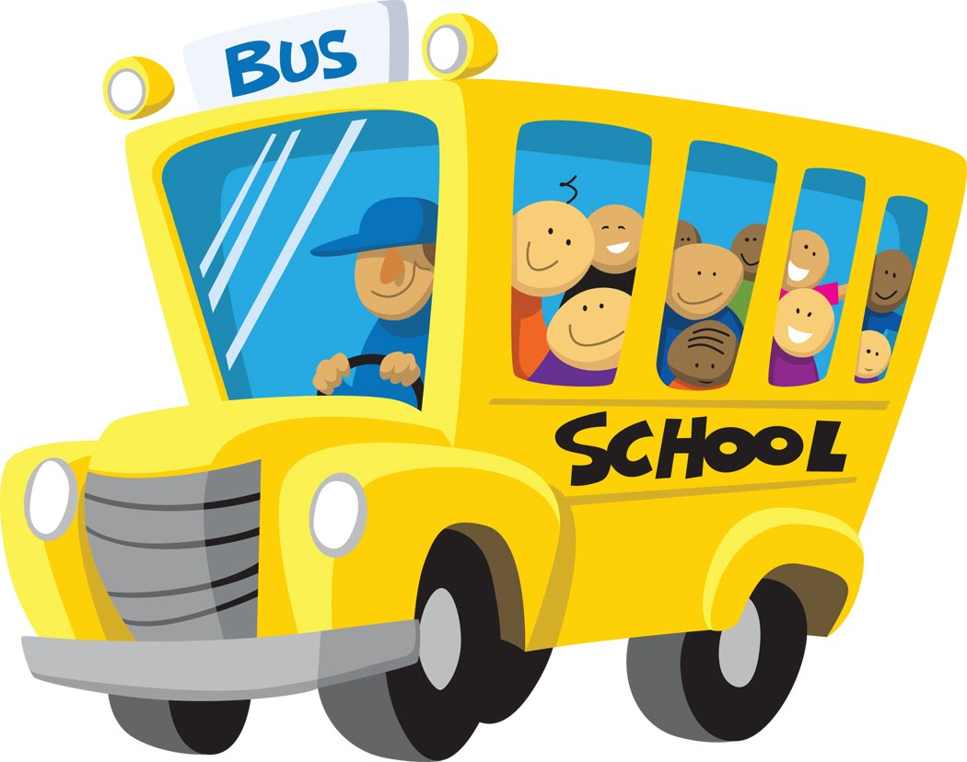
2018-2019 School Calendar

FIRST DAY OF SCHOOL September 4
Teacher Workday (No School) September 28
Teacher Workday (No School) October 29
Election Day (No School) November 6
Veteran’s Day (No School) November 12
Thanksgiving Break (No School) November 21-23
Christmas Program (Early Dismissal) December 18
Winter Break (No School) December 19-31
New Year’s Day (No School) January 1
Teacher Workday (No School) January 2
MLK Holiday (No School) January 21
Teacher Workday (No School) January 22
President’s Day (No School) February 18
Teacher Workday (No School) March 12
Teacher Workday (No School) March 29
Spring Break (No School) April 19-26
Graduation-4’s May 17
LAST DAY OF SCHOOL May 24

