Orono Lions Snowball Open

January 31st 2026 10:00 am to 2:00 pm 39th Annual



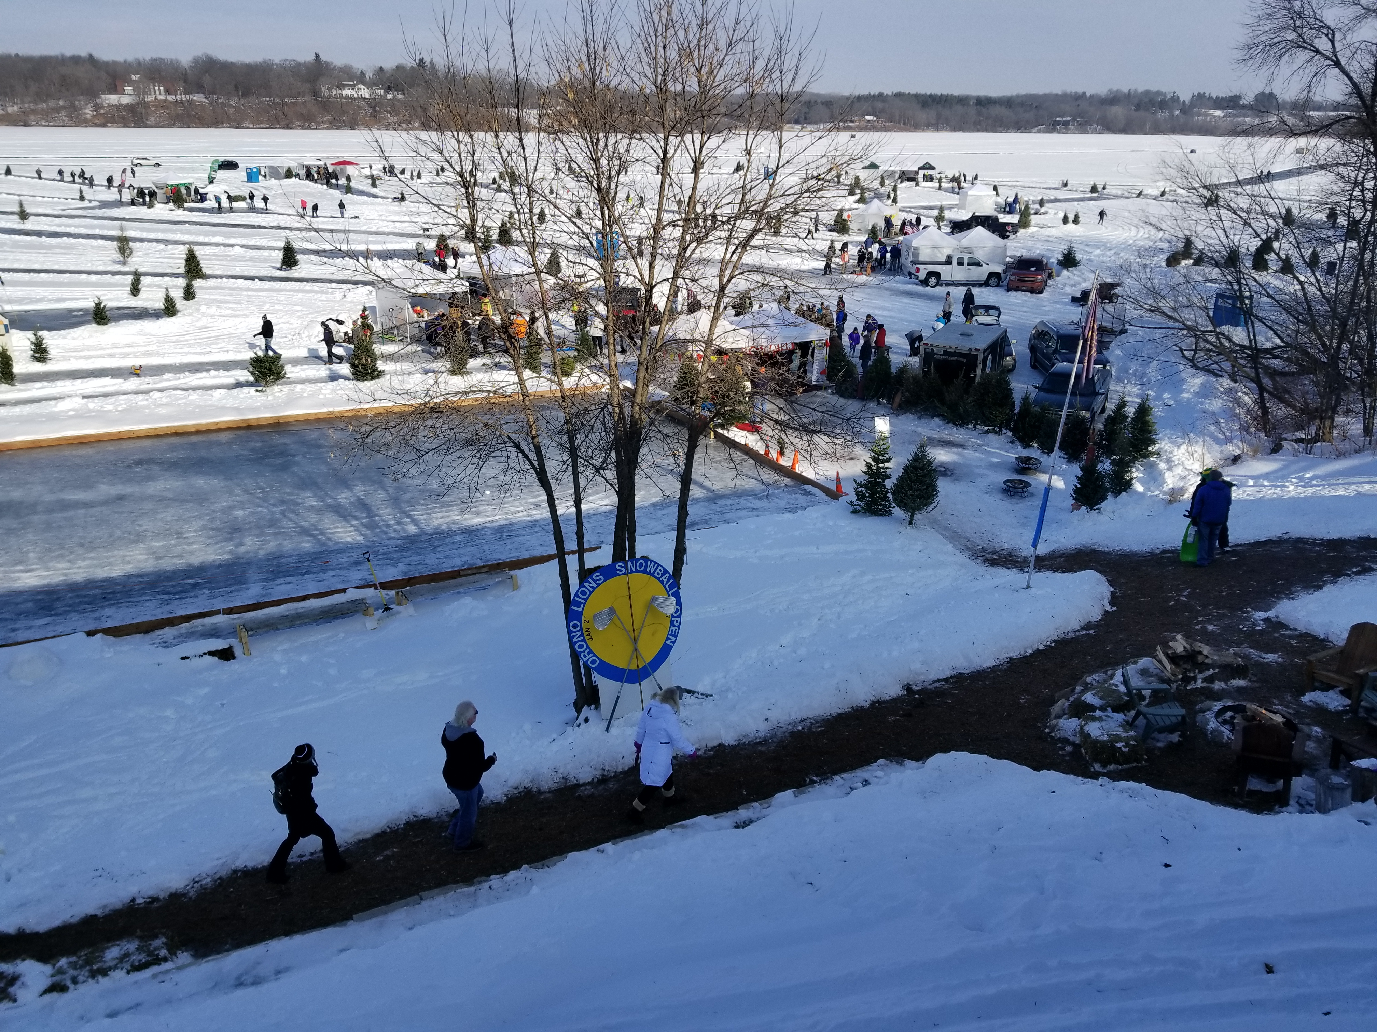

TEE BOX / REGISTRATION TENT SPONSORSHIP FORM

Company Name: _____________________________ Date: _________

Address: __________________________________________________

City: ___________________________ State: _______ Zip: _________

Contact Person: ________________________ Phone: ______________

Email Address: _____________________________________________

As you may already know, the Snowball Open is the primary fundraising event for the Orono Lions. The proceeds from this event support the various community projects sponsored by the Lions. The projects range from support for the students in our local school system, funding special requests for our partners in public safety, plus many other Community Support Projects.

Donation for Sponsoring a TEE BOX is $250.00.
This includes: 4 Sponsor Passes, 10’x10’ Tent with 3 sides, Table, 2 Chairs, fire pit & wood.
You will have a great opportunity to promote your business and meet every player who attends.

The Event starts at 10am. Last tee time is at 2pm. Please stay set up until the last group of golfers finishes.
Allow enough time to set up your decorations before 9:30 am. You can access the lake via Summit Beach.
Your assigned tent will have a tee box marker with your name on it. Firewood will be supplied all day.
Your staff will need an Official Snowball Open Button to be on the ice. If you need help, ask any Lion Member.

Check Box Sign me up for a Tee Box Sponsor: Enclosed $250.00

Donation for Sponsoring the REGISTRATION TENT is $300.00.
Bonus Value $350.00 golf tickets plus Free Advertising Dollars to promote your company name.

This includes: 10 Golf Passes for “Green Fees” to Golf the Event.
You can hand them out to Family, Friends, Co-Workers, or Clients.
Plus “YOUR COMPANY NAME” on Poster in Registration Tent

Check Box Sign me up for a Tent Sponsor: Enclosed $300.00

Contact any Lion Member for more information or contact:
Roger Adams c: 763-360-1709 Bradley Hansen c: 612-965-0153 Scott Stabeck c: 612-747-5863

Make checks payable to:
Orono Lions - PO Box 65 - Long Lake, MN 55356
Thank you again for your support.

