Fennel Pepper Dutch Oven Potatoes

 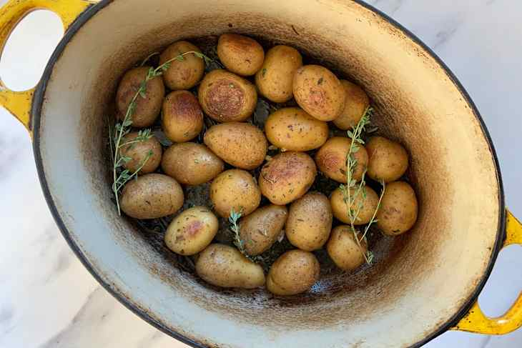

1 ½ lbs fingerling or small creamer or baby potatoes

2 Tbls butter or butter substitute (or just all olive oil.)

1 Tbls olive oil

¼ tsp Fennel Pepper

¾ tsp coarse salt

Fresh ground pepper

Herbs – a few sprigs or lightly chopped thyme or whatever herbs are available in the kitchen. The amount is flexible so use what have that is fresh if available.

Wash the potatoes. No need to peel the potatoes, but make sure to wash off any lingering dirt.

Melt the butter in a large Dutch oven and add the olive oil. The amount of butter you use doesn’t have to be very specific.

Add the potatoes, herbs, Fennel Pepper, salt and pepper to the pot. Stir the potatoes to coat evenly.

Cover the Dutch oven with a lid and shake vigorously to mix the ingredients.

Turn the heat to low and cook. Shake the pot with the lid on every 10-15 minutes during the course of cooking. Be sure to shake the pot vigorously enough that you can hear and feel the potatoes moving around and not stuck to the bottom of the pot.

Cooking time 20-40 minutes depending on the size of the potatoes. Start checking for doneness after about 20 minutes.

Test and serve. Sprinkle the potatoes with some extra herbs if I’ve got them, and a crack of black pepper or salt if needed.