Hummus without Garlic – FennelPepper

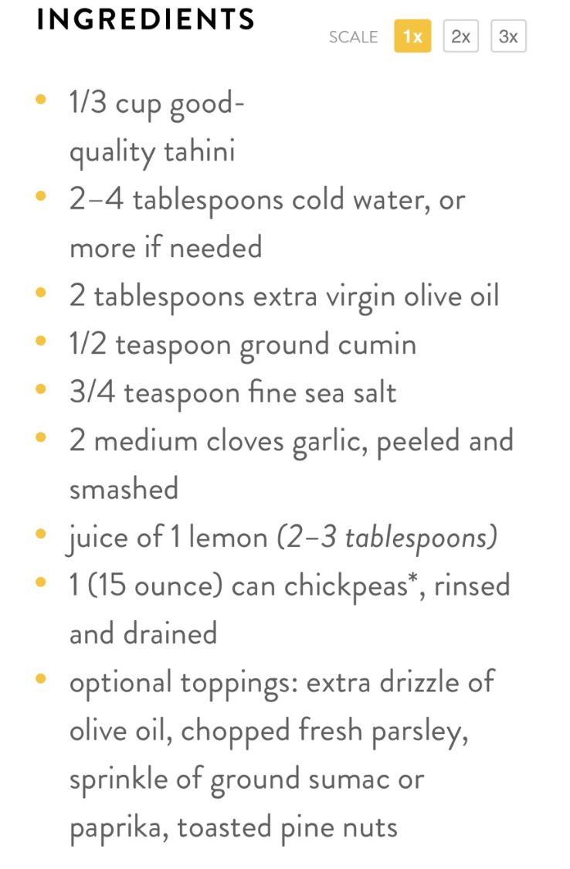 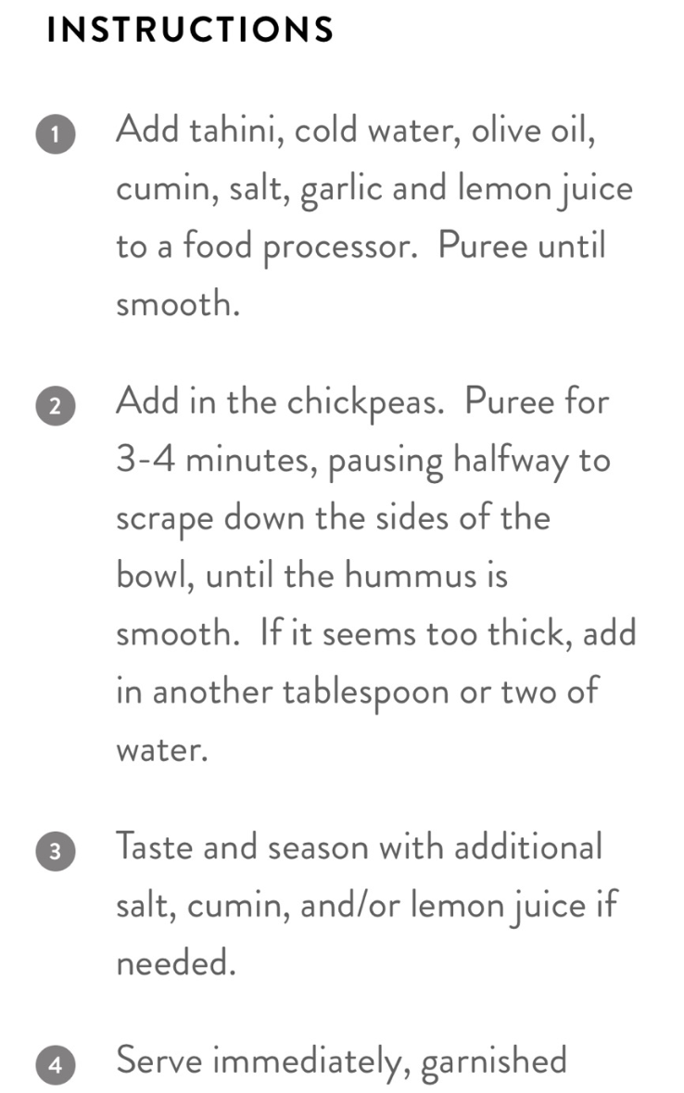

2 Tbls chopped Fennel

1 teaspoon FennelPepper

Plus 2-2.5 TBLS juice of lemon

Plus 1-1.5 TBLS tahini

Plus ¼ TSP salt & pepper

FennelPepper substitute for 4 clove’s worth of fennel as garlic above