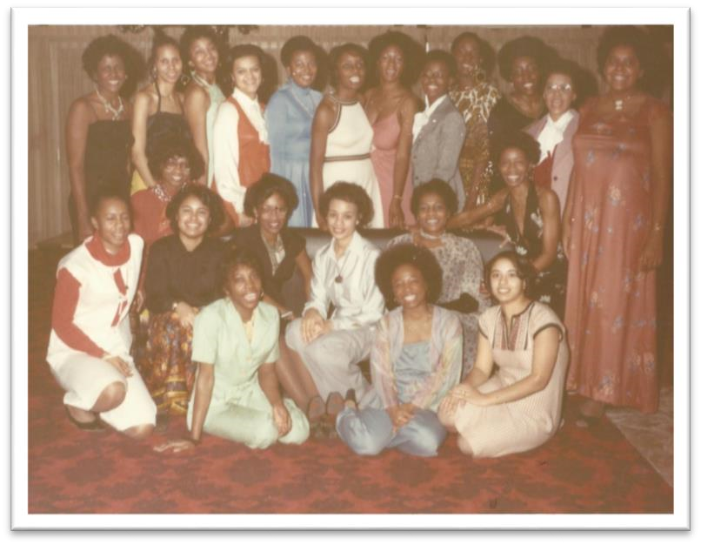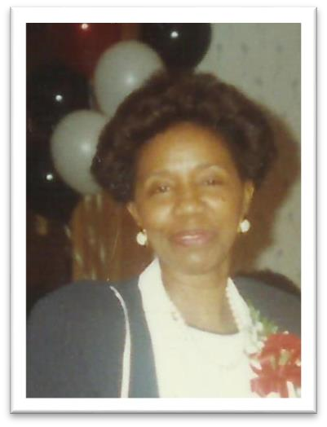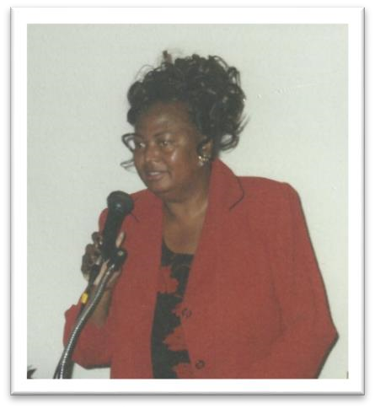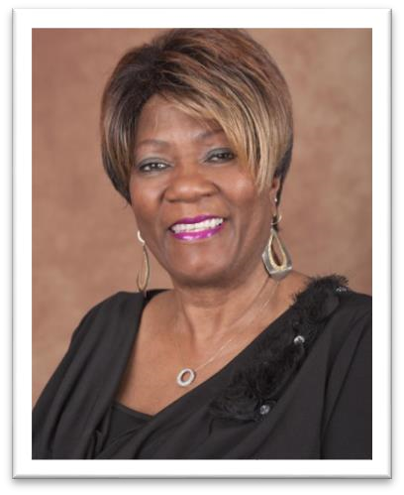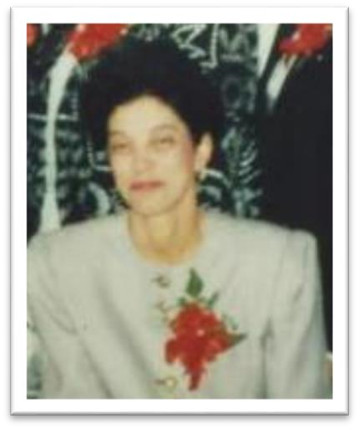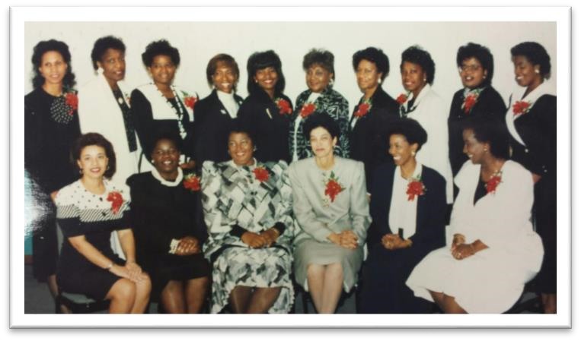

*SBBC*

*FOUNDERS*

*Alice Evans*

*Ella Grady*

*Jackie Hill*

*Dinah Kidd*

*Betty Lassister*

*-*

*Benbow*

*Eartha Smith*

*Aureilia Langhorn*

*-*

*Smith*