JOSH WALD – Ficha Tecnica|Information Sheet

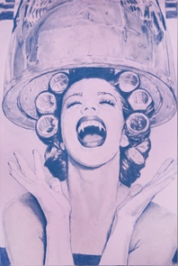
VAMP 1, Curlers 4.250,00

100 X 150 cm
ACRYLIC, GRAPHITE
PENCIL, AND CHARCOAL ON CANVAS

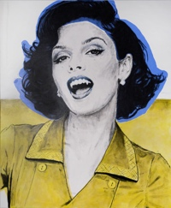
VAMP 2, Mom 4.250,00

121.5 X 152 cm
ACRYLIC, GRAPHITE
PENCIL, AND CHARCOAL ON CANVAS

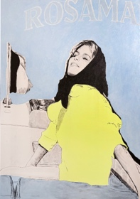
ROSAMAR 4.250,00

135 X 185 cm
ACRYLIC, GRAPHITE
PENCIL, AND CHARCOAL ON CANVAS

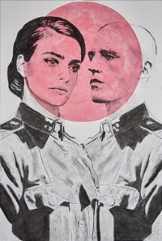
SHE SARGENT 4.250,00

135 X 165 cm
ACRYLIC, GRAPHITE
PENCIL, AND CHARCOAL ON CANVAS

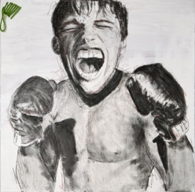
BOXER 1, study 2.250,00

70 X 70 cm
ACRYLIC, GRAPHITE
PENCIL, AND CHARCOAL ON CANVAS

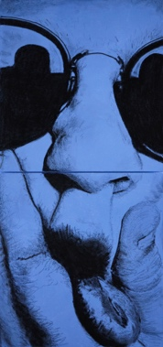

BLUE SQUISHY FACE 2.250,00

64 X 140 cm. (diptych)
ACRYLIC, GRAPHITE
PENCIL, AND CHARCOAL ON CANVAS

SCREEN PRINT (triptych) 1.250.00

JOSHWALD@MAC.COM
IG - @thepigeonparty
JoshWald.com

