La Grange railroad museum & learning center

2021

annual report
- Mission
- accomplishments
- financials &
- acknowledgements
January 2, 2022
1/1/2021 to 12/31/2021
412 E. Main Street
La Grange, KY 40031

 | 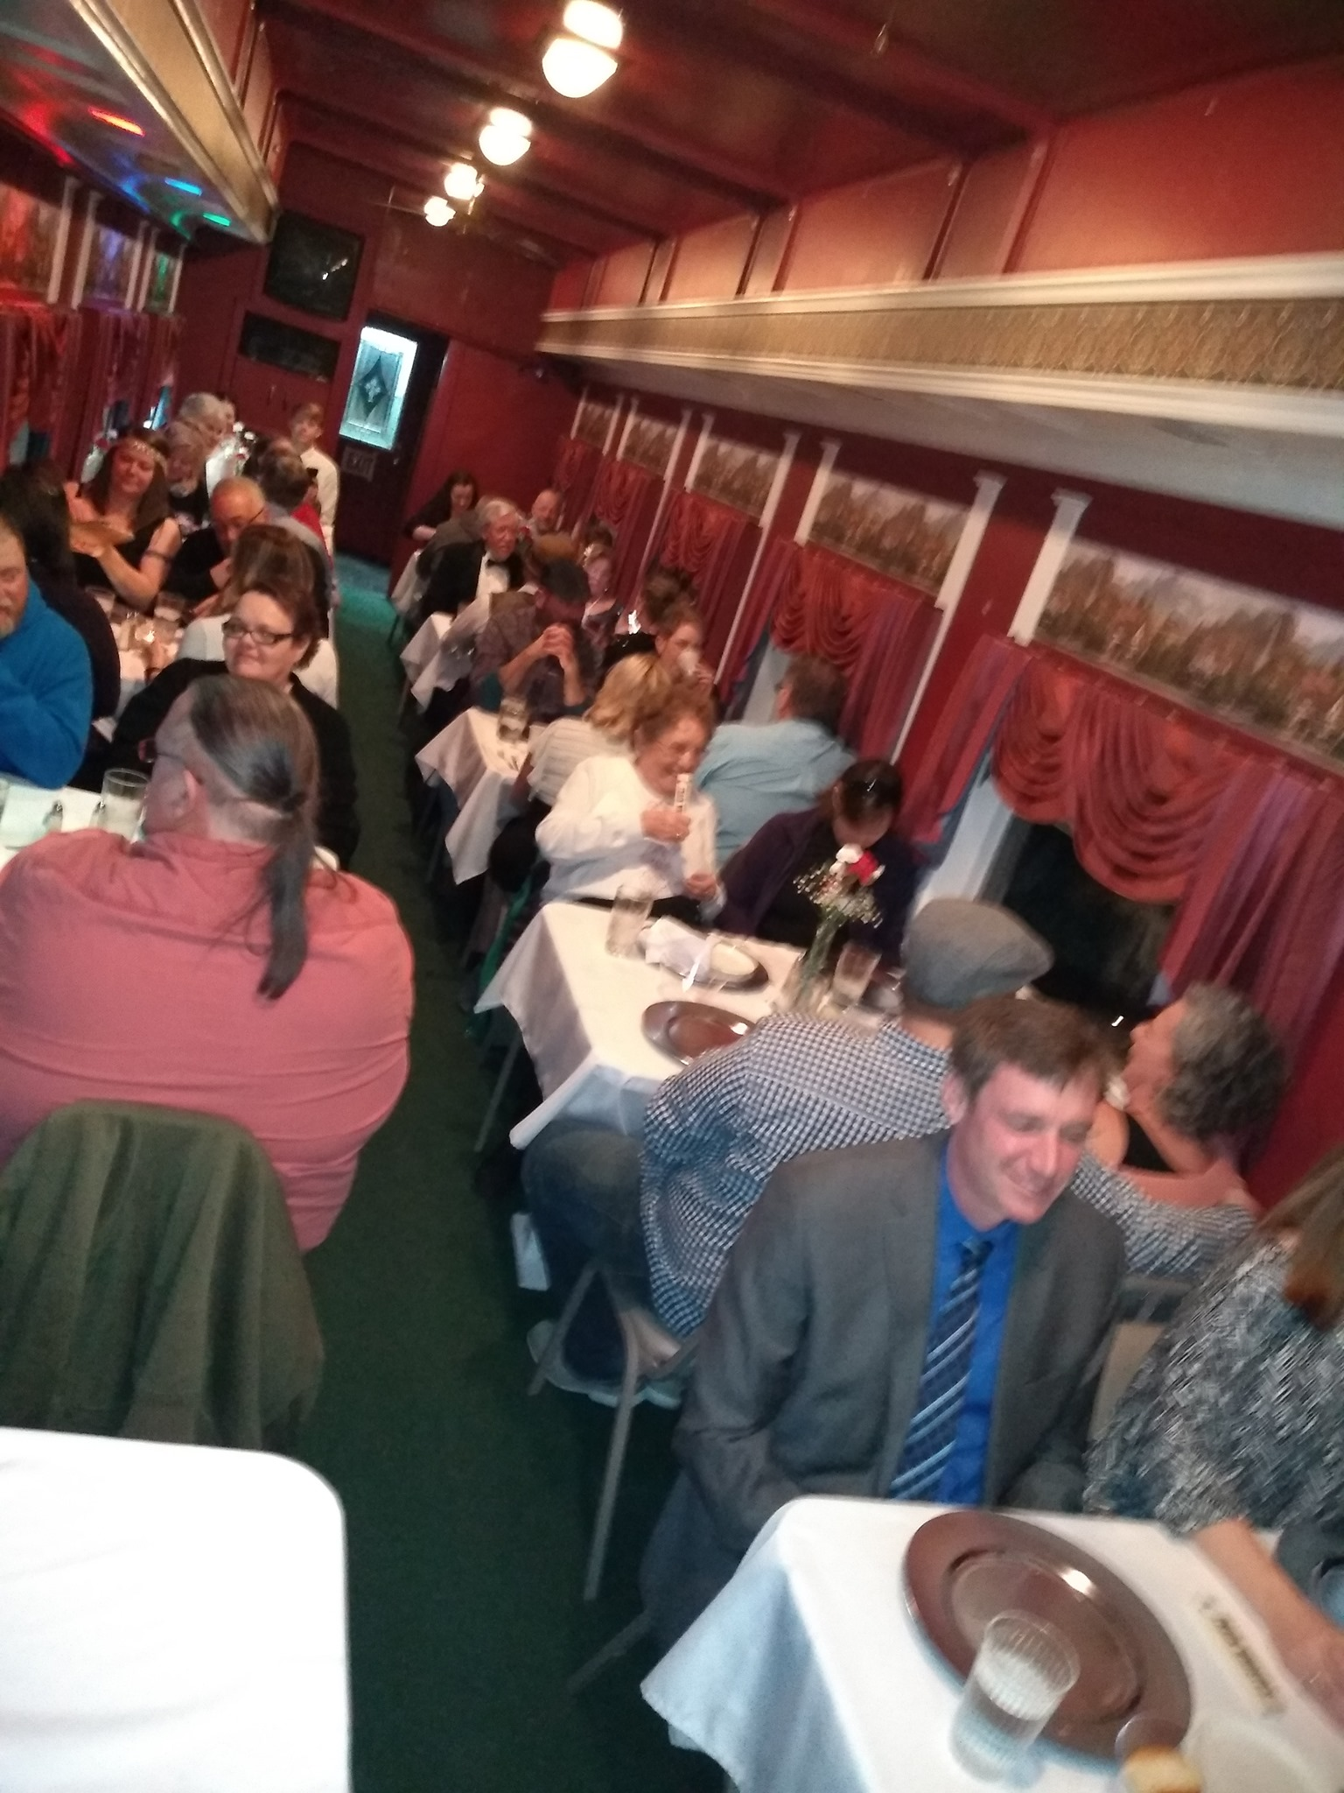 | 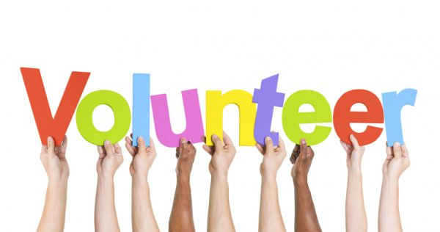
www.lagrangerailroadmuseum.org

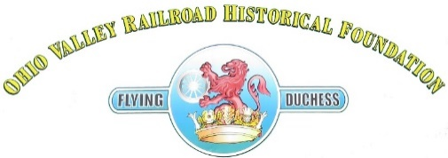
“BRINGING RAILROAD HISTORY TO LIFE”
LA GRANGE RAILROAD MUSEUM & LEARNING CENTER
412 East Main Street
La Grange, KY 40031
2021 ANNUAL REPORT
MISSION & FOCUS
- The Mission of the La Grange Railroad Museum & Learning Center is to "Bring Railroad History to Life." The 100% all-volunteer staff are committed to creating a first-class museum for area residents and visitors.
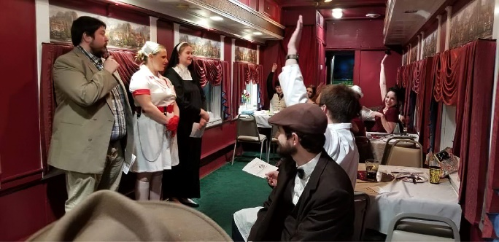
ACHIEVEMENTS
- There have been significant achievements in the past year. In these short 12 months, the museum volunteers have continued transforming the museum into a place that families often return.
- In 2021, the visitor count increased to an average of 750 per month. This upswing in visitors is due to the 7-day operation and the pride of the customer-oriented Docents.
- Interior and exterior improvements have been a vital part of the magic that has attracted many guests. These improvements include the surface upgrade of the Train Observation Deck, significant improvements in model railroad displays and operation, and museum organization and signage.
- During 2021, our name was changed to The La Grange Railroad Museum & Learning Center.
- In two holiday events, the museum hosted nearly 5,000 visitors. During Halloween we had nearly 1,400 visitors and for “Light up La Grange” & Santa there were over 3,500 visitors.

FINANCIALS
- The museum leadership is committed to financial responsibility and transparency. We manage all funds responsibly and effectively to earn the trust of all our supporters and benefactors. As a result, the museum enjoys the best financial position in its history.
- Our continued financial responsibility and planning allowed the museum to survive the challenges of COVID when over 50% of Kentucky nonprofits failed in 2020.
- In 2021, we received solid support from the thousands of contributors that routinely place their resources in the donation box. We received additional support from the city and other benefactors. Every donor can be highly CONFIDENT that the museum honors and protects every dollar received.
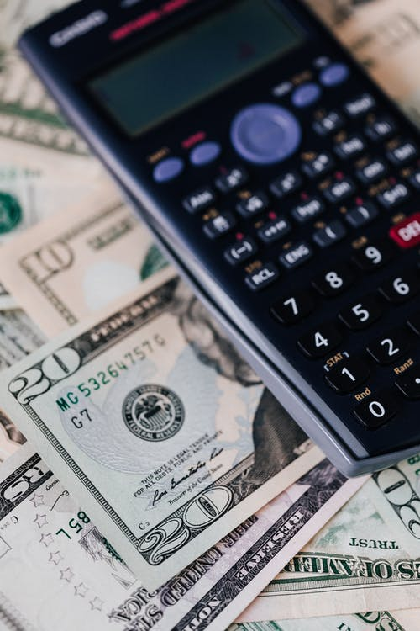
Funds received by the museum in 2021 came from three primary areas:
- Grants
- Visitor donations
- Dining Car rentals

Total 2021 Income was $28,500
Total operating expenses were $15,000.
Total debt payments of $3,000.
By-Laws required (operational expenses) safety-net of $16,000 is now fully funded. (It was the initial funding of the safety-net that allowed us to survive COVID shutdowns in 2020)

ACKNOWLEDGING OUR SUPPORTERS & BENEFACTORS

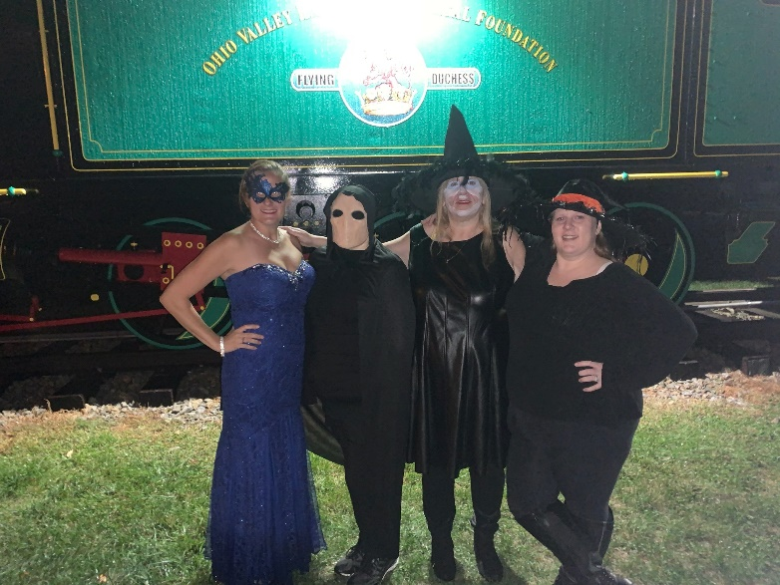

We must acknowledge those that have contributed to the success of the La Grange Railroad Museum & Learning Center.

The most important aspect contributing to the museum's success are the individual volunteers that constitute the lifeblood of the operation. Without these individuals and their ideas, enthusiasm, experience/knowledge, resources, and corporate experience, there would be no museum regardless of ANY external financial support.

Our volunteers contribute as little as on day a month to as much as several days per week. We allow everyone to contribute they way THEY want. As a result, we have a family of volunteers that are having fun while making a difference.

Secondly, we acknowledge EVERY contributor (large or small) that provided a boost to the stability of the museum.

We MUST acknowledge the thousands of individual contributors that through their incredible generosity, provided the museum with the funds needed to expand our mission to offer more services and outreach in the community. Through this expansion, we are fulfilling our MISSION of being the first place the community thinks of when desiring to know more about railroading history in La Grange.

We acknowledge ALL individuals that loan or contribute historical artifacts to the museum. Two significant donations this past year, were the priceless collection of trolley cars and display case in the Interurban Room and the personal collection of items from the Prather family in honor of Pete Prather. Without those artifacts and so many others, there would be no museum to enjoy. We honor and recognize the significance of those donated items. Some of the donations are extraordinarily personal and valuable. The family connection to railroads in the community runs VERY deep, and its importance is significant and unique.

Finally, we sincerely acknowledge everyone who believes in the museum's mission. Our supporters also understand that we are building a museum focused on the short-term success required to continue and know that all we accomplish is to assure the museum is a significant contributor to the success of the city for MANY decades to come.

There are two future projects significant to the museum's future and its mission.
  - Funding & installation of the approved outside Educational Park
  - Addition of ADA access to the beautiful 1929 L&N Dining Car to remove the barrier to tours and private functions.

The future of the museum has never been brighter. The pace of improvements and confidence in our mission is flourishing.

