Thursday, August 10, 2023
4pm-5:30 p.m. EDCOE Golden Center Campus
Thursday, October 5, 2023
4:00pm-5:30 p.m. EDCOE Golden Center Campus
Thursday, December 7, 2023
4:00pm-5:30 p.m. EDCOE Golden Center Campus
Thursday, February 8, 2024
4:00pm-5:30 p.m. EDCOE Golden Center Campus
June Meeting and Planning
Thursday, June 6, 2024
9:00 a.m. to 3:00 p.m. EDCOE Golden Center Campus
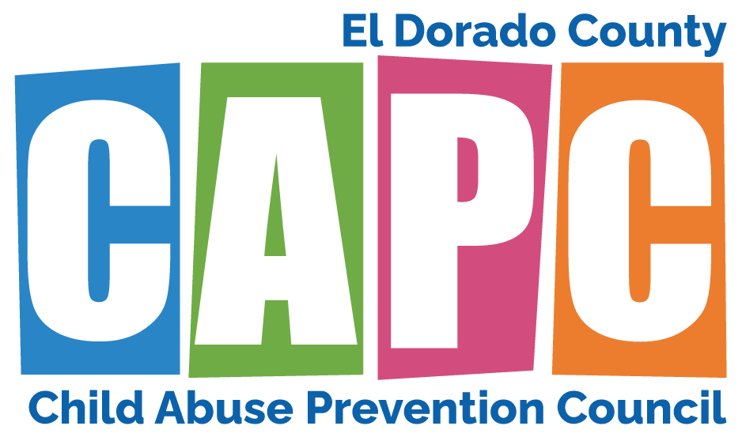
2023-24 Child Abuse Prevention Council
Meeting Schedule

For more information contact:
Deanna Santana, Council Coordinator
530-295-2493

