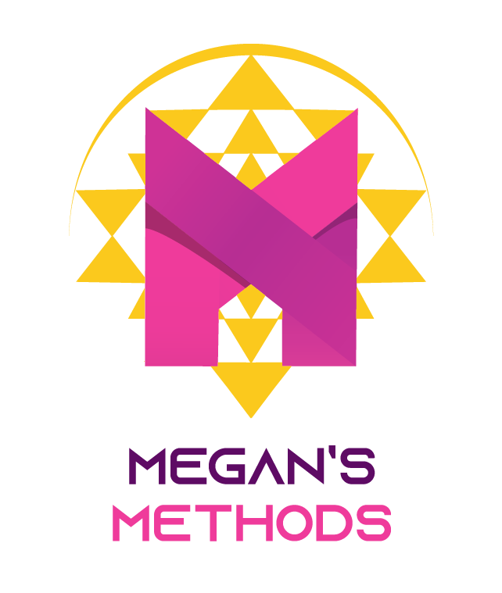

Private Yoga Guidelines and Terms

Guidelines

To make our sessions as productive as possible and to get the most out or our work together, please follow these guidelines.
  - Please wear comfortable clothing, stretchy but not too loose.
  - Give yourself time to digest meals or snacks prior to our session (2 hours for a meal, 1 hour for a snack), and please hydrate adequately beforehand. You may drink water during our session.
  - Try to dedicate time between sessions to practice on your own (ideally daily). This includes the homework stretches I provide. I also have references you can watch and follow on my YouTube channel (Megan’s Methods) to reference and help you in my absence. This will ensure maximum progress toward our goal and optimize or shared time together.
  - Ask questions! Please inquire if there is anything you do not understand or want to learn more about. This is especially true if you are feeling uncomfortable in any way, shape, or form.
  - If there is anything you want to work on, be sure to ask! We will periodically review your goals for these sessions formally to ensure that you are getting the most out of working together.

Terms

  - Please be on time. Due to a full client schedule, sessions must start and end on time.
  - Ensure that you can be present for our session without interruptions (this includes turning off your cell phone!).
  - Cancellation policy. If a session needs to be rescheduled, please notify me within 24 hours, and if we can’t find another time in the same week, you will be held responsible for the full rate of the session.

I understand and agree with the above guidelines and terms.

Client Signature | Date

