JusticeRidge Rhodesian Ridgebacks
Prospective Puppy Owner Profile
“Mo & Glory”
Puppies Expected February 20, 2023
Quality Bred Puppy Firm Price @ $3,000

Tina Jones, Breeder, Owner & Handler
6152 Laguna Villa Way Elk Grove, CA 95758
(916) 684-8786 (H) / (916) 599-1490 (C) “Text for faster reply”
justiceridge@aol.com -- JusticeRidge.org & JusticeRidge.com

Name:
Occupation:
Name of Spouse/Partner:
Occupation:
Address:
City & State:
Zip: | Application Date: ________________ (Important)
Home Phone:
Other Phone:
e-Mail Address:

Where did you hear about JusticeRidge Rhodesian Ridgebacks?
- Have you previously owned a Ridgeback? If so, from which Breeder and when?
- Do you own a dog now?
- Do you own other pets?
- Where do your pets sleep?
- Are you interested in a male or female?
- Do you have a color preference? Light wheaten, wheaten, or red-wheaten.
- Will you consider a ridgeless puppy?
- Have you ever shown a dog before? If you purchase a potential show puppy, would you be interested in showing your dogs to its AKC championship?

- Children of what ages lives with you? ________________________________________________________________
_____________________________________________________________________________________________________
- Do you have a fenced yard?
- What is your reason for wanting a Ridgeback?
Showing |  | Family Pet | Obedience
Lure Coursing |  | Agility | Hunting
Other:
- Where do you live?
Single Family Home |  | Townhouse | Apartment
- What plans do you have for your new puppy’s care during the day?
- What plans do you have for your adult dog’s care during the day
- Who is your current veterinarian?
- What access do you have to socialization and training classes? How much training do you plan to do?
- Have you ever entered in a contract to purchase a dog before?
- Have you ever returned a puppy to its breeder before?
- Why would your home be a great place for a Rhodesian Ridgeback?

Feel free to add any additional information you would like us to know when we review your application that may consider you as a possible forever home for one of our pups.
_______________________________________________________________________________________________
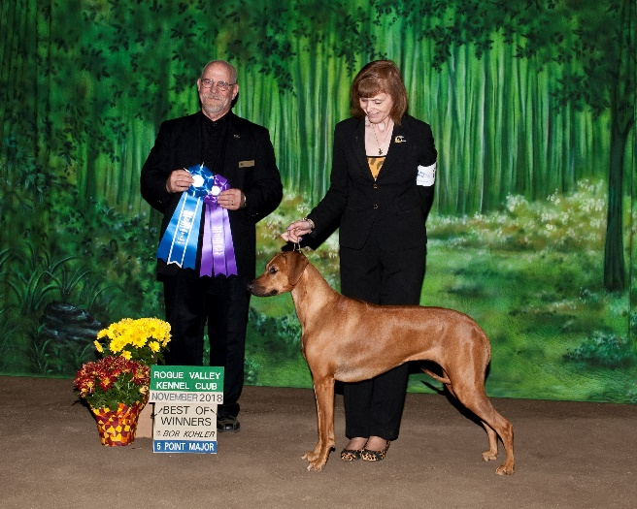
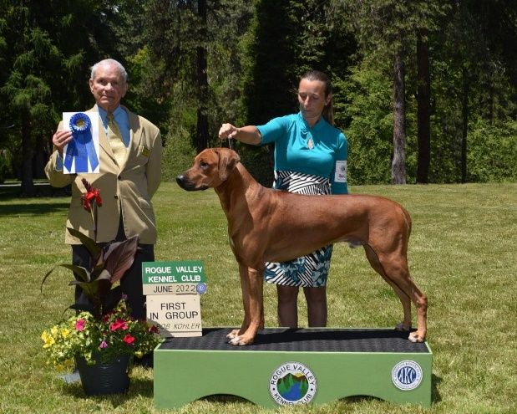
CH JusticeRidge Making Memories Great Again GCH Rosegold’s Perpetual Motion By Maijani
DAM: Glory SIRE: MO

