Detoxification &
Weight Loss System

With Advanced Nutritional Support

Complete Program Guide
Contents.
Forward. 3
Introduction. 5
Program Outline. 8
Step 1: Loading & Preparation. 11
Step 2: Fat Burning …The Fun Part! 16
Step 3: Stop Taking DR’s Choice Drops. 24
Step 4: Maintenance. 25
The “Take It With You” List. 31
Recipes - Step 2 (Fat Burning). 33
Salads. 37
Dressing Sauces & Marinades. 39
Soups. 43
Chicken Entrees. 48
Beef Entrees. 55
Seafood Entrees. 58
Vegetables. 61
Desserts. 63
Ideas & Quick Tips (In A Hurry) - Step 2. 66
Recipes - Step 4 (Maintenance). 68
Suggested Recipes - Step 4. 70
Reshape Shopping List (Detox & Maintenance Ideas). 73
Grocery List Fat Burn Portion. 73
Transformation Weight Mission. 73

Forward.
Proper nutrition is probably the most important part of weight management. There are many diets out there that will help you to reduce in weight, however that is not enough. We feel that in order for a weight loss program to be successful you must keep that weight off long term. By using this cookbook, your eyes just may be opened to a whole new way of staying young, trim, fit and healthy.

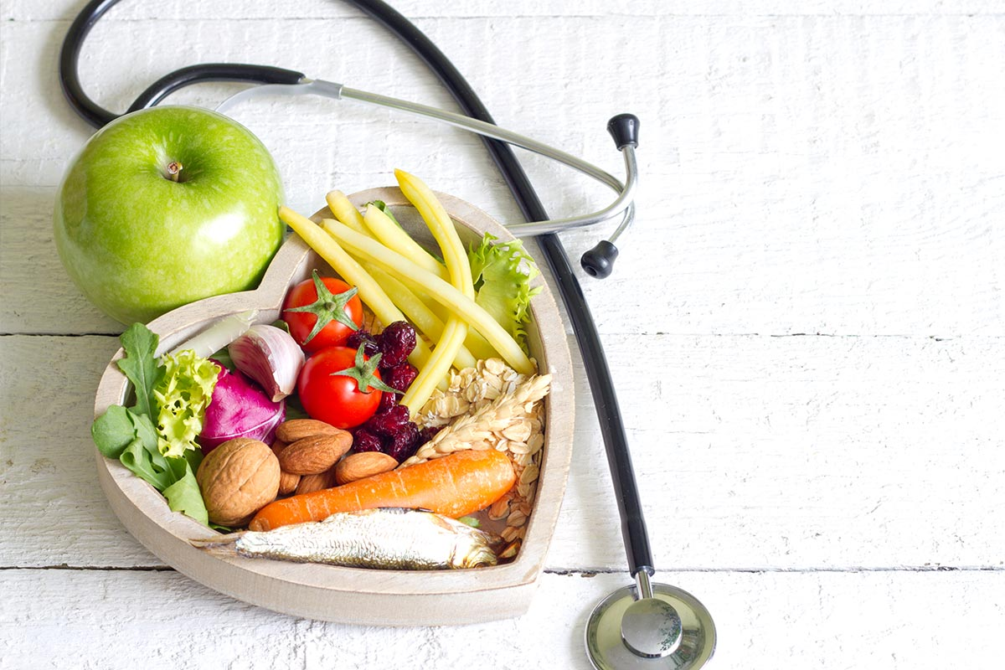

One of the fantastic benefits of doing this program is the amazingly healthy food choices that you will be making while following the meal plan. These foods naturally cleanse your body of ingredients you may have been addicted to without even knowing it...like sugar!! So have fun exploring new tastes. You might surprise yourself! Try a new vegetable or two; it might actually even taste good!

There are so many health benefits from following this program. You can look forward to:

Losing 15-25 pounds in 30 Days!

Reduce appearance of Cellulite

Reshape your body

Decrease body fat percentage

Increase Lean Muscle to Fat Ratio

Deep Cleanse your Body

Look and Feel Younger

Increase over-all Health
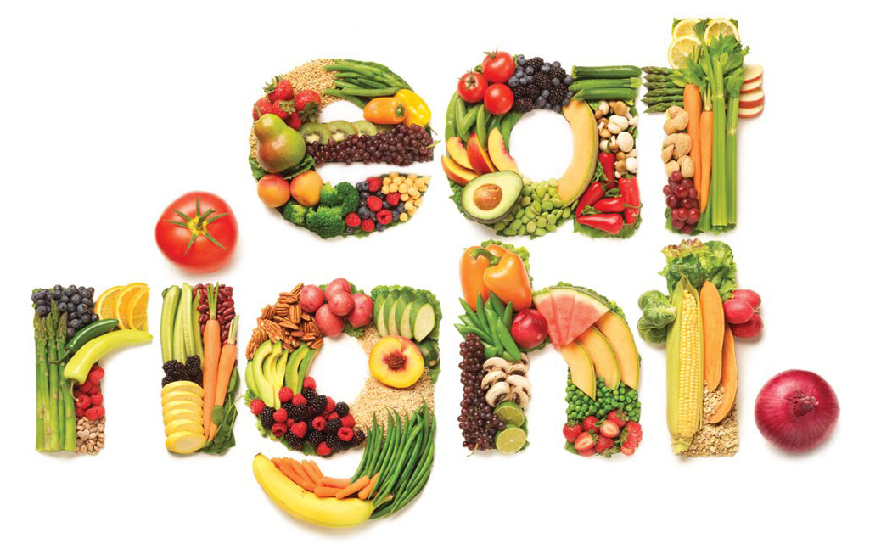In addition to eating deliciously healthy foods we highly encourage you to include the Advanced Nutritional Supplements recommended by your weight loss coach. These specific supplements have been proven to greatly enhance your experience on this program. As we have helped thousands of people reach their goals, those who have used the nutritional supplements recommended rave about the energy and stamina they experienced even while on the restricted menu. You will greatly maximize your experience by opting to incorporate the recommended Advanced Nutritional Supplements as directed and consider a long term program for dietary insurance.
As you complete this program we hope that you have found great success and refer your friends to us. It is our desire is to help families have a better understanding of how simple, cost effective and delicious it is to be healthy, happy and THIN!!

Introduction.

Transformation Mission Welcomes You
You have made an amazing commitment to yourself and your health! Included in this e-book is all the information you need to start dropping excess FAT weight, reach your goals, detoxifying your body and best of all, Keep it off!!

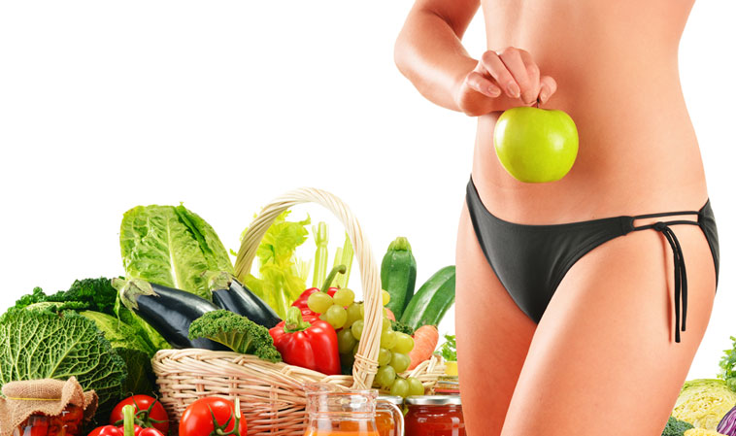

TO ACHIEVE BEST RESULTS

Following the program exactly as outlined is HIGHLY RECOMMENDED!!

Chances are you made the decision to do the TM Program because you know someone that has had significant success with this program. You CAN have those same results if you commit yourself to following the program exactly as outlined. Any modification from this original program may keep you from losing your optimal amount of weight!! This program can deliver results unlike ANY WEIGHT LOSS PROGRAM you have ever seen.
The Program can be the simplest, quickest way to lose weight EVER; if you don't complicate it. Pay strict attention to the details. The structure and specific nature of the program makes it very simple to follow as long as you take the small amount of time necessary to understand the detailed instructions and be prepared.
Read through this protocol booklet completely before beginning the program. Familiarize yourself with how the system works for optimal results. Our best advice is that you treat each of the steps in this program "As If" that Step was the most important one helping you reach your weight loss goals.
Results that you may look forward to!
Whether you have only TEN pounds or over a HUNDRED pounds to lose, the Transformation Mission Program will be the best thing you have ever done for yourself!
These weight loss averages are based on the thousands of clients that have used our exclusive system successfully.
These results are typical!! Follow the program... you will lose the weight!!! Many individuals lose 1-3 pounds per day however,

AVERAGE Weight loss in 30 days:
Female Adults 18-27 pounds
Male Adults 25-39 pounds

The Transformation Mission Weight Loss System was created at the request of the many family and friends that desired us to assist them in reaching their weight loss goals after seeing our personal successful weight loss results. Perfecting methods we learned using the clinical experiences of Dr. Wright, we personalized the Weight Loss System and are helping thousands of people lose weight across the globe.
This all evolved from Dr. Simeons who devoted over 40 years to the study of obesity. More than twenty-five of those years were focused solely on creating and perfecting the widely renowned HCG diet protocol. His in-depth research has introduced new ideas and concepts that give new understanding to the way our bodies lose weight and also maintain that loss based on his research.
The DR’S CHOICE drops we use in this customized program does NOT contain HCG however it does utilize the characteristics of HCG specifically through a vibrational process called Digital Energetic Signature. Characteristics of HCG as well as other vital characteristics have been added to the DR’S CHOICE product using vibrational technology. The additional vibrational signatures are: Guarana Seed, Hoodia Cactus, Fennel Seed, Gymnema Leaf, Kelp Thallus, Bladderwrack Thallus, Gravel Root, Black Walnut Hull, Uva-ursi Leaf, and Senna Leaf. These characteristics give added assistance with appetite control and energy levels during the reduced calorie portion of the DR’S CHOICE Program.
Over the years, we have witnessed many clinics deviating from Dr. Simeons’s original protocol. Unfortunately, the clients were not experiencing the true miracle of his program. When our Transformation Mission Weight Loss System is followed using the DR’S CHOICE Drops and customized supplement package recommended, there is no comparison to the results you can achieve with this program.
There are many different weight loss programs offered today with a wide array of products to choose from. Do not confuse this to any other products or systems. Although they may appear similar, weight loss results from our patented DR’S CHOICE product, the advanced nutritional supplements, continual customer education and the customer support make our program completely unique.
Our DR’S CHOICE drops are manufactured in the USA in an FDA supervised lab. DR’S CHOICE DC1000 is certified Vegan and Kosher. Hands down the DR’S CHOICE Weight Loss System with Advanced Nutritional Support is by far the most superior weight loss system available!!

We look forward to help you reach your goals!

Program Outline.

Transformation Mission Detoxification & Weight Loss System
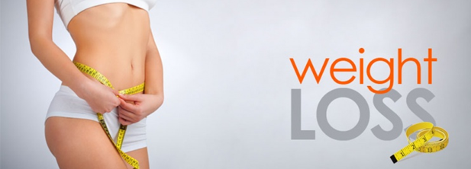
Program consists of 4 Main Steps:
STEP 1: | Loading days & Preparation - Start DR’S CHOICE Drops (2-3 days in duration) Prepares your body for fat burning. You begin using the drops and load as directed. Begin Journaling.

STEP 2: | Fat Burning/Specialized Menu - Continue DROPS-Start Nutritional Supplements. Menu taken from “list of allowed foods” supplement instructions included in daily regimen.

STEP 3: | Preparing for Maintenance/End of DROPS (3 days in duration) - This step is necessary to prepare your body for maintaining your new weight as you increase calories.

STEP 4: | Maintenance /NO Drops - (2-6 weeks in duration talk with adviser) By following the outlined program in Step 4, your body will reset to your new lower weight for long-term stabilization. Most important step for lifetime success.

Getting Started
It is important to make a master plan to achieve maximum success! This has to do with your mindset, timing and preparation. Be mentally prepared. Have a super attitude! Make this FUN. Keep your commitment to the final stages of the program! Have fun increasing your menu food options by trying new recipes during the fat burning and the maintenance!
By preparing ahead, you will optimize your results! It leaves no room for frustration when our hectic lives get in the way of our well-intentioned plans.

Choosing Your Start Date
Because of the specific structure of this program, the time you choose to start is very important. There are several factors to consider to ensure the best possible results.

Determine the next 30-day period you can commit to the structure of this system. Life is always busy, simply find the dates with the least amount of distractions, holidays, vacation, travel etc.

To get off to a good start, it is best to have 2 days off work to prepare and for Step 1 “Loading” to be effective. The weekends are the usually the best days to properly load, shop, cook and prepare, it is highly recommended to start loading on a Friday and go through Sunday .

Women it is important to start immediately after your monthly cycle ends OR at least 2 weeks before you know it is going to start.

Preparation Tips!
Before we just jump right in, let's do a little housekeeping. There are a few inexpensive items that you will need to purchase that make this program work effectively. Preparation is the key to making this program simple and effective

Required Items

Digital Bathroom Scale is necessary you will be recording your weight first thig every day in the daily tracking journal. Have the same scale and weighting first thing in the morning on an empty bladder is imperative.

Containers to store prepared measured proteins, vegetables and fruits. Ziploc bags, aluminum foil and other plastic or glass containers simplify meal planning. We encourage you to prepare ahead all the proteins you will need for the next 30 days and have them easily available always, frozen and in the refrigerator.

Nutritional supplements provide optimal nutrient support during the fat burning, detoxification and through the maintenance process. Many clients report feeling more sustained energy and increased weight loss result with the use of these vital support nutrients.

Daily tracking journal, as found in the last pages of this document, has some great tools to help you track your success. Your health coach can also use it as a tool to help you see where there may be some changes in types of foods or timing, water intake etc.….

Use of your Health Coach is vital! Set up a text, phone contact or personal meetings to assure the questions get answered. If you have any stalls, feel hungry or tempted to go off the program you MUST contact your advisor for some rescue methods we have tested and used with great success. You are not in this alone.

High fat foods for loading...7,000 - 10,000 calories per day.
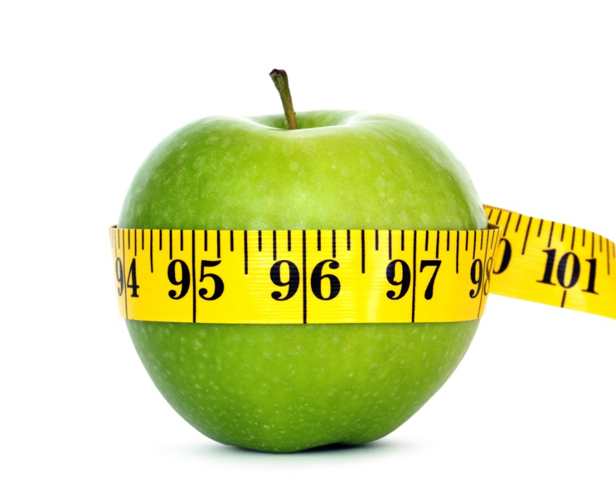

Step 1: Loading & Preparation.

Fat Building (Day 1 & 2)

This Step Is Critical To The Success Of This Program.
The first 2 days minimum, are loading days. You will be required to eat large quantities of high fat foods. (Preferably healthy fats) while this may sound counterproductive, loading is what triggers fat burning. Loading is not to eat beyond capacity, but high fat foods while taking drops. Your goal is to gain over 4 pounds in two days! Read this section thoroughly to understand the importance.
We cannot impress upon you enough the importance of this Step. Don't load casually and expect fabulous weight loss results. If you were to skip the loading step and begin Step 2 with reduced calories, your body would go into protective mode and begin storing fat instead of burning it!
Many people today, because of busy, high stress lives, are overweight simply due to skipping meals or continual reduced calories during the week. Perhaps skip breakfast, and/or lunch; maybe snack here and there, then at some point, usually nights and weekends, eat more to play "catch up". The body is then always in feast or famine and will store fat to prepare itself for the next famine. The worst part is, the body stores that fat in a very safe place that it doesn't want to let go of easily. This is EXACTLY the fat you want to burn! This program is designed to do just that. To load correctly, it is important to know "why" this step is important! Loading is the key that unlocks the hidden fat stores.

Why Loading Is Important (FAT BUILDING To Open The Fat Doors)
Loading encourages your body to burn fat instead of storing it as you begin the reduced calories portion of the Specialized Meal Plan.
Loading forces your body to replenish the healthy fat that has been depleted from other diets you have been on. Low amounts of healthy fat will cause you to experience intense hunger while on the Specialized Meal Plan.
If loading is not done properly, typically individuals weight loss results are half of that of those that load sufficiently.

IMPORTANT >> You may need to increase the number of loading days from two days to three days if you fall into any of these categories:

If you have had surgery that limits the amount of food you can consume at one time; like Gastric By-Pass or a Lap Band etc.

If after two days of loading, you don’t gain up to 4 pounds, and don’t feel you ate enough FAT, you will need to contact your personal weight loss consultant to see if one additional loading day is needed.

In some cases, some have loaded and lost weight. This is generally due to continual dieting and/or limiting your fat calories for an extended period. Your body is just happy to finally eat some fat! If this happens to be the case for you, simply load for at least three days to be sure and get off to the best start possible.

ATTENTION >> If you know that your body doesn't handle consuming fat well due to some specific medical condition such as gallbladder problems; please discuss with your consultant the best possible solution. We also highly recommend that you consult with your Physician prior to beginning this program.

It is best if you have at least two days away from work and free from any other distractions for it to be effective. You will not be able to do this effectively at work, on vacation or running errands. It needs to be a planned concentrated effort.

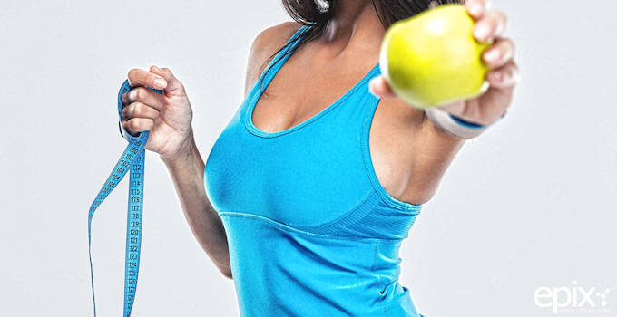

Don't be confused by foods that make you fat such as foods high in sugar or high in carbohydrates such as bread, pasta and rice. It needs to be foods with high fat content. Fat is the main goal not sugar although they are almost always together! Not to scare you, but realize that it is not uncommon to eat between 7,000 to 10,000 calories each day and over 350 grams of fat. If you figure out that just one slice of pepperoni pizza available at any popular retail outlet has 718 calories and 33.5 grams of fat...so you can see how quickly this will add up if you are loading properly.
One side benefit of fat loading is that as you really read labels to optimize your loading, you will be gaining a deeper awareness of the nutritional value of specific foods. It has amazed many people who simply were not aware of the calorie and fat content of some of their favorite foods. This will be a great tool to assist you in making healthier choices when you move into maintaining your new healthy lifestyle. Use these fun tips: Make a game out of it. Eat things you would normally never allow yourself to. Go out with friends to your favorite place. Go on a grocery scavenger hunt. Read labels and find the foods containing the highest fat content for the most economical price. Use cream or Half and Half to make chocolate milk.

Food Suggestions During The Loading Days

Breakfast
Cheese and Meat Omelets | Pastries and Donuts | Real thick Bacon or Sausage
Sausage and Gravy Biscuit's | Greasy Fried Potatoes | Eggs Benedict with extra Hollandaise sauce
Fruit with Heavy Whipping Cream | Irish Butter | Coconut or Olive Oil

Lunch & Dinner
Cheese Burgers with Fries & Thick Ice Cream Shake | Hot Dogs/Chili Cheese Dogs | Enchiladas loaded with cheese, sour cream and guacamole
Pizza with extra meat and cheese | Bacon Cheese Burgers | Carne Asada Fries

Snacks
Ice Cream | Chocolate milk made with Half & Half or heavy cream | Cheese
Loaded Nachos | Nuts | Potato Chips

Milk Chocolate

THE MORE YOU EAT – THE MORE YOU LOSE!

Instructions: How To Take The Dr’s Choice Drops

BEGIN USING DR’S CHOICE DROPS ON THE FIRST DAY OF STEP 1 LOADING.

You will do this 3 TIMES DAILY for duration of your program STEPS 1 & 2

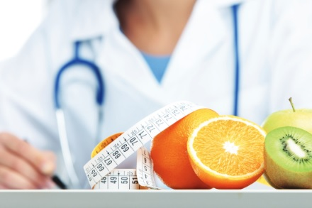

Place 10 drops UNDER your tongue; Using the dropper, OR amount advised by your Doctor. Allow your tongue to rest into the liquid so it can absorb. Hold liquid under tongue for about 15-30 seconds then swish around in mouth before swallowing.
Best results are achieved if taken at least 15-25 minutes prior to meals. WAIT 15-25 minutes before AND after you drink or eat to take the DR’S CHOICE DROPS. Eating or drinking too soon before or after taking drops may dilute the absorbability.

Step 2: Fat Burning …The Fun Part!

Specialized Menu (Day 3 – 30)
This is where all the weight loss occurs! As you begin Step 2, you are just happy to be done loading, right! It was awful, we know!
There are a few things to be aware of as you move to Step 2. Your body is going through a lot of changes, especially this first week. You just loaded beyond what you thought was possible and now we put you on a low calorie restricted menu! Your body is trying to adjust the best it can!
There are a few normal adjustments you may experience the first week. Below is a list of some things that are common that you may need to prepare for: Hunger Light-headedness/Weakness Headaches Cranky and Irritable Intestinal Changes. The supplements are designed to help.
If you happen to have these experiences, they should quickly correct themselves within a few days, by about day 6 you should feel great! This is simply dietary changes due to loading and then reduced calories. You may use whatever you feel necessary for headache pain. If you experience a headache that won't let up, consult your weight loss consultant for suggestions.
If you work away from home, be prepared to avoid snack machines if more food is required these first couple of days. Bring an extra meal...just in case! Use only if needed to really achieve optimal weight loss.
If you experience any of these symptoms more than mildly, or they do not seem reasonable, contact your consultant. Other than noticeable hunger the first few days, you should not feel hunger on this program. There are a few exceptions, but let us discuss this with you. The amount of DR’S CHOICE drops may need to be adjusted.
The first week sets the pace for the entire program. It is NOT recommended that you eat out EVER on this program. It will not yield good results in the end! Eating out gives you zero control on measurements or how food is prepared. If you must eat out due to circumstances beyond your control please refer to the restaurant guide in the back of this guide for ways to minimize the damage. Eating out will decrease your overall weight loss results.
Your weight loss should be significant this first week and then taper off to about 1 pound per day average by day 7 and on. It is not uncommon for some to lose up to 12 pounds or more the first week. Loading weight should come off completely within the first couple days on Step 2. If you lose less than 7 pounds BY DAY 7, contact your weight loss consultant. We may need to make minor adjustments now to increase your overall results.
It is next to impossible to catch up if we get off to a slow start. Low weight loss the first week is almost always due to these three things:

Not loading well

Not being prepared with recommended type and portions of foods.

Not drinking enough water or herbal tea.

Going too long without food

Stress & hormonal changes
As you work through this program, should you need some help, the only thing that we can do to help is to review your journal. If you have not kept accurate notes it will be a guessing game as to what the problem really is.

Detoxification & Constipation
On this program your body will happily release toxins which are stored in the body fat and in the colon. This is a great aspect of the program. As you eat more unprocessed and natural foods, your body may release toxins that have been stored for quite some time. Although you are drinking plenty of fluids, it is quite common to experience slow moving bowels and or constipation. As your body is flushing, impacted waste may need to be released. We highly recommend using Detox or a laxative tea like “Smooth Move” for this situation. Also to move your bowels, gentle daily walking or activity maybe called for. See the enclosed recipe for a powerful detox bath.

List Of Allowed Foods: Step 2

Proteins: 3 A Day!
Eat 4 oz. of protein 3 x day from choices below (Approx. 100gms of protein weighed raw with all fats removed) easy rule…as deep and thick as the palm of your hand. It is ideal to grill or bake (George Foreman Grill)
Venison  Veal  Bison  Extra Lean Beef | Skinless Chicken Breast  Chicken packed in water | Lobster  Shrimp  Prawns  Crawfish  Crabmeat | Wild Chilean Sea Bass  Flounder  Any white fish  Pharmanex Protein Powder

Fruits: Limit 2 Per Day!

One medium organic apple, or

1/2 organic grapefruit, or

Organic orange or

One handful of organic strawberries.

Vegetables: Eat 2 A Day!
Prefer organic vegetables raw, steamed, or grilled (NO butter, margarine, prepared salad dressings)

Spinach- 3 cups

Beet greens -3 cups

Lettuces of any kind -4 cups +

Field Greens- 4 cups

Tomatoes -1 ½ cups

Celery -3 cups

Red radishes -2 cups

Cucumbers -1 ½ cups(pickles)

Onions- 1 cup

Asparagus -2 cups (pickled ok)

Cabbage- 2cups (sauerkraut)

Chard- 3 cups

NO Dairy, eggs, wheat, sugar or alcohol should be used for the first 21- 30 days on program for detox purposes and ideal fat loss. Phase 2 has much more flexibility depending on individual health goals.
You may season any of the food with the juice of half an organic lemon or lime, Stevia liquid or powdered sweeteners only, organic raw apple cider vinegar, Braggs Liquid Aminos, salsa (no sugar or oil), low sodium, low fat organic broth (beef, chicken or vegetable), sea salt etc. Spices are fine to use; however, mixed seasonings usually can contain sodium and MSG and oil should, therefore, be avoided. Also, NO butter, prepared salad dressings or spices that contains oil! Remember, if it is not on this list, do not eat.

Sample Day For Maximum Weight Loss & Detox

Supplements: AM

1 Probio

3-6 capsules R2 Day (Vitality)

1 Cortitrol

Breakfast
1 scoop TR90 Protein Boost Powder vanilla (may use 1 T Cacao powder to make chocolate flavor)
Add ¼ cup fruit (optional) strawberry, apple, orange, grapefruit or spinach (limit 2 fruits per day)
*As an alternative to the Protein drink in the morning …choose any protein from the list of allowed foods (see breakfast sausage recipe)

Mid-Morning Snack
Fruit or vegetable
*The 2 fruits from master list may be eaten daily either as a snack OR used with meals not both

Lunch
1 scoop TR90 Protein Powder
or
Choose 1 lean protein source (size and thickness of the palm of your hand)
1 serving vegetable

Dinner (30gms protein)
Choose 1 lean protein source (size and thickness of the palm of your hand)
1 serving vegetable

Supplements: PM

2-ageLOC R2 Night

1-2 Cortitrol
*Use “Pharmanex TR90 Protein Boost” for additional protein
(*may need extra canister if replacing 2 meals a day)

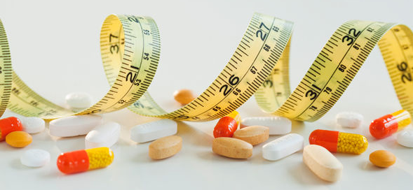

Tips To Achieve Maximum Results
To achieve the best results possible, make sure you understand the details of Step 2 inside and out! Such as:

The list of allowed foods, how to prepare them and how much to eat and when.

Keep a very accurate journal so if you're not getting the results you want, we'll know where to adjust.

Do your best to weigh yourself at the same time every morning EMPTY BLADDER.

Take before pictures of yourself. You'll be so glad you did for an amazing reference later!

Update your personal coach with your progress at least weekly.

Don't cheat! Cheating will cost you 3-5 days of weight loss results.

It's simply not worth it. It's only 30 days! You can do it!

Only do strenuous exercise if you are already in an established habit. If you are not already in an established routine, adding walking would be a great idea. Regular exercise is important to maintain overall good health.

Avoid artificial sweeteners of all kinds. They have many side-effects that you should be aware of. They are also known to increase appetite. Use Stevia instead as it is a natural and a delicious alternative.

Only use approved supplements. The recommended supplements are the only ones that we have found so fat that do not inhibit weight loss.

Don't use any salad dressings except those in cookbook...or possibly Walden Farms Calorie Free...works for some. Use in moderation.

Watch out for combination spices containing sugar and starches. You will do great! This will be an incredible learning experience you'll be thrilled with. It never ceases to amaze us as we hear and see the amazing testimonials that pour in.

Success Tips

Take Supplements as directed and Stick to list of allowed foods!!

Avoid SIMPLE Carbohydrates (sugar, starches, breads, grains & alcohol)

No dairy, wheat, eggs

Drink 64-128 oz. of water per day

Drink Green Tea it speeds up metabolism or take (Tegreen 97 capsules)

1 T Apple cider vinegar or lemon water 2 x day

Don’t go too long in between meals (small frequent meals is key)

Rotate foods don’t eat the same meals everyday

Weigh yourself on scale (morning only w/ empty bladder)

Take measurements weekly and focus on inch loss

Walking or moving 5-6 days’ week plan it into schedule!

Minimum 8 hours of sleep per night

Stalled Or Plateau Weight Loss
Stalled weight loss or as we call them "plateaus", are common, especially for women at some point after the second week (Generally due to ovulation). This is simply your body retaining water. You are still burning fat and it will correct itself. However, if after four days you are concerned, you may trick your body to release the retained fluids by doing what is called "An Apple Day", not to be confused with "Steak and Apple Day" which is to be done during maintenance ONLY.
The Apple Day will help your body to release water weight and get you back into daily loss. (This should only be done if your weight has remained the same for FOUR days or more. Not to be used to compensate for cheating on the program.) Beginning at lunch, eat only apples until just before lunch the next day. . Eat a maximum of 6 apples in that 24 hour period. Don't eat or drink any additional foods or liquids except plain water that day. Drink only enough water to quench your thirst as needed. You should show a good weight loss the following morning. Begin again with the normal menu that next day. Your weight loss should resume as normal.

Things To Do Before Your Start
Having a structured plan in place before you start the program is a critical step if you want to reach your goals. Get out your calendar and mark the days. Look for events that may prevent you from being successful. The following list will help you stay focused and encouraged as you see and document the progress you are making.

Purchase your drops & and set up supplement account

Purchase a digital bathroom scale to weigh yourself 1 x daily, first thing in the morning.

Read through this guide at least 2 times & familiarize yourself with the "Foods Allowed"

Print a copy of “Shopping List" & Hit the grocery store!

Prepare: Measure, cook and store your proteins. Preparing enough for 2 weeks works great!

Pack a cooler bag with supplements, drops & food for the day (take it with you at all times)

Print a copy of "My Daily Journal” to record your progress for the number of days planned

Print a copy of “Take your picture“ and follow the directions

Use the 'Take-it-with-You" list located behind book snap a picture for your phone so you have it with you at all times.

Duration Of Step 2
The length of time for Step 2 is determined by the amount of fat loss desired. 30 days is average yet it may vary based on individual desired results. However, it is important to be on the drops for at least a minimum of 23 days (includes loading days) in order to reset your body at your new weight.
If you reach your desired goal weight before day 30, you will simply remain on the program as outlined, increasing the volume of food while maintaining your weight loss. Once you reach day 23, AND you have achieved your desired goal, you may then move to Step 3 with complete confidence.
If you need to lose more weight than one session will allow, you may stay on the program until you reach your weight loss goals. For those wanting to lose more than 75 pounds consult your adviser. If you have additional questions, consult your weight loss adviser.

Step 3: Stop Taking DR’s Choice Drops.

Final Stage Of The Specialized Menu (Day 31 – 33)
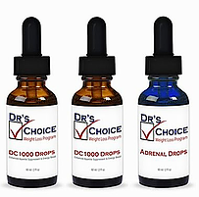
These last 3 days are in preparation for beginning Step 4, Maintenance. Just as it took a few days for the DR’S CHOICE drops to become completely effective in your system during Step 1, it is now necessary for your body to completely release the DR’S CHOICE drops from your system.
You will NOT take the drops on day 31 and discard remainder of liquid. Day 32 mark your weight in your journal. This will be your final weight. You may lose additional weight on day 32 and 33 however, as you begin the maintenance portion you will be increasing your food consumption and you will tend to add a pound or so that first day. This is normal. Your body is just adjusting to the new foods.
While staying on the Specialized Menu for these final 3 days, you should still feel satisfied with your meal portions. Maintain same calorie intake (around 850)
If you are 100% at your goal weight, you may feel a bit more of an appetite as you have successfully burned all abnormally stored body fat.

Congratulations!!

If you need a little extra food it should be fine as long as you maintain your goal and stick with the allowed foods.

Step 4: Maintenance.

Six Weeks Starting On Day 34
The maintenance plan is simple and fun! You will begin increasing your variety and quantities of food! The goal is to be eating normal at the end of the 6 week Maintenance Period. You must complete Step 3, to begin Maintenance Plan. It is Imperative that you continue to weigh yourself daily and keep up with your journaling. It will teach you a lot about your body!
Your new goal is to stay within 2 pounds of your final weight on day 32. In order to maintain your new weight and reset long term you should not go over or under your final weight by more than those 2 pounds. If you gain over 2 pounds you must correct it immediately! Not the next day, but immediately! This is corrected by doing a "Steak and Apple Day" as explained in detail.

Maintenance is broken down into two parts:

First three weeks: Avoid ALL sugars and starches. Gradually increase caloric intake

Second three weeks: Gradually add sugars and starches into your diet.

List of Foods to ADD First 3 weeks!
All Meats | Dairy and Eggs | "No-Sugar Added" treats
Most Vegetables | Combining of Vegetables | Fats and Oils
Nuts | Salad Dressings | Low Sugar Fruits

List of Foods to Avoid for first 3 weeks!
All Grains | Breads | Breads
Rice | Beans | Legumes
Lentils | Corn | Potatoes
Peas | Carrots | Jicama
ANY AND ALL SUGAR! | Alcohol

Caloric Intake Formula- Suggested Guidelines Many people get very nervous when they begin maintenance; especially if they gain weight the very first day of eating more. The structure of Step 2 and Step 3 is very nice however it is time to spread your wings and learn to live again in the real world of lots of choices. Here are a few important things to understand about the basics of good nutrition that will help you as you plan your meals from here on out.

Eat foods in their most natural form as you have been doing during Step 2. This means avoid processed foods as much as possible. Prepackaged foods are generally highly processed. • Eat a balance of protein, fruits and vegetables at each meal. Make sure each meal has one of these and you will make eating balanced much simpler.

Keep simple carbohydrates like bread, pasta and sugars as a treat rather than the majority of the meal. This refers to after the first three weeks of maintenance. Follow the maintenance plan as outlined regarding the adding of carbohydrates.

Read labels and watch for artificial stuff! Avoid foods with words you can't pronounce. Make it fresh, cooking is actually quite easy right? MSG or Mono-sodium Glutamate is a flavor enhancer that is highly addictive, increases hunger and has many negative side-effects such as ADHD, brain fog, headaches...to name a few. Avoid it as much as you can.

Avoid sodas; even diet sodas. Both are equally bad for different reasons. Review this article for additional insight. http://www.e medexpert.com/tips/soft-drinks.shtml

Do not eat late at night. This is basically adding an extra meal of calories.

Avoid at all costs skipping meals! Your body will start to store fat again for that famine that it thinks is obviously coming!

Continue to drink lots of water or tea as this keeps your system flushing properly.

Continue with high quality nutritional supplements. Be sure to discuss with your weight loss consultant which supplements are best for you!

Exercise regularly to stay healthy and strong. At least 30 minutes of cardio daily will greatly increase your metabolism and help to keep your muscles, including your heart, strong!

Other important things you really need to understand about maintenance. It is normal to have violent fluctuations in your weight on maintenance during the first week. Women especially tend to go over the 2 lb. limit at least once in the first 7-10 days. You are normal! Gaining weight at this point can be very emotionally stressful. Do not fret! Your body is simply adjusting to the added foods and calories. It is most likely water weight. This can and must be corrected immediately!
Read about the "Steak and Apple Day", a few paragraphs down, do it immediately and the weight is gone overnight! If you ignore it, you will gain your weight back gradually! Stay disciplined, the program is not over for 6 more weeks!
ALSO you could equally frustrate the program if your body responds very well and you take advantage of it. Perhaps you decide to cheat a little by eating some forbidden sugar or carbs the first 3 weeks...and you DON'T gain any weight back...at least at first. Sometimes your body can trick you into a false sense of security and you begin with small little cheats with no apparent setbacks. However, you will suddenly gain 3 lbs. one day; a "Steak and Apple Day" may not be enough to fix it completely. Do Not Be Fooled. Maintenance, exactly as written, is absolutely as important as Steps 1, 2 & 3. Whatever caused you to gain your weight in the first place, can happen again if you do not follow this council. You can gain your weight back, or you can keep it off. It is completely your choice.
When you choose to follow the Maintenance exactly, you will be so amazed at the amount and types of foods that you can eat and enjoy and maintain your weight. No more being frustrated over the holidays or after vacation. You now have the tools to deal with it. Simply keep track of your weight regularly and if you go over, fix it right then. If you eat too much over the holidays, begin eating foods more like listed on Step 2. You will need to increase the amount, however by avoiding starches for a few days your body should go right back where you re-set it during maintenance.
Journaling during maintenance will give you an opportunity to see how your body responds to the foods you eat on a daily basis. It can be a great help in long term maintenance. You may see where you need to make permanent adjustment that will greatly improve your new healthy lifestyle.

A "Steak and Apple Day" is as follows:
You must skip breakfast and lunch yet drink plenty of fluids. For dinner eat a HUGE steak with only an apple or raw tomato. It is very important that this is done the same day as the noted weight gain and not pushed to the following day. Otherwise the weight will not be lost and may take several days of strict dieting to correct the situation. The amount of fat content in the steak doesn't matter. Any size of steak, within reason, is fine.
Carbohydrates such as sugar, rice, bread, potatoes, pastries, starches, etc., are foods that are not beneficial to maintaining your weight loss initially. If carbohydrates are not eaten then fatty foods can be eaten more liberally during maintenance. But as soon as fats and starch are combined your weight is liable to get out of hand. Observe this rule very carefully during the first three weeks and you will do great!
You should not lose additional weight during this period. It is called a maintenance phase for a reason! The goal is to maintain this new weight to allow your body to reset your metabolism at this new lower weight to the best of your ability. If you are struggling...you know who to call!

Attitude is everything and awareness is the key to transformation!

Focus on all the food that you can eat rather than what you are not allowed. Celebrate the variety and make it FUN!

The Eating Out Guidelines
Should you be in a position that you must eat out, here are a few suggestions that will help you to stay as close to the program guidelines as possible. Be advised that eating out is not optimal. You very well may sacrifice some of the weight loss you may have experienced.
If you must eat out, try to choose a restaurant that makes their food from scratch as opposed to a chain restaurant. Most all chain restaurants meats come pre-seasoned from their supplier. This leaves no ability for the chef to cook without added sugar or fats.
Compare the list of allowed foods to the menu. See what will work the best. Ask the waiter for pricing suggestions. It can be very frustrating to spend more and eat less! Below is a list of suggestions typically found at most restaurants:

Caesar Salad with Grilled Chicken. Ask for NO croutons, cheese or dressing. Lemon wedges, vinegar or fresh salsa may be used as a dressing.

Childs plate hamburger with a side salad or allowed vegetable pick out the lettuce from the salad; it's not ok to eat the carrots). Toss the bun and enjoy as a lettuce wrap. Mustard may be used.

Grilled White Fish, no added seasonings, NO rice on plate; add side salad as noted above.

Make sure to tell your server to request NO oil or sugar. Mention an allergy...they'll keep it off!

Fresh salsa can be used as your vegetable OR fruit. This makes a great salad option. A plain house salad, beef patty and salsa are a great meal. Ask for extra lettuce.

Steamed broccoli with no butter, although not on the list of allowed foods, maybe a good alternative on a rare occasion.

Specific fresh fruits are not readily available at most restaurants or are very expensive. So it is suggested that you bring your own. Eat them as a snack before or after your meal if you're more comfortable with that. Apples and oranges travel quite easily.

Here Are A Few More Tips That Work Well While Traveling

Fresh salsa can be used as your vegetable OR fruit. This makes a great salad option. A plain house salad, beef patty and salsa are a great meal. Ask for extra lettuce.

Steamed broccoli with no butter, although not on the list of allowed foods, maybe a good alternative on a rare occasion.

Last Resort

McDonalds® kids’ meal with a burger, side-salad and apple dippers tends to do well on program. No other fast foods options seem to work because they seem to be much greasier.

McDonalds ® Salads with Grilled Chicken. NO dressing and remove all added vegetables.

Chick-fil-a ® chicken and fruit salad, same as above. Remove the excess, no dressing.

Should you need to travel and you know that even these suggestions are not possible, although not recommended there is one other alternative. This alternative works well as long as you have been on the program for at least 20 days, before then will greatly reduce the overall weight loss experience. If you know that following the program will be impossible while traveling, move to Step 3 three days prior to your event and then move to Step 4. AS SOON as you return, as long as it is less than 14 days, you may immediately resume back to Step 2 and finish your program without any side-effects.

The “Take It With You” List.

Basic Program Outline
Step 1: Loading & Preparation/Start DR’S CHOICE DROPS (2-5 days in duration; explanation page 4)
Step 2: Fat Burning/ Specialized Menu/Continue DR’S CHOICE (Minimum of 23 days - Maximum of 40 days depending on desired loss amount. Read further instructions)
Step 3: Preparing for Maintenance/End of DC DROPS (3 days in duration)
Step 4: Maintenance /NO DR’S CHOICE Drops (6 weeks in duration)

List of Allowed Foods

Proteins
100 Grams of lean protein: two servings per day. Different choices should be made for each meal daily.
Chicken breast | Lobster | Tilapia, Cod, Haddock, Sea Bass, Pollack, Sole, Halibut, Flounder
Beef 93% lean | Crab
Venison | Shrimp
Buffalo | Fresh white fish

Veal

Vegetables
Serving size is 2 very large handfuls per meal. No mixing of vegetables is allowed exceptions garlic, onions for seasoning. Different vegetable choices should be made for each meal.
Spinach | Chicory | Chard
Beet greens | Lettuce | Celery
Tomatoes | Radishes | Onions
Cucumbers | Asparagus | Cabbage

Fruit
One PIECE of fruit allowed twice a day. May used as breakfast, with meals OR as a snack. Size doesn't matter, only quantity! Total of two fruits per day only.
1 apple | 1 orange
½ grapefruit | Large Handful of fresh strawberries

IF IT'S NOT ON THE LIST...DON'T EAT IT!!!!
Make sure to journal your progress daily as outlined! This step is very important and will help you learn about your body and how it responds to the foods that you eat. This information is invaluable in creating a healthy new lifestyle.

Recipes - Step 2 (Fat Burning).

Suggested Recipes - Step 2
As you will be consuming large amounts of liquids on this program daily that do not contain calories or caffeine we have included a great healthy drink recipes that you may choose to try to keep your taste buds happy. Unsweetened mineral/carbonated water may also be used.

Super Detox Drink
Secret Recipe Detox Drink will help your body burn fat, lose weight, fight diabetes.

Ingredients

1 glass of water (12-16 oz.)

1-2 Tbsp. Bragg – Apple Cider Vinegar

2 Tbsp. lemon juice

1 tsp. cinnamon

1 dash cayenne pepper (optional)

1 packet Stevia Powder

Directions
Blend all ingredients together 3x a day before meals.

Apple Cider Vinegar is full of enzymes and good bacteria. It contains acetic acid which has been shown to lower blood pressure up to 6%. It can also help eat up the starches if you do eat grains in your diet. I use Bragg – Apple Cider Vinegar Lemon juice helps balance blood sugar and has an alkaline effect on your body helping to regulate ph. It contains, Vitamin C.
Cinnamon is one of the best anti-oxidants on the planet. It is the number one herb/spice for balancing blood sugar.
Cayenne Pepper has been shown to drop blood pressure, increase metabolism. Optional
Stevia is an all-natural sweetener made from the stevia plant and it is a great replacement for any artificial sweeteners.

The Favorite Herbal Fruit Tea Recipe

Ingredients

One full box celestial seasonings fruit tea sampler or 16-20 tea bags of assorted fruit flavors

Directions
Bring 2 Cups water to a boil in a saucepan.
Remove from heat and add ALL tea bags: Let the tea bags steep (rest in the hot water) for about 5 minutes. Remove them promptly and pour this amazing concentrate into a jar that can easily be stored in the fridge. It will last several days refrigerated. This way you do not have to make tea every day.
To make each day, dilute about 1/4 to 1/2 cup tea concentrate to 2 quarts of water. You may add one half of a lemon squeezed into 2 Qts. of tea. Then sweeten to taste with the Stevia. Remember that the juice of only one lemon is allowed daily. So if you want to add lemon to your food, use wisely.

Some of our favorite stevia sweeteners are: Sweet Leaf® Stevia Drops, Valencia Orange Stevia®, or Stevia powder in Lime or Orange
The plain powdered stevia's tend to be bitter and leave an aftertaste. That is why we choose the flavored drops made by SweetLeaf® or Stevia flavored powders. All of the flavors are amazing. If you cannot find this in your area, ask your weight loss consultant for their recommendations.

Passion Tea Lemonade Recipe
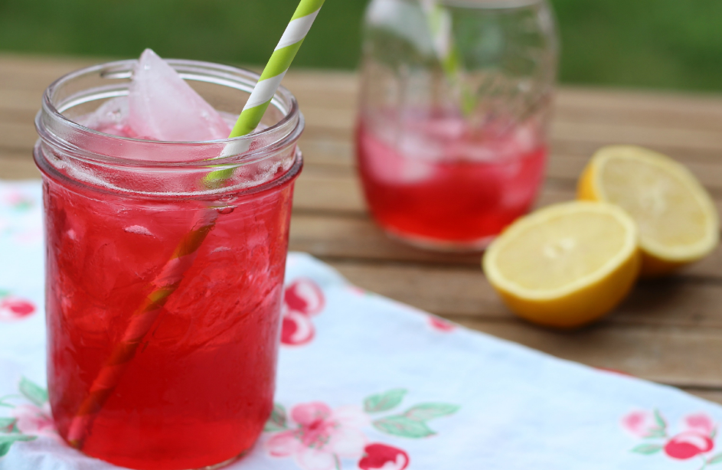

Taos Passion Fruit Tea Bag

8-12 oz hot water

Stevia to taste

Squeeze of lemon

Pour over ice

Salads.

Chicken Salad

Ingredients

100-150 grams of Fantastic Chicken, baked

1 TBSP. lemon juice 1/4 tsp.

Organic poultry seasoning (Such as Simply Organics)

1 TBSP. minced onion Salt and pepper to taste

Directions
Reheat chicken in a little water or chicken broth with all spices. Finely chop chicken. Serve with celery sticks or mix in diced celery and your choice of dressing or dipping sauce. Cucumbers would be good too! Or place on Lettuce! Makes 1 serving (1 protein, 1 vegetable)

Spinach Salad with Chicken and Strawberries
One good handful of baby Spinach Leaves 100 grams Fantastic Chicken diced or sliced I like it warm! 5-6 Sliced Strawberries Dressing of choice listed in this book! Makes 1 serving.

Mexican Salad
1 large handful Chopped Romaine lettuce 100 g Chicken or Beef Chopped cilantro to taste Salt and pepper to taste Salsa (recipe in book) or prepared if it contains no sugar or oil.

Chicken Salad + Apples

Ingredients

100- 150 grams Fantastic Chicken

1 apple diced

1 TBSP. lemon juice

1/8 tsp. cinnamon

Dash of salt

Plain Stevia sweetened to taste Wedge of lemon

Directions
Mix ingredients together, sprinkle with stevia and cinnamon. Chill for 20 minutes. Serve with a wedge of lemon and enjoy. Add a vegetable for a complete meal. Variations: Celery, cucumbers or place on bed of lettuce. Makes 1 serving (1 protein, 1 fruit).

Chinese Chicken Salad

Ingredients

100 grams basic Chicken

1 large handful of Shredded cabbage

1 TBSP. Braggs Apple Cider Vinegar

1 TBSP. chicken broth (organic or homemade)

1 TBSP. minced green onion

1 clove of garlic pressed

Fresh grated ginger or a dash of powdered ginger

Dash of ground “Chili"

Stevia to taste Salt and pepper to taste

Directions
Reheat the chicken in a saucepan with lemon juice, 1 TBSP. Chicken Broth, garlic and onion. Steam Cabbage, lightly until tender. Drain off excess liquid. Add chicken, ginger, salt and pepper and chill. Sprinkle with additional Bragg’s Aminos if desired. Makes 1 serving.

Dressing Sauces & Marinades.

Strawberry Vinaigrette

Ingredients

2-3 Strawberries

1 tsp. Bragg's Apple Cider Vinegar

1 TBSP. lemon juice Valencia Orange

Stevia to taste

Dash of salt

Directions
Mix Combine all ingredients in food processor. Puree until smooth. Slice remaining Strawberries and enjoy with meal. Variations: use as a marinade, sauce for chicken or salad dressing!

Citrus Vinaigrette

Ingredients

2 TBSP. Bragg's Apple Cider Vinegar

1 TBSP. Lemon juice

1 TBSP. Orange juice Orange Liquid Stevia to taste (5-10 drops)

1/4 tsp. minced onion

1 clove pressed garlic (optional) Dash of salt

Directions
Stir well and enjoy as a salad dressing or marinade.

Citrus Ginger Dressing/Marinade

Ingredients

1 TBSP. lemon juice

1 TBSP. orange juice

2 tsp. Bragg's Apple Cider Vinegar

Ginger fresh or ground to taste

Salt and fresh black pepper to taste

Orange Liquid Stevia to taste (5-10 drops)

Directions
Combine spices with liquid ingredients. Enjoy over salad or double the recipe for use as a marinade. Warm slightly to enhance the flavors when serving over meat!

Salsa
(May use store bought salsa fresh or bottled BUT NO sugar or oil)

Ingredients

1 cup fresh chopped tomato

1 TBSP. lemon juice

1 tsp. Bragg's Apple Cider Vinegar (optional 2 cloves garlic crushed and minced

2 TBSP. finely chopped onion

1/4 tsp. chili powder

1/4 tsp. fresh or dried oregano

Cayenne pepper to taste

Fresh chopped cilantro

Salt and pepper to taste

Directions
Puree ingredients in food processor for smooth salsa or chop ingredients by hand for chunkier salsa. Add spices and chill in the refrigerator for 10 minutes or more to allow flavors to blend. Makes l serving (1 vegetable).

The Barbeque Sauce

Ingredients

3 ounces tomato paste

1/4 cup Bragg's Apple Cider Vinegar

3 TBSP. lemon juice

1 TBSP. hot sauce

1 TBSP. minced onion

3 cloves garlic crushed and minced

1/4 tsp. chili powder

1/2 tsp. Worcestershire sauce

1/2 tsp. garlic powder

1/2 tsp. onion powder

Plain Liquid Stevia sweetened to taste

Salt and pepper to taste

Chicken broth (organic or homemade) as needed to achieve the desired consistency

Directions
In a small saucepan, combine all ingredients. Mix well and bring to a boil. Reduce heat and simmer for at least 5 minutes adding a little broth to achieve desired consistency and to make sure it doesn't bum. Use as a barbeque sauce for chicken or beef.

Italian Sauce

Ingredients

1 cup fresh diced tomato

1 TBSP. organic tomato paste

1/2 tsp. oregano

1/2 tsp. basil

1/2 clove fresh garlic

Salt and pepper to taste

1/2 cup homemade broth or organic (no oil or sugar)

Directions
In a sauce pan, simmer all ingredients until bubbly. You can use chunky or blend the ingredients before cooking for a smoother sauce.

Sweet Orange Dressing or Marinade

Ingredients

Juice of 3 orange juice segments

2 TBSP. lemon juice

1 tsp. Bragg's Apple Cider Vinegar (optional)

1/4 tsp. ginger powder

Pinch of turmeric

Pinch of orange zest

Stevia to taste

Directions
Dissolve spices and stevia in juice mixture. Heat the dressing slightly in a saucepan then chill until ready to use. You may double the recipe for a marinade. Serve with remaining orange slices.

Soups.

Cabbage Soup
(Add a Protein!) make big pot for the week store in refrigerator

Ingredients

1 Large handful of shredded cabbage

2 cups water

2 TBSP. Bragg’s Aminos Seasoning

2 cloves garlic crushed and minced

1 TBSP. chopped onion

1/4 tsp. thyme (rub between fingers when adding)

1/4 tsp. rosemary (rub between fingers when adding Fiery Chili) Fusion Grinder (optional)

Salt and pepper to taste

Directions
Heat broth and seasonings with cabbage in a sauce pan. Reduce heat and simmer for a minimum of 10-30 minutes depending on how tender you like your cabbage. Add additional water to broth as needed. Variations: Add your protein! Add some lemon to give it a little sour kick! One of my favorites is to cook Tilapia fish in with the cabbage also adding the Lemon! Makes 1 serving (1 vegetable) (1 protein if added)

Vegetable Beef Soup

Ingredients

100 grams Super lean ground beef (93% lean)

Celery, cabbage, or tomato diced 2 cups water or vegetable

1 TBSP. onion chopped

1 clove garlic pressed l bay leaf

1/8 tsp. dried basil

1/8 tsp. fresh/dried oregano (rub between fingers as adding) Pinch of thyme (rub between fingers when adding)

Salt and pepper to taste.

Directions
Combine onion, garlic and spices with beef broth. Add celery and ground beef. Simmer for 20-30 minutes. Add tomatoes and simmer for an additional 5 minutes. Makes 1 serving (1 protein, 1 vegetable).

Homemade Vegetable Broth

Ingredients

10 or more cups of water

1/2 large onion chopped

6- 10 stalks celery

10 cloves of garlic chopped

2 bay leaves 1 tsp. paprika

1 tsp. garlic powder

1 tsp. basil

1 tsp. of thyme

Salt and pepper to taste

Directions
Bring water to a boil in a large soup pot or crock-pot. Add vegetables and spices. Cook slowly for 2-4 hours. Strain out vegetables and cool. Use as a base for soups. Makes multiple servings.

Savory Chicken Soup

Ingredients

100 grams chicken breast cubed

1-2 cups chopped celery or tomatoes

2 cups water or homemade broth

1 TBSP. minced onion

2 cloves garlic pressed

1 bay leaf

1/2 tsp. organic poultry spice blend (rub between fingers when adding)

Cayenne pepper to taste

Salt and black pepper to taste

Directions
Bring chicken stock to a boil. Add onion, garlic and spices. Add chicken and vegetables and simmer on low heat for 20 minutes or more until chicken and cabbage is tender and fully cooked. Serve hot. Makes 1 serving (1 protein, 1 vegetable).

Homemade Chicken Broth

Ingredients

3 large boneless skinless chicken breasts

10 or more cups of water

1/2 large onion chopped

4 stalks of celery chopped

5 cloves of garlic sliced

1 bay leaf 2 tsp.

Salt & pepper to taste

Directions
In a large soup pot or crockpot combine chicken and 10 or more cups of water. Water should slightly cover the chicken. Add celery and spices. Bring to a boil, then reduce heat to a simmer. Allow to slow cook for 2 hours. Remove vegetables and chicken from broth. Refrigerate stock and then when solid skim off the chicken fat. Put through a fine strainer for a clear broth. Save the chicken use for chicken salad or add to soups. Makes multiple servings.

Chili

Ingredients

100 grams Extra lean ground beef (less than 7% fat)

1 cup chopped tomatoes

1 TBSP. tomato paste

1/4 cup water

1 TBSP. minced onion

2 cloves garlic crushed and minced

Pinch of garlic powder

Pinch of onion powder

Pinch of cumin

1/4 tsp. chili powder

Pinch of oregano (rub between fingers when adding)

Cayenne pepper to taste (optional)

Salt and pepper to taste

Directions
Brown ground beef in a small frying pan, add onions and garlic. Mix together tomato paste, water and broth.
Add to Beef and stir in tomatoes. Add spices and simmer slowly until liquid is slightly thickened.
The longer it cooks the more tender and flavorful. Add a little broth as needed to prevent burning.
Serve with chopped green onion or tomato as a garnish and salt and pepper to taste.
Makes 1 serving (1 protein, 1 vegetable).

French Onion Soup

Ingredients

2 cups Vegetable Broth

1 TBSP. Bragg's Liquid Aminos (optional)

1 tsp. lemon juice

1/4 to 1/2 of an onion in thin strips

1 clove garlic crushed and minced

Salt and black pepper to taste

Plain Liquid Stevia sweetened to taste (a few drops)

Directions
Brown the onions in a little water and lemon juice. Add broth and spices and simmer for 20-30 minutes. Top with Melba toast croutons. Adding Beef or eating with Beef is Delicious! Makes 1 serving (1 vegetable) (1 Protein if added).

Tomato Basil Soup

Ingredients

1 cups Vegetable or Chicken Broth

1 12oz can Chopped organic Tomatoes

1 t garlic chopped

2 T fresh or dry basil

Salt & pepper

Directions
Brown garlic in a little bit of the broth. Add the tomatoes basil, salt and pepper bring to a high simmer. Serve chunky or you can puree the tomatoes for a creamer soup.

Chicken Entrees.

Fantastic Basic Chicken
This can be Baked or Grilled for a variety!

Ingredients

1 package fresh boneless skinless chicken tenders

Lemon juice Salt and pepper to taste

Directions

Weigh out each of the Chicken Tenders to 100 grams. BAKED: place in baking dish so that you can distinguish each 100 grams unit. Pour about 1/2 cup lemon juice over chicken in a 9x13 pan.

Sprinkle with salt and pepper to taste. Bake at 350 for 30-35 minutes covered in foil. Bake just until it's not pink. Maybe start checking after 25 min. This is the MOST tender, moist chicken ever. I don't freeze it; I keep it fresh in the fridge. GRILLED: Place in George Foreman Grill, squeeze with lemon, sprinkle spices and cook until juice runs clear and chicken is still tender!

About 2-3 minutes. Cool slightly and wrap in foil and store in freezer in a Freezer Bag.

To thaw and reheat chicken, place chicken still in foil in a small saucepan with just enough water to cover the bottom of pan.

Cover with lid. Cook on high until water begins to bubble and then tum burner off. Let sit for about 10 minutes! Use this time to prepare your veggies and fruit!

Mexican Style Chicken

Ingredients

100 grams Fantastic Basic Chicken

1 TBSP. Salsa

Sprinkle with Cumin to taste

Sprinkle with Chili Powder

1 tsp. chopped Cilantro leaves

Directions
Remove the chicken from foil and reheat with above ingredients. Then slice or shred the chicken as desired. Delicious as a lettuce wrap with 1 TBSP. of approved Salsa! Makes 1 serving (1 protein).

Italian Chicken and Cabbage

Ingredients

100 grams cubed boneless skinless chicken breast

1 cup Finely Shredded Cabbage

2 TBSP. Italian Tomato Sauce (no sugar or oil)

Directions
While chicken is reheating, steam or par-boil cabbage just until limp. Warm the Italian tomato sauce. Put it all together like spaghetti and Bon Appetite! See recipe Makes 1 serving (I protein, 1 vegetable).

Chicken Asparagus Bake

Ingredients

100 grams cubed boneless skinless chicken breast

Asparagus chopped

1/2 cup water or homemade broth

1 TBSP. lemon juice

1 Melba toast crushed (optional)

1 clove garlic crushed and minced

2 TBSP. onion chopped

Dash of paprika

Salt and pepper to taste

Directions
Place chicken, asparagus, liquids, and spices and pour into small baking dish. Bake at 375 degrees for 30 minutes or until bubbly and hot. Makes 1 serving (1 protein, 1 vegetable).

Barbeque Chicken

Ingredients

100 grams chicken One serving Barbeque Sauce (see recipe)

Directions
Prepare BBQ sauce. Cook the chicken with the sauce in small saucepan with the juices or bake in oven at 375 degrees for approximately 20-30 minutes or until cooked thoroughly. Makes 1 serving (1 protein).

Rosemary Chicken

Ingredients

100 grams thick sliced or whole chicken breast

1 serving Melba toast crumbs

1/4 cup water or homemade broth

3 TBSP. lemon juice

1/2 tsp. fresh rosemary

1/2 tsp. onion powder

1/4 tsp. garlic powder

Salt and pepper to taste

Squeeze of lemon

Directions
Marinate chicken in lemon juice, salt and rosemary.
Mix spices and Melba toast crumbs together in shallow bowl or plate.
Coat the chicken pieces with spice mixture and place in baking dish. Add broth and top chicken with additional spice mixture. Bake chicken at 350 for approximately 20 minutes or until cooked.
Sprinkle chicken with lemon juice, salt, and pepper to taste.
Garnish with fresh chopped parsley and lemon slices. Makes 1 serving (1 protein, 1 vegetable).

Chicken Tacos

Ingredients

100 grams finely chopped Fantastic Basic Chicken or extra lean ground chicken breast

1/4 cup water or homemade broth

1 TBSP. chopped onion

1 clove garlic crushed and minced

1/8 tsp. oregano

Cayenne pepper to taste

Pinch of Cumin

Fresh cilantro chopped

2-4 large lettuce leaves

Directions
In a small frying pan cook chicken in broth. Add onion, garlic, and spices. Rub pan with lemon juice or a little water. Serve chicken taco style in butter lettuce or romaine leaves or top with salsa. Makes 1 serving (1 protein, 1 vegetable).

Buffalo Style Chicken Fingers

Ingredients

100 grams of chicken cut into long thin strips

Melba toast crushed (optional)

2 TBSP. hot sauce (Frank's Red Hot Sauce works the best for this recipe)

4 TBSP. lemon juice

Salt and black pepper to taste

Directions
Marinate chicken strips in lemon juice and salt. Coat chicken strips with Melba crumbs. Fry in frying pan until lightly browned and cooked thoroughly. Toss with hot sauce and black pepper to taste. Serve as finger food or as an entree. Serve with raw celery sticks or desired vegetable. Makes 1 serving (1 protein).

Baked Apple Chicken

Ingredients

100 grams cubed chicken

1/2 finely chopped apple

2 TBSP. lemon juice

1 TBSP. Bragg's Apple Cider Vinegar

1/8 tsp. cinnamon

Salt and pepper to taste

Plain Liquid Stevia sweetened to taste Dash of cayenne

Directions
Lightly brown the chicken in lemon juice. Add chopped apple and evenly coat with a mixture of Bragg's Apple Cider Vinegar, lemon juice, stevia, cinnamon, cayenne and pinch of salt. Put in small baking dish and add additional vinegar and lemon juice. Serve with the rest of the apple in thin slices on the side. Makes 1 serving (1 protein, 1 fruit).

Orange Glazed Chicken Breast

Ingredients

100 grams chicken

One serving spicy orange sauce or sweet orange marinade

Directions
Prepare orange sauce. Cook the chicken with the sauce in small saucepan with the juices or bake in oven at 375 degrees for approximately 20-30 minutes or until cooked thoroughly. In a small saucepan reduce liquid until desired consistency. Deglaze the pan periodically by adding water and pour remaining mixture over chicken breast. Makes 1 serving (1 protein).

Breakfast Sausage

Ingredients

1 package ground chicken breast or lean ground beef

2 tsp. Sage

1/2 tsp. thyme

1 tsp. ground pepper

1-1/2 sea salt

1/4 tsp. ground Nutmeg (I use what I had in the cupboard)

1/4 tsp. Paprika (bump that up if you like)

Dash of cayenne pepper or red pepper flakes (optional)

Directions

Put all spice ingredients together and mixed them up good, then add the mix, slowly, hand mixed, to the chicken (wear gloves prevents sticking to fingers) to get is blended well. 1 package of ground makes 3 blobs, a little more than the 100 grams each.

Fry them in a Teflon pan, no water, no oil, just the patties, salt both sides and try to under cook them just a bit so that when you heat each one up they are not dry. Pack in foil for quick reheating and traveling. Freezes well.

Beef Entrees.

Fajitas/ Carne Asada

Ingredients

100 grams sliced beef or chicken

Tomatoes Sliced onion cut into thin strips

1 clove garlic chopped

3 TBSP. lemon juice

2 TBSP. orange juice (optional)

1/8 tsp. oregano

1/8 tsp. cumin

1/8 tsp. chili powder or to taste

Pinch of cayenne pepper

Directions
Marinate meat in lemon juice and spices. Barbeque for Carne Asada or cook strips in a frying pan (Foreman Grill works great!) with garlic and onion. Add chopped tomatoes during the last 5 minutes of cooking and enjoy with lettuce leaf mock tortillas and salsa. Makes 1 serving (1 protein, 1 vegetable).

Cabbage Rolls

Ingredients

100 grams lean ground beef or shredded chicken for each serving

1 cup broth

1 TBSP. chopped onion

1 clove garlic crushed and minced

Dash of garlic powder

Dash of onion powder

Directions
Preheat oven to 375. Lightly blanch large cabbage leaves in boiling water and set aside. In a small frying pan combine meat, onion, garlic and spices and cook until brown.
Spoon meat mixture into cabbage leaves, tuck in ends and roll up (burrito style). Put cabbage rolls in a baking dish and add broth to the bottom of the pan.
Brush lightly with broth and bake in oven for 20-30 minutes. Spoon sauce over cabbage rolls periodically to keep moist.
Make multiple servings at one time for best results. It is also great to freeze rolls in foil packets for future use. No need to thaw prior to reheating.
Makes 1 serving (1 protein, 1 vegetable).

Beef Cabbage Stir Fry

Ingredients

2 cups of shredded cabbage

2 TBSP. Bragg’s Aminos Seasoning

2 cloves garlic crushed and minced

1 TBSP. chopped onion

Salt and pepper to taste

Directions
In a frying pan add all ingredients and stir around over medium heat. Reduce heat and simmer for an about 6 minutes depending on how tender you like your cabbage. Variations: Add Stevia to add sweetness like a teriyaki. This can be done with any protein and vegetable of choice. Makes 1 serving (1 protein 1 vegetable).

Beef with Italian Sauce Over Cabbage

Ingredients

100 grams lean ground beef

1 cup fresh diced tomatoes (COUNTS AS A FRUIT IF USED WITH CABBAGE!)

1 TBSP. organic tomato paste

1/2 tsp. oregano

1/2 tsp. basil

1/2 clove fresh garlic

Salt and pepper to taste

Directions
In a sauce pan, brown ground beef; then add all ingredients and simmer for about 10 minutes or until your desired consistency. You can use chunky or blend the ingredients before cooking for a smoother sauce. Serve over steamed cabbage. Makes 1 serving (1 protein 1 vegetable 1 fruit).

Seafood Entrees.

Tilapia with Herbs

Ingredients

100 grams of Tilapia fish

2 TBSP. lemon juice

1 clove garlic crushed or minced

1 TBSP. chopped onion

Directions
Sauté fish in lemon juice with a little water then add onion, garlic. Or bake in baking dish with a little water at 350 for 20 minutes until fish is tender and delicious. Variations: Use oregano, thyme, or tarragon. Also great to assemble and freeze the foil packets. No need to thaw prior to cooking. Makes 1 serving (1 protein).

Zesty Lime Tilapia

Ingredients

100 grams of Tilapia fish

2 packets True Lime® (crystalized lime)

Sprinkle with a red pepper seasoning

Sprinkle with garlic powder

1 TBSP. chopped onion

Salt and black pepper to taste

Directions
Wrap fish in aluminum foil sprinkle on 2 packets True Lime®, onion, garlic powder, Red Pepper seasoning and Salt and black pepper as desired. Wrap securely and place on grill or bake in baking dish with a little water at 350 for 20 minutes until fish is tender and delicious! Also great to assemble and freeze the foil packets. No need to thaw prior to cooking. Makes 1 serving (1 protein).

Poached Halibut

Ingredients

100 grams per serving halibut

1/2 cup vegetable broth or water

1 TBSP. lemon juice

1 TBSP. chopped onion

1 clove garlic crushed and minced

1/2 tsp. fresh ginger

Pinch of grated orange zest

Salt and pepper to taste

Stevia to taste

Directions
Heat up the vegetable broth in small frying pan. Add lemon juice, onion, garlic and spices. Poach halibut filet for 5-10 minutes until fish is tender and cooked thoroughly. May also be wrapped in foil and placed on the barbeque. Serve topped with remaining juices as a sauce. Makes one serving (1 protein).

Citrus Glazed Orange Roughy BBQ Wrap

Ingredients

100 grams Orange Roughy Fillet

1 large Orange

3 TBSP. orange juice squeezed from fresh orange

1 TBSP. lemon juice

1 TBSP. chopped green onion

Dash of garlic powder

Dash of onion powder

Salt and pepper to taste Stevia to taste

Directions
Place fish on aluminum foil. Baste with juice and spices. Thinly slice orange yielding 3 slices. Top with orange or lemon slices. Wrap up and place on barbeque grill or in the stove at 350 degrees for 10-15 minutes until well cooked and fork tender. Serve with juices and remaining whole orange sections. Sprinkle with parsley. Makes 1 serving (1 protein, 1 fruit).

Vegetables.

Chopped Cabbage

Ingredients

1/2 - 1 head of cabbage finely chopped into rice sized pieces.

Varieties

Mexican rice style

1 cup chicken or vegetable broth

2 TBSP. minced onion

1 clove of garlic crushed and minced

1/4 tsp. oregano

1/4 tsp. cayenne pepper or to taste

Dash of cumin to taste

Fresh chopped cilantro

Salt and pepper to taste

Italian style

1 cup chicken or vegetable broth

1/4 tsp. fresh or dried oregano

1/4 tsp. dried basil or 5 leaves fresh basil rolled and sliced

2 TBSP. minced onion

1 clove garlic crushed and minced

Salt and pepper to taste

Directions
Combine all ingredients into a pan and heat on Medium heat until the cabbage is to your preferred texture. 3-6 minutes approx.

Asparagus With Herb And Lemon Sauce

Ingredients

One large handful Asparagus Juice of

1/2 lemon with rind

1 tsp. Bragg's Liquid Aminos

1 clove garlic crushed and minced

1/4 teaspoon rosemary

Dash of garlic powder

Dash of onion powder

Salt and pepper to taste

Cayenne pepper to taste

Directions
Marinate asparagus in lemon, garlic, salt, cayenne pepper and Bragg's Liquid Aminos for 20 minutes in fridge for added zest or cook immediately.
Place asparagus in a skillet and gently toss pan while the asparagus spears are cooked to desired level of doneness. In a small saucepan place remaining lemon marinade along with lemon rind, 1/2 cup water, spices and cook until pulp starts to come out. You may add a little stevia if you wish for added sweetness.
Cook until liquid is reduces by half Remove the lemon rind and pour over grilled asparagus. Garnish with lemon wedges and salt and pepper to taste.
Makes 1 serving (1 vegetable).

Desserts.

Sorbets and Fruit Smoothies
Using the many delicious flavors of Stevia that we have available you can make some amazing treats with a few simple ingredients! Sonic Drive-In crushed ice is perfect for this. Most Sonic stores sell their ice by the bag. Freezing fresh Strawberries in portion sized storage bags makes this quick and easy.

General items you will need

Ice

Cold Water

Blender

Frozen Strawberries

Fresh Fruit

Flavored Stevia

Directions
Blend together and enjoy. It is like an ice cream!!! Add more liquid and it's a smoothie. Be creative! Strawberry 6 ounces frozen fresh strawberries 3 ounces of Herbal Fruit Tea or water Orange or Strawberry Liquid Stevia to taste Orange 1/2 Fresh Orange 10 drops Orange Liquid Stevia 1 TBSP. skim milk 1 cup Ice and Water.

Fruit Sorbet

Ingredients

Several cups of Frozen Strawberries, papaya, mango, mixed berries, raspberries, blueberries etc.

1/2 cup water or coconut milk

1/4 cup lime/lemon juice

Mint sprigs

Sweeten with Vanilla stevia or any type of stevia

2 teaspoons vanilla extract (opt)

Directions
Pulse two or three times then process until smooth, stopping to scrape down the sides and stir as necessary. Transfer the sorbet to a large serving bowl. Serve immediately or freeze until ready to use.
Make Ahead Tip: The sorbet will keep in the freezer, without freezing solid, for up to 3 hours.

Chocolate Sorbet

Ingredients

1 T Cacao (unsweetened cocoa powder)

10 drops Vanilla Liquid Stevia

1 TBSP. skim milk

1 cup Ice and Water

Chocolate Mocha Sorbet

Ingredients

1 T Cacao powder

1 tsp. Pero® Instant Natural Beverage

10 drops Vanilla Liquid Stevia

1 TBSP. skim milk

1 cup Ice and Water

Ideas & Quick Tips (In A Hurry) - Step 2.
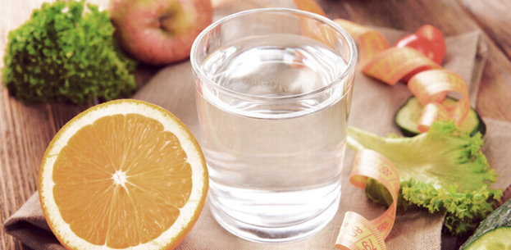

Prep a week in of food, portion out and pack in containers freeze and refrigerate (1-2 hrs)

Basic chicken recipe (crock pot or bake a casserole pan of chicken breast)

Pot of cabbage soup (no meat)

Pot of chili (chicken or beef)

Fry up Ground beef or chicken breast in non-stick pan or in chicken broth for salads or soups

Lean beef or chicken patties (seasoned or not)

Bag up cooked shrimp frozen or fresh (12 to a bag) season salt and pepper with lemon refreeze

Bag up dill pickles, celery, cucumbers, asparagus

Slice up apples, lemons

Mince garlic, onions, celery

In a pinch

Used canned tomatoes (no sugar, no oil) to pour over chicken, beef, fish or shrimp

Cacao powder with stevia for hot chocolate treat

Keep shrimp frozen and put in lunch bag to keep other items cold will thaw by lunch

Use organic chicken broth in box to make quick soups and to use for frying

Canned chicken breast (in water) mix with salsa and 1 T of non-fat unsweetened greek Yogurt

Prepare ahead for lunches making a variety of different salads… 3 cups (lettuce, cabbage or spinach) in a 1 gallon zip lock bag, pack smaller bag with protein and another with the dressing. When read to eat just shake and serve. This method coats the salad and is very satisfying.

Make a baggie of your favorite teas and stevia to carry with you

Have a shaker cup and protein powder with you at all times. just add ice and water

Carry a water bottle with you make sure you track how many bottles are needed for your quota

Bag up and portion out cinnamon apples. When apples are beginning to get mushy, add cinnamon and stevia eat fresh or bake for a tasty dessert.

Recipes - Step 4 (Maintenance).

Step 4 Maintenance

6 Weeks Minimum Of Maintenance Is Required Before

Beginning A Subsequent Dr’s Choice Weight Loss Program.

Your weight needs to stabilize to create a permanent change in your body's ability to maintain the loss and your new weight. Remember the maintenance plan is simple and fun! You have completed Step 3, and are now ready to begin Step 4, maintenance. You will begin increasing your variety and quantities of food!

First Three Weeks
Increase your food options and volumes. Avoid all sugars and starches.

Second Three Weeks
Gradually add sugars and starches into your diet.

Keep up with as much water and tea intake as possible.

Keep on Journaling!! You will have great insights into your body's use of calories.
A few suggestions of what great things you can eat now. You are able to venture out on your own as long as you follow the above guidelines.

Breakfast Ideas
We love to make all kinds of omelets. From lean meats and cheese to wonderful vegetable omelets! Protein shakes are a great way to add vegetables early in the day. Use kale, spinach, flax seeds, blueberries etc…add coconut water, nut butters etc..

Great Snack Ideas!
Keep your fresh fruit and vegetables handy. Cheese sticks and cut vegetables are a great snack. Cheese slices with apples are delicious. Raw nuts are good to have around. Small amounts of organic semi-sweet or dark chocolate chips mixed with whole raw almonds are a fabulous treat!

Lunch & Dinner Ideas
Stir-fry's are a delicious, quick and easy way to have a very nutritious filling meal. Enjoy a large salad! Just remove the croutons and eat up!! The only thing you have to watch out for is dressings that have a lot of sugar, and any other hidden starches. Make your own with olive oil and vinegars.

Suggested Recipes - Step 4.

The Omelet For Two

Ingredients

4 eggs 2 tablespoons milk

2 teaspoon salt

1/8 teaspoon freshly ground black pepper

Directions

Melt 1 tablespoon butter in a small skillet over medium heat. Coat the skillet with the butter. When the butter is bubbly add 1/2 the egg mixture and cook the egg. Gently lift the edges allowing the runny egg to flow under cooked portion until the omelet begin to become firm yet not burned.

When it seems firm enough, carefully flip the omelet over. It's easy if you let it slid off to one side by tilting the pan so you can get under it good with the spatula. Cook the other side just long enough to set the bottom and it is not raw.

Remove from pan onto a serving plate. Repeat for the Second Omelet. Fill with filling of choice.

Denver Omelet

Ingredients

2 tablespoons butter

1/2 small onion, sliced

1 green bell pepper, chopped

1/2 cup ham Julienned or Chopped

1/2 cup shredded cheese (we like cheddar)

Directions

Melt one tablespoon butter in a medium skillet over medium heat. Place ham, onion and bell pepper inside of the skillet. Cook for 4 to 5 minutes stirring occasionally until vegetables are just tender. Sprinkle with salt. • Shred the cheese into a small bowl and set it aside. • Sprinkle the cheese over the omelet and spoon the ham and vegetable mixture into the center of the omelet.

Using a spatula gently fold one edge of the omelet over vegetables. Place a lid or warm pan over the omelet until the cheese melts to your desired consistency. Repeat for the second omelet!! Delicious!! Great with Salsa also!

Ham and Cheese

Ingredients

2 tablespoons butter

1/2 cup ham Julienned or Chopped

1/2 cup shredded cheddar cheese

Directions
Same as above.

The Veggie Omelet

Ingredients

2 tablespoons butter

1/2 small onion, sliced

1 green bell pepper, chopped

1/2 zucchini sliced thinly

1/2 cup chopped tomatoes

1/2 cup shredded Sharp Cheddar Cheese

Directions
Same as above only leaving tomatoes out. Zucchini takes a little longer to cook, so I place it in the pan for a minute or two before the other veggies. Right before I take the veggies out of the pan I put in the tomatoes! Assemble the omelet the same and allow the cheese to melt! TASTY.

Frittata's

Frittata With Herbed Ricotta Cheese

Ingredients

TBSP. olive oil 4 large egg(s), beaten

2/3 cup ricotta cheese

1/3 cup basil, fresh, coarsely chopped

1/3 cup chives, fresh, coarsely chopped

1/3 cup parsley, fresh, coarsely chopped

3 oz. Canadian-style bacon, finely julienned

1/8 tsp. black pepper, freshly ground, or to taste

Directions
Heat oil in a 9-inch nonstick skillet over medium heat. Add remaining ingredients to hot skillet; stir occasionally with a wooden spoon until eggs are set and only the surface is runny, about 3 minutes. Flip frittata out onto a plate so browned side is face-up. Slide frittata back into skillet and cook until second side is slightly browned, about 3 minutes more. (Note: If you do not want to flip the frittata, you can finish cooking it in the oven using an ovenproof skillet. Broil until slightly browned, about 2 to 3 minutes.) Slide frittata out of pan and cut into 8 wedges; serve immediately. Yields 2 wedges per serving.

Spinach & Cheddar Frittata

Ingredients

4 large eggs 2 large egg whites

1 cup spinach, fresh, baby leaves, chopped

2 TBSP. scallions, finely chopped

1/4 tsp. table salt

1/4 tsp. black pepper

1 serving cooking spray (5 one-second sprays per serving)

1/2 cup cheddar cheese

Directions

Preheat oven to 400 F. Beat together eggs and egg whites in a large bowl; stir in spinach, scallion, salt and pepper.

Coat a 12-inch ovenproof nonstick skillet with cooking spray; heat skillet over medium heat. Pour egg mixture into skillet and cook until partially set, about 5 minutes. 3. Sprinkle cheese over eggs. Bake in oven until cheese softens and eggs firm up, about 5 minutes. Remove from oven and let stand 1 minute before cutting into 8 wedges. Yields 2 pieces per serving

Veggie Frittata

Ingredients

1/2 small sweet red peppers (thinly sliced)

1 medium zucchini, grated

1 medium tomato, chopped

2 large eggs lightly beaten

3/4 cup fat-free skim milk

1/4 tsp. dried oregano

1/4 tsp. dried thyme

1 TBSP. parsley, chopped

Directions
Coat a small ovenproof skillet with cooking spray and heat. Add red pepper, zucchini and tomato and cook until tender. Combine eggs, milk, herbs and parsley in a small bowl. Stir into vegetables, reduce heat and cook until eggs are firm. Place skillet under a preheated broiler and cook until top is browned. Serve immediately.

Broccoli & Beef Stir-Fry

Ingredients

2 TBSP. Olive Oil 1 lb. beef cut into strips or 1 lb. extra lean ground beef

1/4 cup onions chopped

2 cloves fresh garlic minced

2 heads of broccoli crowns cut into pieces

2 cups shredded Cabbage (optional)

Bragg's Aminos Liquid seasonings or soy sauce

Directions
Slice beef and marinate in 1/2 cup soy sauce. Set aside. Heat oil in wok or large skillet. Sautee onion and garlic in oil until onions clear. Do not brown garlic. Add Beef strips or ground beef. Cook until beef is brown on all sides then add broccoli and cabbage. Stir and cook until the broccoli is tender. Serve immediately. Add more soy sauce if desired 2-3 servings.

Stir-Fry

Asparagus & Shrimp

Ingredients

Stir-Fry 2 cups water 1 bunch asparagus - ends trimmed, cut in 1" pieces

2 TBSP. Sesame oil

1 clove garlic - minced

1 tsp. chopped fresh ginger

1 lb. raw jumbo shrimp - peeled, deveined, tails removed

2 TBSP. soy sauce

Sweeten with Stevia to taste

Salt and white pepper to taste

Directions
Bring water to a boil; add asparagus and boil for 3 minutes; drain and set aside. In a wok, sauté ginger and garlic in oil for 1 minute. Stir in shrimp and stir-fry for 3 minutes. Stir in asparagus, soy sauce, stevia, salt, and pepper and stir-fry for 2 minutes, or until shrimp is pink. Serve immediately. 2 Servings.

Cashew Chicken & Vegetable Stir-Fry

Ingredients

2 TBSP. Olive Oil

1 lb. Chicken Breast cut into strips

1/2 onion sliced

2 cloves fresh garlic minced

Broccoli crowns cut into pieces

1 bunch asparagus - ends trimmed, cut in 1" pieces

1 small sweet red pepper sliced

1 medium zucchini sliced

2 cups shredded Cabbage

1/2 cup cashew pieces

Directions
Slice Chicken and marinate in 1/2 cup soy sauce. Set aside. Heat oil in ok or large skillet. Sautee onion and garlic in oil until onions clear. Do not brown garlic. Add Chicken strips and cook until chicken is done. Add remaining ingredients. Stir and cook until the veggies are tender. Serve immediately. Add more soy sauce if desired 2-3 servings

Chicken & Ginger Stir-Fry

Ingredients

2 TBSP. Olive Oil

1 lb. Chicken Breast cut into strips

1/2 onion sliced

2 cloves fresh garlic peeled and minced

1 tsp. chopped fresh ginger Optional vegetables: 1 bunch asparagus - ends trimmed, cut in 1" pieces 1/2 small sweet red peppers sliced 1/2 cup celery sliced 1 handful snow peas, washed and ends trimmed 1 medium zucchini washed and sliced 2 cups shredded Cabbage 1/2 cup cashew pieces

Directions
Slice Chicken and marinate in 1/2 cup soy sauce. Set aside. Heat oil in wok or large skillet. Sautee onion and garlic in oil until onions clear. Do not brown garlic. Add Chicken strips and cook until chicken is done. Add remaining ingredients. Stir and cook until the veggies are tender. Serve immediately. Add more soy sauce if desired 2-3 servings.

Teriyaki Stir-Fry sauce

Can be used on any Stir-Fry recipe above.

1/2 cup Braggs Aminos or soy sauce Clear Stevia to taste (about 16 drops of liquid) The sweetness makes it a teriyaki. 1/2 tsp. fresh grated ginger is also a nice addition. About 2 servings.

Reshape Shopping List (Detox & Maintenance Ideas).

Frozen

Chicken Breast Tenderloins

Tilapia, cod, halibut, sole, salmon

Prawns and shrimp cooked or uncooked

Mixed strawberries, mixed berries or fruit

Fresh

Lean beef 93%, ground chicken or turkey BREAST

Lean meats and protein: ham, turkey, pork

Low-fat or non-fat cottage cheese

Fage Total 0% Non-Fat Greek Yogurt

Kirkland Greek Yogurt Plain Non-fat

Greek yogurt dips for vegetables or dressings ex: Jalapeno & dill

Salsa & Hummus

Low-fat cheeses; look for part-skim i.e. Jarlesburg, Mozzarella etc.

Eggs

Spinach, Lettuce, mixed organic greens, kale

Asparagus, Broccoli, Celery, Peppers, Cucumbers, vegies for snacking

Tomatoes

Lemons, limes

Grapefruit, Oranges, Apples

Miscellaneous Costco

Canned Chicken Breast in Water

Canned Beef

Organic Chicken Broth

Canned organic tomatoes

Pickled asparagus, pickles, sauerkraut

Green tea

Canned beans

Franks hot sauce

Nuts and seeds (raw or dried unsalted)

Non-Costco Misc

Braggs – Liquid Aminos, Braggs Apple cider vinegar (health section of Fred Meyer)

Herbal or Green Teas

Yerba Mate (unsmoked) Eco Teas mix with mint tea

Original DECAF Good Earth tea or Orange Spice Tea – Good Earth

Detox Tea– Yogi or Every Day Detox-Traditional Medicinal

Smooth Move (caffeine free) – Traditional Medicinal (only take it for one day per week if needed)

Passion tea – Tazo (with Stevia and lemon)

Stevia, Truvia

Coconut oil

Olive Oil (good quality & price Trader Joes)

Grocery List Fat Burn Portion.

Meats
Beef | Extra Lean Ground Beef
Chicken | Chicken Breast Skinless  Chicken Breast Tenders
Seafood | Lobster  Crab  Shrimp  Tilapia  Orange Roughy Filet  Mahi Mahi  Cod

Packaged
Plain Liquid Stevia  Flavored stevia (Whole Foods or PCC)  Vanilla Liquid Stevia  Valencia Orange Stevia  Stevia Delight | Lemon juice  Lime juice  Melba Toast  Wasa Crackers

Canned Broth
Low Sodium/Non Fat  Vegetable broth | Chicken Broth

Produce
Fruit | Grapefruit  Apples  Lemon  Lime  Oranges  Strawberries
Frozen Fruit | Frozen Strawberries
Vegetables | Spinach  Chicory  Chard  Beet Greens  Lettuce  Celery  Tomatoes  Radishes  Onions  Cucumbers  Asparagus  Cabbage

Seasonings/Spice
Bay leaf  Cayenne pepper  Chili powder  Cilantro  Cinnamon  Dried basil  Dried oregano  Fresh ginger  Garlic powder  Ginger powder  Mexican oregano | Onion powder  Orange zest  Organic Poultry Spice  Organic Poultry Seasoning  Pepper  Red pepper seasoning  Rosemary  Salt  Thyme  Turmeric

Beverages
Herbal fruit tea  Pero Instant Natural Beverage  Green Tea | Good Earth Sweet & Spicy  Smooth move

Condiments
Bragg's Liquid Aminos  Frank's Red Hot Sauce | Bragg's Apple Cider Vinegar  Organic tomato paste

Transformation Weight Mission.

Doctors Choice Drop Program $75-125

Each option includes: Private Coaching, Program Guide

Additional Supplements

Option 1
(Detox & Energy) $182.20

ageLOC R2

Probio

ageLOC TR90 Protein Boost Shake

Option 2
(Detox, Energy, Stress) $205.60

ageLOC R2

Probio

ageLOC TR90 Protein Boost Shake

Cortitrol

What is difference between Preferred Customer, Retail Customer and a Distributor?
The above prices are a special offering to our workshop attendees. These prices are available with a Preferred Customer Account. To get the best pricing we offer it at our cost which is 5% below wholesale pricing and includes a rewards program option. If your coach does not have to stock and deliver the product we can offer a considerable savings to you! We set you up with a monthly Rewards Program (ADR) and teach you to manage your own account, this also gives you a performance guarantee if you have access to the Antioxidant Scanner and wish to monitor your progress.
There are several advantages to this type of account, an offering of 20-30% product credit for each order, discounted package options, free product gifts and reduced shipping. You can change orders, place on hold or cancel this at any time. If you prefer a Retail Customer account, we can obtain the supplements for you at full retail cost. With any account, you choose at any time you wish to financially benefit from your referrals we can always switch you over to a Distributor Account.

