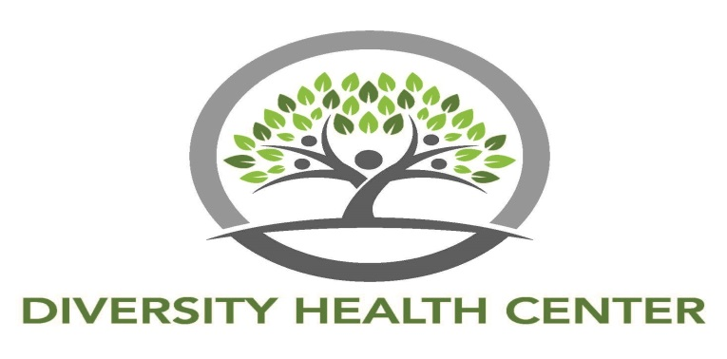

JOB DESCRIPTION

POSITION TITLE: Dentist
FLSA CLASSIFICATION: Exempt
EEO -1 CLASS: Professionals
DEPARTMENT: Dental
REPORTS TO: CEO/Medical Director
SUPERVISION OF: Dental Hygienist and Dental Assistant

POSITION SUMMARY To provide superior quality, competitive value and outstanding service by providing the highest standard of quality dental care to Diversity Health Center patients through the primary care medical home model. Under the supervision of the CEO and in collaboration with the Medical Director and administrative team, provides extraordinary patient care through DHC Dental Clinic. Will provide dental services in a clinical setting and mobile dental setting.

GENERAL EDUCATION REQUIREMENTS

Doctor of Dental Medicine degree (D.M.D. or D.D.S.) from an ADA-accredited institution.

ADDITIONAL QUALIFICATIONS

- Clear and active Georgia Dental License.
- Drug Enforcement Administration (DEA) License.
- Five + years experience as a practicing dentist in a dental health care environment.
- Practice management and personnel management experience.
- Current BLS Provider.
- Demonstrates strong oral and written communication skills.
- Meets department skill requirements.

PRIMARY ACCOUNTABILITIES

- Delivery of Dental Care:
- Provides direct patient care, treatments and oral health education in the Department of Dentistry. Assesses dental condition and needs of patient using approved patient screening procedures, including medical history review, dental charting and periodontal charting.
- Provides oversight of delivery of dental care across the organization by providers through direct supervision and audits; serves as a mentor and manages the resolution of practice related problems of provider staff.
- Examines teeth, gums, and related tissues, using dental instruments, x-rays, or other diagnostic equipment, to evaluate dental health, diagnose diseases or abnormalities, and plan appropriate treatments.
- Advise or instruct patients regarding preventive dental care, the causes and treatment of dental problems, or oral health care services.
- Provides direction and professional oversight for the dental assistants and dental hygienists.
- Serves as a resource for consultation and referral for providers from other disciplines.
- Assures compliance with dental regulations and procedures.
- Effectively utilizes Dentrix Dental Management Software.
- Community Outreach:
- Serves as liaison to dental community at large.
- Commits professional time to community outreach activities.

