**Roofing Inspections: What’s really going on up there?**

One of the most important components of our homes is often one of the least thought of, until it leaks. During these summer months few of us really think about the roof and its condition but we should. Really the only time we are concerned with the roof is when the water is coming in and we are scrambling around to find the buckets and towels! While the rains (and snow) seem far off, proper planning for the winter starts in the summer months.

Most homes built in the last 20 years utilize asphalt composition shingles (comp roofs) with life spans of 30-50 years or even more. While this may give one comfort that the roof will not need replacement for many years, the roofs still need periodic inspection and maintenance. Because comp roofs are the overwhelmingly most popular roofing system here, we will focus on those. Much less common are roofs that use wood shakes or shingles. These roofs have a *much* shorter life cycle and require significantly more maintenance. Other types of roofing systems we sometimes see on homes are concrete tile and flat membranes. Each of these roofing systems requires specific inspection and maintenance to ensure their efficacy and longevity. Remember, just because your car has a warranty doesn’t mean you don’t have to change the oil and complete other maintenance. It’s the same with your roof.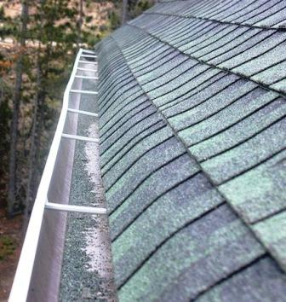

Inspecting the roof periodically can help to identify potentially significant issues and repair them before real damage can occur. Walking the roof during an inspection can help find excessively worn or soft spots in the roof. Worn or deteriorated areas can be potential leak spots in the future and soft spots can be a sign of an existing leak. As comp roofs age they shed granules which collect in the gutters and can create blockages preventing the rainwater or snow melt from running freely. A soft spot can occur when the water has leaked under the shingles and is causing the plywood underneath to rot and fail. Another area for potential leaks is the flashings. The flashings are the galvanized metal pieces that direct water away from the roof where there is either penetration, such as a skylight or pipe, or at a junction in the roof. If the flashings are not secure, your roof will eventually leak.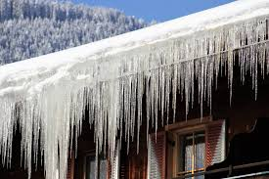

Who doesn’t love the idyllic image of icicles hanging from the eaves? While these create a pretty picture, they could be a sign of impending damage. When icicles form, they create an avenue for water to creep back into the attic and cause damage. Also, the weight of the ice can damage the gutters causing a costly repair. While many of our communities are newer and do not have established mature trees, debris still collects in the gutters and can clog them. Not cleaning your gutters before the winter storms can cause the water buildup to freeze and create an ice dam, which in turn creates those lovely but pesky icicles. Icicles can also be a result of insulation issues, but we’ll visit that in another article.

Additionally, downspouts should have some sort of diversion attached to them. Typically, the downspout terminates near the ground with a small elbow to direct the water away from the house. Ideally the downspout would be connected to a subterranean drainpipe but at least there should be a “splash block”. Letting the water simply drain near the foundation can cause erosion and additional damage.

So now is the time to start thinking about getting your roof inspected and repaired. Don’t wait until the storms arrive and there is an active leak through the ceiling to call the roofer. Be proactive. Schedule that inspection and your gutter cleaning *before* you have a problem. It’s much easier and cheaper in the long run.

Arden “Chip” Anderson is the owner of the Anderson Property Group, Inc., a property inspection and consulting firm in Star.

986-226-5355

[arden@theandersonpropertygroup.com](mailto:arden@theandersonpropertygroup.com)

[www.theandersonpropertygroup.com](http://www.theandersonpropertygroup.com)