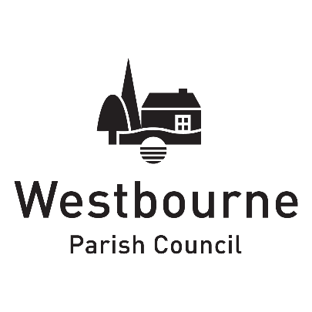

Job description

Job title | Assistant Clerk
Responsible to | Parish Clerk
Responsible for | Work from home on days to be agreed  Attending occasional meetings in Westbourne
Duties | As per job description
Hours | 10 hours per week  12 month six month contract  Opportunity for further hours and for the role to become permanent
Salary | NJC Scale 17-23. £16.08 per hour depending on experience

The Assistant Clerk supports the Parish Clerk/RFO to carry out the functions of the Parish Council to secure its aims and objectives and to assist with community projects.

This includes supporting the Clerk to produce information required for making decisions, assisting with implementing decisions, working with other organisations and principal authorities. To ensure that the needs of the Parish are being met through the smooth administrative running of the Council and acting as an initial point of access for enquiries. The Assistant Clerk is answerable to the Council through the Clerk and is line managed by the Clerk.

Key responsibilities

- Respond to enquiries and requests for information from telephone calls, emails and letters.
- Liaising with other organisations and principal authorities on Council-related matters.
- To assist the Parish Clerk in the preparation of agendas and supporting information for Council meetings.
- Proactively following up actions from any Full Council or Committee meeting as appropriate, including the reading of all Full Council and Committee minutes to keep informed of all Council developments and requirements.
- Assisting in producing information and quotes in the format required for the Council in liaison with the Clerk.
- Undertaking and/or assisting with the organisation and administrative support for events and projects as required.
- To assist with updating the Parish Council website and other social media used by the Parish Council, in liaison with the Clerk.
- Undertake training for, and carry out play area and defibrillator inspections, reporting issues to the Clerk and assisting in their resolution, ensuring paperwork is maintained.
- Ensuring all office filing is completed within the correct files and that both electronic and hard copy filing is maintained in a user friendly and tidy way.
- Contributing to an annual appraisal the postholder’s performance.

Continuous professional and personal development

- To attend training courses or seminars on the work/role of Assistant Clerk and the Council’s activities as required by the Council.
- To continue to acquire and maintain the necessary professional knowledge and skills for the effective management of the Council.
- To undertake any other duties commensurate with the level of the post as required by the Council from time to time.

