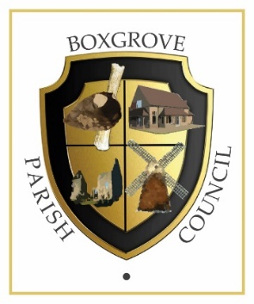

Parish Clerk and RFO

Overall Responsibilities

The Clerk to the Council will be the Proper Officer of the Council and as such is under a statutory duty to carry out all the functions, and in particular to serve or issue all the notifications required by law of a local authority’s Proper Officer.

The Clerk will be responsible for ensuring that the instructions of the Council in connection with its function as a Local Authority are carried out.

The Clerk is expected to advise the Council on, and assist in the formation of, overall policies to be followed in respect of the Authority’s activities and in particular to produce all the information required for making effective decisions and to implement constructively all decisions.

The person appointed will be accountable to the Council for the effective management of all its resources and will report to them as and when required.

The Clerk will be the Responsible Financial Officer and responsible for all financial records of the Council and the careful administration of its finances.

This post requires:

- Excellent administrative and organisational skills

- Experience of financial record keeping / book keeping

- Good IT skills

- Sound written and verbal communication skills online, on the telephone and face to face

Specific Responsibilities

- To ensure that statutory and other provisions governing or affecting the running of the Council are observed.

- To monitor and balance the Council’s accounts using SCRIBE accounts software (training possible) and prepare records for audit purposes and VAT.

- To ensure that the Council’s obligations for Assertion 10 of the AGAR are properly met, to include but not limited to the following: Freedom of information and transparency; Accountability and Transparency; Website accessibility and legal compliance; Risk Assessment, Document retention schedules; Data Protection and UK GDPR Compliance; IT policy.

- To prepare and issue, in consultation with appropriate members, notices and agendas for meetings of the Council and Committees. To attend such meetings and prepare minutes for approval.

- To attend all meetings of the Council, including any committees and sub-committees, other than where such duties have been delegated to another Officer.

- To retrieve correspondence and documents on behalf of the Council from the postbox at the Village Hall, and to deal with the correspondence or documents or bring such items to the attention of the Council. To issue correspondence as a result of instructions of, or the known policy of the Council.

- To receive and report on invoices for goods and services to be paid for by the Council and to ensure such accounts are met.

- To manage and maintain the Council’s website.

- To study reports and other data on activities of the Council and on matters bearing on those activities. Where appropriate, to discuss such matters with administrators and specialists in particular fields and to produce reports for circulation and discussion by the Council.

- To draw up both on her/his own initiative and as a result of suggestions by Councillors, proposals for consideration by the Council and to advise on practicability and likely effects of specific courses of action.

- To monitor the implemented policies of the Council to ensure they are achieving the desired result and where appropriate suggest modifications.

- To act as the representative of the Council as required.

- To issue notices and prepare agendas and minutes for the Annual Parish Meeting: to attend the assemblies of the Parish Meeting and to implement the decisions made at the assemblies that are agreed by the Council.

- To prepare, in consultation with the council, press releases about the activities of, and/or decisions of, the Council.

- To attend training courses or seminars on the work and role of the Clerk as required by the Council.

- To continue to acquire the necessary professional knowledge required for the efficient management of the affairs of the Council: suggested is membership of your professional body The Society of Local Council Clerks.

