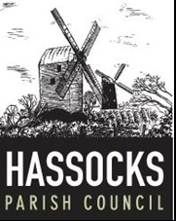

Job Advert – Community Engagement Officer

Salary: £31,537 – £35,412 (SCP 18–24)
Hours: 37 hours per week (some evenings/weekends)
Location: Parish Centre, Adastra Park, Hassocks BN6 8QH

Hassocks Parish Council is looking for a creative, motivated individual to lead our community engagement and communications work. You’ll manage online and print media, organise events and work with Councillors and local groups to facilitate the delivery of community projects.

You will need:
- Experience in community engagement or outreach
- Strong communication and digital skills
- Confidence managing events and supporting meetings
- A proactive, community-focused approach

How to apply:
For a job description and application form please download details from our website www.hassocks-pc.gov.uk, telephone 01273 842714 or email info@hassocks.gov.uk
Closing date Wednesday 25 February 2026. Interviews w/c 2 March 2026.

