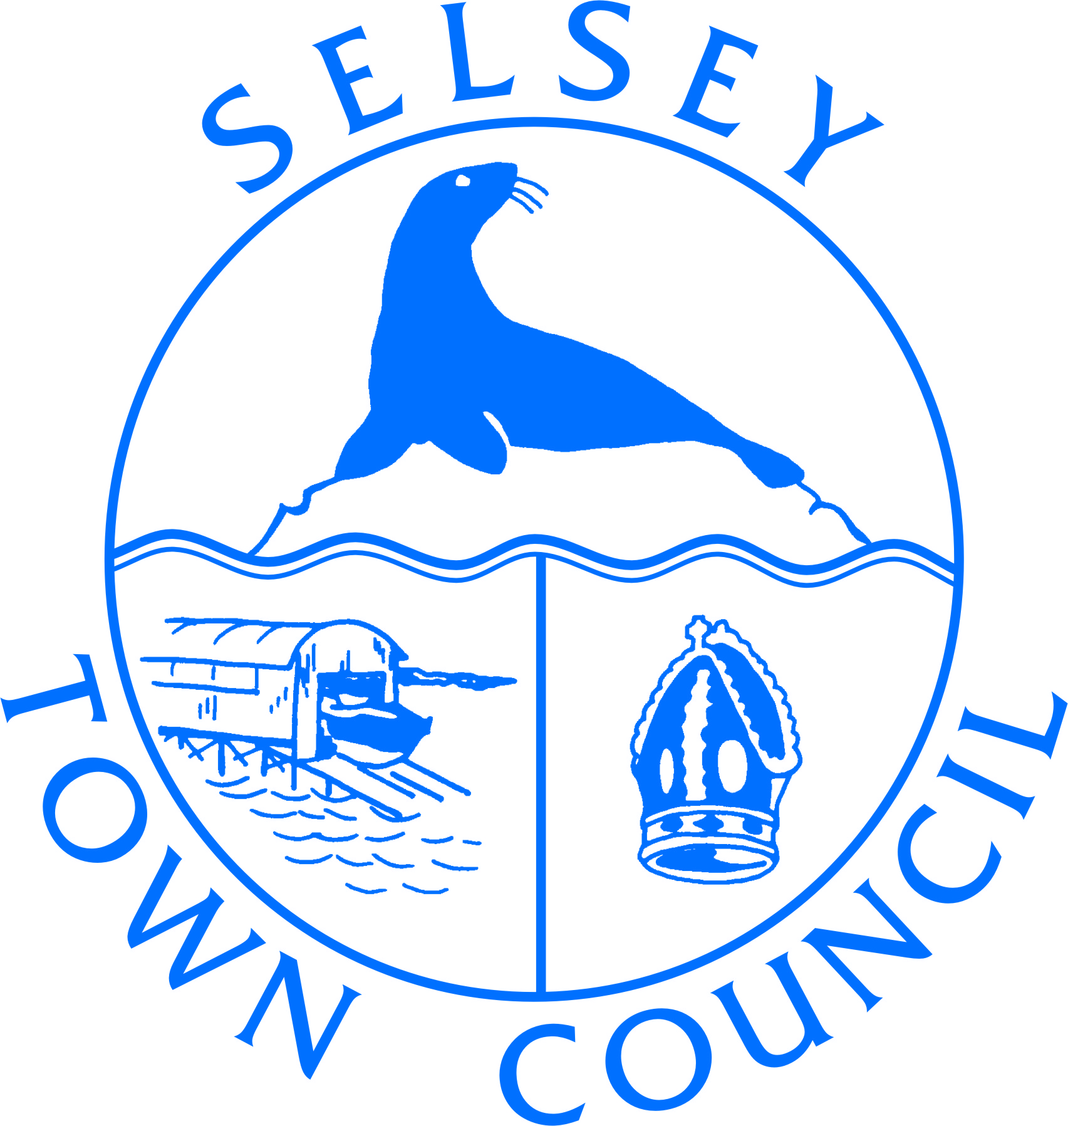

JOB DESCRIPTION

JOB TITLE: Governance Administrator/Officer
Grade SCP 7-10 (Progression up the scale to Governance Officer (SCP 10) is subject to satisfactory performance and qualifications obtained).

HOURS: 30 hours per week [with additional overtime
by prior arrangement with the Deputy Clerk]

BASE: Selsey Town Council
55 High Street, Selsey, West Sussex PO20 0RB

RESPONSIBLE TO: Deputy Clerk

PURPOSE:
To provide full-time operational administrative support to senior colleagues and the maintenance team, an enquiry service to members of the public and to assist in the day-to-day duties of the Town Council offices.

The person appointed will be expected to undertake training that will be valuable in developing a career in local council administration.

This role has no management responsibilities.

DUTIES AND RESPONSIBILITIES

General:
- To provide general administrative support to include the processing of post, preparing and distributing letters, photocopying, maintenance of filing systems and databases, stationery and office equipment stocks, information, and resource library.
- To ensure all literature and information provided to the public is up to date and replenish as required.
- To signpost members of the public with enquiries and documentation on behalf of Selsey Town Council, Chichester District Council and West Sussex County Council.
- To act as a point of enquiry for the public and a source of general tourist information.
- To update & maintain a diary, manage the bookings software and generate invoices for the suite of halls available within the Town Hall complex to provide a comprehensive bookings service.
- To ensure the booked halls are correctly laid out for the meetings or classes with enough tables, chairs, or equipment as appropriate.
- To undertake accurate cash handling and reconciliation, including through direct sales to the public.
- To administer the wedding bookings and assist clients as appropriate.

- To participate in any relevant training provided by Selsey Town Council or an external training provider.
- To adhere to the Town Council’s policies and procedures.
- To provide cover during periods of staff absence including at the Selsey Centre if required.

As directed by and in support of the Clerk and Deputy Clerk

- To maintain and schedule standard social media posts for day-to-day information relating to West Sussex County Council, Chichester District Council and Selsey Town Council
- To arrange the distribution and display of Council documentation both in hard copy and upload documents on the website, including agendas, minutes, public notices, and finance information.
- To provide administrative support for the Maintenance Team and the Festive Lighting Working Group
- To provide the administrative support for the Annual Town Meeting.
- To add/amend/delete Council assets on Parish Online.
Training

- The post holder will undertake training and self-directed study from the second year with the Council (and for which appropriate time will be allocated) leading to the award of
    - The Introduction to Local Council Administration (ILCA) by the end of year 2
    - The Financial Introduction to Local Council Administration (FILCA) by the end of year 3.
Funding for these qualifications will be provided by the Town Council.

General
- To carry out such other duties as may be required, commensurate with the role.
- To be responsible for the security of the premises, including safe custody of premises keys when necessary.
- The job description will be reviewed as necessary and may be changed in the light of experience and in consultation with the post holder.
- This document does not constitute a job specification and accordingly does not purport to represent an exhaustive list of all duties. It is intended to indicate the main areas of activity.

Candidate Profile
 | Essential | Desirable
GCSE English Grade C/4 or above | E
GCSE Maths Grade C/4 or above | E
IT literate with excellent Microsoft Office skills | E
A willingness to undertake further study | E
Well organised | E
Able to attend evening meetings | E
Able to work on weekends occasionally | E
An understanding or knowledge of local government |  | D

