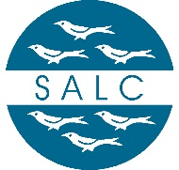

West Sussex Association of Local Councils Limited
Agenda for a Board Meeting
Thursday 28th May 2026 at 10.30am
At Billingshurst Community & Conference Centre
Item | Item Description | Action(s) | Who
 | Apologies for absence | To receive apologies for absence | Chair
 | Minutes of the previous meeting | To approve and sign the minutes of the meeting held on 23rd March 2026 | The Board & Chair
 | Second Consultation on Local Government Reorganisation | To discuss and formulate a response to the second consultation ahead of the closing date of 15 June 2026 | The Board

